ne urriciai h'UDiication ot alua—An internacionai Association 01 becuniy hruiassiuiiais

**Plus:** Recess Control Goes Wireless,  
Computer-Managed Recess Control, S&G’s Neui  
Rotarybolt Z02 Solenoid Electronic Safe Lock,

Cycle Chronicles Goes Harley (Part 2),

Programming a Honda Transponder (Part 2),  
Nauigating the LUhiteuiaters of Pass-Through  
Programming, R Closer Look at the KRBR MRS K-09,  
the Curious Curator presents French Masterpieces  
and Morel!

*******#***##**#**#‘j_£)jQj,j' *3*Q*3*

Breck H. Camp CML PO Box 47070 Atlanta GA 30362-0070

[www.aloa.org](http://www.aloa.org)

July/August 2004

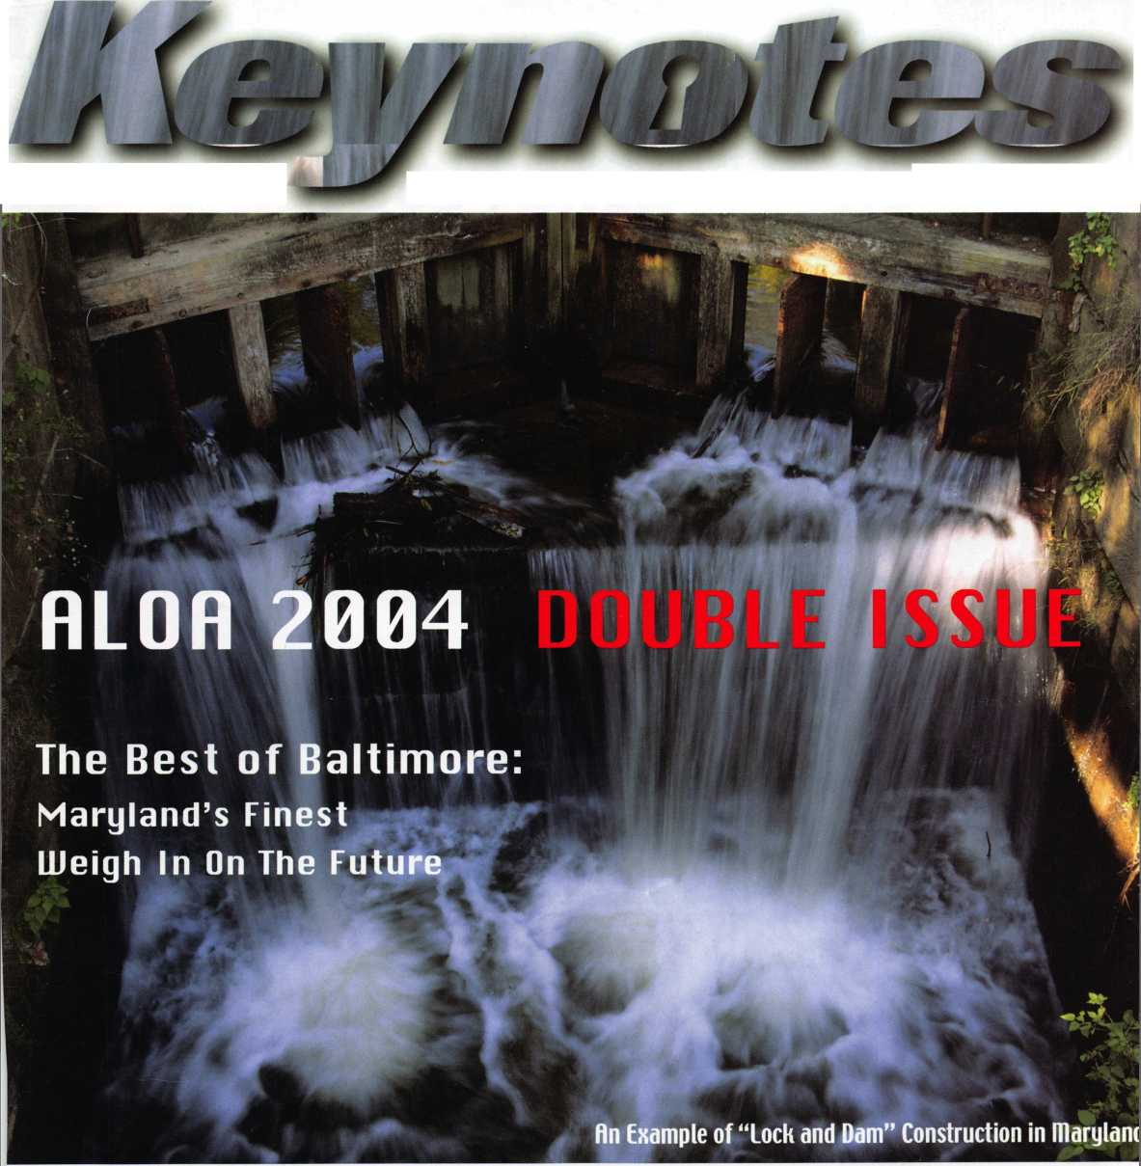

PART NO.

**708751 MASTER PACK** Variety of domestic and import transponder keys. **GET THE TRAVEL CHAIR FREE!**

**708752 EXPERT PACK** Variety of domestic and import read-write transponder keys. **GET THE IGLOO COOLER FREE!**

**708753 PRO PACK** Variety of domestic and import molded head non-transponder keys. **GET THE MAG-LITE FREE!**

CALL YOUR DISTRIBUTOR NOW to get one

of these gif

"‘White Keypack supplies last.

FREE WITH EACH KEYPACK* ORDER.

Ife **strattecXL**

X;: ONE SOURCE. MANY SOLUTIONS.

l»i

WHAT IS THIS. YOUR BIRTHDAY?

When you order any STRATTEC XL Keypack. you get more than just an assortment of XL keys. You get the  
most convenient way to build an immediate inventory of a variety of the XL keys your customers need -  
at a discount - PLUS a FREE gift. All just for ordering the products you know you can trust. Shouldn't  
every shopping experience be this convenient?

AN INCREDIBLE DEAL KEYPACKS PLUS A

FREE GIFT?

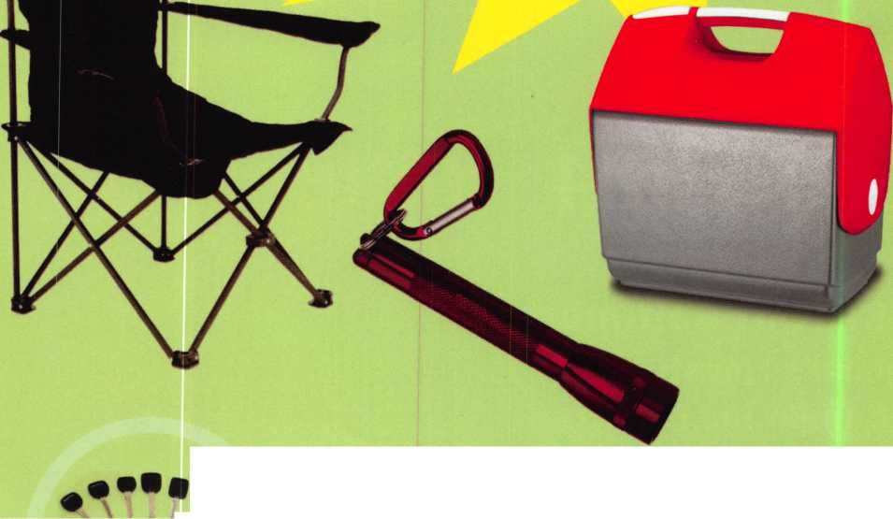

.29.95

.19.95

.19.95

.29.95

.29.95

29.95

.79.00

.45.00

.85.00

.19.95

.29.95

.19.95

.29.99

.19.95

.55.00

.39.95

.89.95

.39.95

PRP Resource Guide 25.00

Locksmithing from Apprentice

to Master 27.00

Wafer Lock Reading 19.95

Door Lock Encyclopedia 39.95

Lock Repair Manual 14.95

Interchangeable Core Cylinders 34.95

Picking & Impressioning 45.00

The Lure of the Lock 29.95

High Security Safes, vol 1 175.00

High Security Safes, vol 2 175.00

Safeman's Guide, vol 13 9.95

Safe Deposit Depth and Space Manual 99.00

Safe Technician's Reference Manual 155.00

Gun Safes 110.00

Modern Safe Opening 59.95

Dave McOmie on Vault Doors, vol 1, Bank Vaults 1 10.00

Dave McOmie on Vault Doors, vol 2, Fire and Plate Vaults 1 10.00

Modern Safe Locks 95.00

Drilling Safes 95.00

Safe Deposit Box Service 39.95

Foreign Car Impressioning Book 29.95

Impressioning Ford and GM Side Bar Locks 29.95

Automotive Lock Servicing Update #1: GM 10-Cut Locks 29.95

Automotive Lock Servicing Update #2: GM 10-Cut Locks 29.95

Automotive Lock Servicing Update #3: GM 8-Cut Locks 29.95

GM Locks: Perfect for the Beginning Locksmith! 29.95

Ford Locks: Pin Tumbler and Ten-Cut Systems 29.95

Chrysler Pin Tumbler Locks 29.95

Chrysler Double-Bitted Locks 29.95

Toyota Split-Tumbler Locks 29.95

Basic Door Panel Servicing 29.95

Advanced Door Panel Servicing 29.95

Motorcycles on CD 99.00

The Guide to Motorcycles 99.00

Japanese High Security Auto Servicing 29.95

Revised GM Steering Column Course 1 15.00

Foreign & Domestic Auto Service 69.95

Auto Lock Service 14.95

The Sieveking Auto Key Guide & Illustrated Cross Reference 27.00

Servicing Interchangeable Cores—Sargent 25.00

Servicing interchangeable Cores—Arrow, Best,

Eagle, Falcon, and Lockwood 25.00

The Ultimate CCTV Program on CD Rom 595.00

Just a Few

of Our Titles...

Learn About Basic Electricity

Spacing and Depths, vol 1

Spacing and Depths, vol 2

Filing for Dollars

Antique Padlocks

VATS Made Simple (Revised)

Guide to Transponders

2000 Transponder Update

Bread & Butter

Locks and Lockmakers of America

Learn About Electronic Locking Devices

The Best of Locksmithing, vol 1

Logical Lock Diagnostics

How to Pick Lever Locks

Fundamentals of Master Keying

Guide to Electronic Locksmithing

Security Solutions Locksmith Marketing Program The Ultimate Techtips Collection

Visit our website to view more available titles.

Place your order online or by phone today!  
[www.aloa.org](http://www.aloa.org) • (214) 827-1701 • Please allow 3-4 weeks for delivery.



**presidentia**

viewpoint

Dear Members,

The election results are in and I would like to congratulate your new  
secretary, John Soderland, CML, CMST and welcome two new board  
members, Jim Jeffries, CPS, in the northwest region and Vernon Kelly,  
CPL, in the northeast. Bob Mock and Pete Sarailian, CRL, were  
reelected to directorship in the northeast and Hans Mejlshede, CML,  
was reelected as European Director. C.D. Lipscomb CML, CPS, will  
continue to serve as Southeast Director, Joe Lee, CRL, will continue as  
Asian Director and Paul Justen will continue as Associate Director until

those positions are properly elected. John Soderland will serve a dual  
role and finish his term as North Central Director. The three bylaws changes were passed  
and the bylaws have been updated.

I was very discouraged by the election response this year. Even though this was a national election where a secretary was being elected and bylaws changes were voted on, we barely achieved the quorum for the election to be valid. As members, we all need to be active and concerned for the well being of our association. Your ballot is your voice in how the associa­tion is run and the majority of you chose not to exercise that right. It is not only a right but, a responsibility!

I attended my first European Locksmith Federation convention in May in Berlin, Germany, and it was an enjoyable experience. Bill Gibson and I presented a 40th Anniversary plaque to Interkey (the German Association) president, Erhardt Achilles and, a 20th Anniversary plaque to ELF president, Peter Ostman. ALOA was well received and we were well treated. We invit­ed all in attendance to our convention in Baltimore.

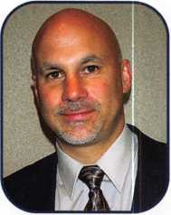

During the ELF convention, I was invited to sit in on a meeting arranged by the Automotive Lock Association with Silca, Europe's leading producer of automotive keys. Roberto Gaspari, managing director of Silca, represented his company to the representatives of many of ELF's member associations. Mr. Gaspari was gracious in answering questions and promised continued support and training for the automotive locksmiths of Europe.

As you receive this issue of Keynotes, our convention in Baltimore will be in full gear.

I look forward to seeing you there. It will be a great show!

Sincerely,

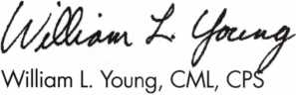

Keynotes • July/August 2004

**A notch**

TOPNOTCrl

DISTRIBUTORS, INC.



**Since 1975, we have built our reputation on personal service and a complete in-stock inventory of quality architectural hardware lines. It's true; no one treats you better than our full-service team! We are committed to your complete satisfaction. No other company carries a wider selection of architectural hardware styles and finishes. All of which are in stock and available for immediate shipment. Together, our people and products are what make us** a notch above.

**Serving North America**

**Pennsylvania Missouri Nevada [www.topnotch.bz/al](http://www.topnotch.bz/al)**

1-800-233-4210 1-800-211-4607 1-800-722-4210 [sales@topnotch.bz](mailto:sales@topnotch.bz)

**Top Notch Distributors, Inc., represents all major door hardware products:**

|  |  |  |
| --- | --- | --- |
| • ACSI | • llco Unican | • Rixson |
| • Acorn | • Ives | • Rockwood |
| • Adams Rite | • Kwikset | •SOSS |
| • Arrow | • LCN | • Schlage |
| • Baldwin | • Lab | • Simplex |
| • Bommer | • Locknetics | • Stanley |
| • Detex | • McKinney/Essex | • Trimco |
| • Don-Jo | • Monarch | • Von Duprin |
| • Dor-o-matic | • National Guard | • Weiser |
| • Falcon | • Norton |  |
| • Glynn-Johnson | • Pemko |  |
| • Hager | • Pro-Lok |  |



features

CONVENTION ISSUE 2004

12

20

**26**

ALOA 2004: The Best of Baltimore

Variety captures the essence of Maryland's geography, economy and distinct communities. Over 5 million people live and work on almost 10,000 square miles of land in Maryland. From mountain terrain to sandy beaches, Maryland is home to private industry, educational institutions, commercial facilities, Federal Government installations, military bases and much more. By c/a/re Cohen, cml

Institutional: Access Control Goes Wireless!

If you were to ask a security director who purchased an access control system in their organization what the most expensive seg­ment of the system was, most would respond that the labor was the highest line item in the overall bill. I am here to inform you of some good news: a solution called Wyreless Access, a wireless access control device that cuts your time and increases your profits.

By Bill Neff, CML

Access Control: Locks vs. Computers

Computers have advanced a lot in the last 15 years and we, the old crotchely locksmiths, have had a hard time catching up. But its worth your while to take a look at computer-managed, or CM access control. I'll show you how it will save you many

headaches. By Adam Black, CRL

**32**

Sargent & Greenleaf's New Solenoid Safe Lock

In the world of electronic safe locks, there is a confusing plethora of features and functions, but the job of physically blocking the safe's boltwork is usually accomplished by either a motor or a solenoid. Why two blocking systems? Well, why were there both roller fences and drop levers in the heyday of mechanical safe locks? The answer is obvious. Each system has its strengths and each offers something different to the end user. S&G's new Rotarybolt Z02 solenoid electronic safe lock offers plenty to the

end user. By Brian CosHey, CML, CMST

**38**

Cycle Chronicles: 100 years of Harley-Davidson, Part 2

In our last installment of Cycle Chronicles, we documented main­stream key systems found on Harley Davidson motorcycles from the company's infancy in the early 1900s through the 1980s. In this issue, we will start at the beginning of the post-AMF period (app. 1981) and finish at the beginning of the 21 st Century.

By Ray D 'Adamo, CML

**44**

PROGRAMMING AN ACURA 3.5 R. with TRANSPONDER MODULE, PART 2

In the first part of this series, we looked at the Acura 3.5R, a great example of a Honda transponder-equipped vehicle that uses read/write keys and is a little more involved than just program­ming a transponder key. Locksmiths need to be aware of read/write keys and know how to clone them, which is what we will focus on in this article. Let's take a look.



**56**

By Jeff Trepanier, RL

Navigating the Whitewaters of Pass-Through Programming

The future of automotive locksmithing may seem dim to some; to others, it's an exciting ride on the whitewaters of new technology. Recent news has covered the Controller Area Network, or CAN system, that all manufacturers are moving towards. This article cov­ers another technology, briefly discussed in earlier articles, and the new direction in vehicle programming: Pass-Through programming.

By Tom Seroogy

**Greg's** Corner: Revisiting the Kaba Mas X-09

Two years ago, in the November 2002 issue of Keynotes, I went over the then brand new Kaba Mas X-09. Since that time, I've installed many, opened dozens with a dead blow hammer and a couple with a drill. The X-09 is currently the only lock approved under FFL2740, a government specification for storing classified materials. The X-09 and its predecessors (the X-07 and X-08) have provided a good source of income for those safe technicians lucky enough to perform work for the government. Let's take a look at how this lock has performed, look at opening techniques and con­trast it with the X-07 and X-08 in a few areas. ByGreg Perry, cml, cps

**60**



Meet This Year's ALOA Scholarship Recipients

Member Milestones

State of the Association

ALOA Financial Report

The Curious Curator

Presents French Masterpieces By aj Hoffman, cml

About the Cover:

Water flows smoothly through a lock on the Maryland side of the Potomac River.

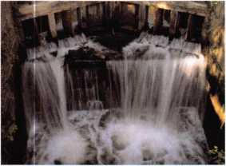

**Departments**

|  |  |  |  |
| --- | --- | --- | --- |
| Executive | 5 | Legislative |  |
|  |  | Update | 70 |
| Applicants .... | 6 | Classified | 72 |
|  |  | Associate |  |
| Calendar | 8 | Members | 62 |

**Visit our website**

**at [www.aloa.org](http://www.aloa.org)**

executive

Volume 50, Issue 7



Additional contact information for the ALOA Board and most Keynotes authors is available through "Locksmith Search'" on the ALOA Web site- [www.aloa.org](http://www.aloa.org) or by contacting the ALOA office at 3003 Live Oak Street; Dallas, TX 75204; (800)532-2562; FAX (214)827-1810; e-mail [aloa@aloa.org](mailto:aloa@aloa.org).

|  |  |
| --- | --- |
| Art Director  Betty Henderson | [betty@aloa.org](mailto:betty@aloa.org) |
| Technical Editor  David Lowell, CML, CMST | [david@aloa.org](mailto:david@aloa.org) |
| Editorial Advisor  John Cannon, CML | [secretary@aloa.org](mailto:secretary@aloa.org) |
| Advertising Sales  Kim Hammond | voice: 817-645-6778  Fax: 817-645-7599 e-mail: [adsales@aloa.org](mailto:adsales@aloa.org) |
| Executive Director  Charles W. Gibson, Jr., CAE. | [charlie@aloa.org](mailto:charlie@aloa.org) |
| Convention & Meetings Manager  Jo Anne Mims [joanne@aloa.org](mailto:joanne@aloa.org) | |
| PRP/Education Manager  David Lowell, CML, CMST | [david@aloa.org](mailto:david@aloa.org) |

Contributors

Jerome Andrews, CML Paul Chandler, CRL Claire Cohen, CML Brian Costley, CML, CMST Eric Costley, CRL

Operations/Membership Manager

Mary May [mary@aloa.org](mailto:mary@aloa.org)

Government Relations Manager

Paul Kanitra [paul@aloa.org](mailto:paul@aloa.org)

IT Operations Manager

Greg Jackson [greg@aloa.org](mailto:greg@aloa.org)

Comptroller Kathy J. Romo

Membership Coordinator Shelly Jett

Convention & Meetings Assistant Karen Lyons

PRP/Education Coordinator Hope Rodriguez

Accounting Coordinator Essie Goode

Mail Room Coordinator Kevin Wesley

Publications Coordinator Bryan Dease

Receptionist Cliff White

A.J. Hoffman, CML Greg Perry, CML,CPS

Jeff Nun berg, CML, CM ST Tom Seroogy

Randy Simpson, CML Charles Stephenson, CPS

Robert Stafford, CML Dennis Watanabe, CML, CMST

Dave Thielen, CML

Ray D'Adamo, CML Sal Dulcamaro, CML Billy Edwards, CML Dan Graffeo, CRL,CMST Jim Hancock, CRL

Mission Statement: The Associated Locksmiths of America, Inc. is dedicated to enhancing the professionalism, education and ethics among locksmiths and those in related sectors of the physical security industry. With approximately 10,000 members in the United States, Canada and the freeworld, ALOA is poised to help members obtain the knowledge, the strength, and the confidence to perform their role in the physical security field with pride and dignity. But it is only through active involvement and participation that ALOA can fully achieve its potential—and can help members to achieve theirs.

Policies: Keynotes® is the official publication of the Associated Locksmiths of America, Inc. (ALOA). Keynotes® acts as a moderator without approv­ing, disapproving, or guaranteeing the validity or accuracy of any data, claim, or opinion appearing under a byline or obtained or quoted from an acknowledged source. The opinions expressed by the authors do not necessarily reflect the official views of ALOA. Also, appearance of advertisements and new products or service information does not constitute an endorsement of products or services featured by the Association. The Association does not accept responsibility for the inaccuracy of any data, claim, or opinion appearing in this publication, due to typographical errors on the part of the authors, Association staff or its agents.

Editor's Note: This publication is designed to provide accurate and authoritative information in regard to the subject matter covered. It is provided and disseminated with the understanding that the publisher is not engaged in rendering legal or other professional services. If legal advice and other expert assistance is required, the services of a competent professional should be sought.

Authors' Payment: Payment for eligible submissions to Keynotes will be based on the following criteria: topic, time spent and past contributions. Authors who regularly submit to Keynotes® are generally paid a higher rate. The latter is especially true of authors who write to fit specific editorial needs and submit said copy by Keynotes® deadlines. As a general guideline: Average payment for a 750 word, business or light' technical article would be $200. Payment for a 1500 word article involving significantly higher time and research efforts would be $400.

Payment will not be offered for articles submitted by ALOA employees or members of the ALOA Board of Directors (unless material is of a technical nature), nor for articles submitted by a company that promote that company's products or services. ALOA reserves the right not to pay for articles sub­mitted by an individual(s) that promote a particular company's products or services.

Disclaimer: The Associated Locksmiths of America, Inc., (ALOA), reserves the right to refuse any article for any reason. Additionally, ALOA reserves the right to edit, amend or modify any article submitted for publication in order to preserve technical accuracy, clarity, fairness or grammatical correct­ness. ALOA will make the best efforts to notify the author of any changes. The extent of ALOA's liability for any article or information contained there­in will be a notice of correction or retraction in the next possible issue.

Keynotes® (ISSN 0277 0792) is published monthly except for the combined June/July issue by The Associated Locksmiths of America, Inc., 3003 Live Oak St., Dallas, TX 75204-6186. Telephone: (214) 827-1701; FAX (214) 827-1810; e-mail [aloa@aloa.org](mailto:aloa@aloa.org). Subscription rates for members—$15.00 per year. Periodical class postage paid at Dallas, Texas. POSTMASTER: Send address changes to: Keynotes, 3003 Live Oak St., Dallas, TX 75204-6186. © Copyright 2003, All rights reserved. No part of the contents may be reproduced or reprinted in any form without prior written permission of the publisher.

President

William L. Young, CML  
(610)647-5042  
president@a!oa .org

Secretary

John D. Connon, CML  
(703) 960-6413  
secreta ry@a loa. org

Directors, Northeast

Robert E. Mock  
(856) 863-0710  
[nedirector@aloa.org](mailto:nedirector@aloa.org)

Peter Sarailian, CRL  
(973)890-9797  
[nedirector@aloa.org](mailto:nedirector@aloa.org)

William L. Young, CML  
(610) 647-5042  
[nedirector@aloa.org](mailto:nedirector@aloa.org)

Directors, Southeast

Tom Gillingham, Jr., CML, CPS

(615)264-0747  
sed i rector@a loa. org

Ken Kupferman, CPL  
(813)961-5784  
sedirector@aloa .org

Directors, North Central

Mark E. Blum, CML, CPS  
(517)482-5809  
ncd i rector@aloa. org

John Soderland, CML, CMST  
(414) 327-5625  
[ncdirect6r@aloa.org](mailto:ncdirect6r@aloa.org)

Director, South Central

CD Lipscomb, CML, CPS  
(903)874-3522  
[scdirector@aloa.org](mailto:scdirector@aloa.org)

Directors, Southwest

Gordon R. Racine, CML  
(719) 384-4707  
swd i rector@a loa. org

Julie McCJuney, CRL  
(714) 636-5652  
[swdirector@aloa.org](mailto:swdirector@aloa.org)

Director, Northwest

Scott L. Henke, CPL, CPS  
(907) 248-3785  
[nwdirector@aloa.org](mailto:nwdirector@aloa.org)

Director, European

Hans Mejlshede, CML  
(453)539-3939  
eurd i rector@aloa .org

Director, Asian

JoeJ. Lee, CRL  
(215)289-2404  
asiandirector@aloa .org

Director, Associate

Paul M. Justen  
(800)333-6953  
[asdirector@aloa.org](mailto:asdirector@aloa.org)

Trustees

[trustees@aloa.org](mailto:trustees@aloa.org)

Randy Simpson, CML  
(281)240-5959

JohnJ. Greenan, CML, CPS  
(773) 486.2030

Dallas Brooks  
(334) 826-8990

Past Presidents

2001 -2002 Randy Simpson, CML  
1999-2001 John Greenan, CML, CPS  
1997-1999 Dallas C. Brooks  
1995-1997 David Lowell, CML, CMST  
1993-1995 BreckCamp, CML  
1991-1993 Henry Printz, CML  
1989-1991 Evelyn Wersonick, CML, CPS  
1987-1989 Leonard Passarello, CPL  
1985-1987 Joe Jackman, CML  
1983-1985 Stanley Haney, CPL  
1981-1983 Louis LaGreco, CPL  
1979-1981 John Kerr, RL  
1977-1979 Clifford Cox, CML  
1974-1977 Charles Hetherington  
1972-1974 Gene Laughridge  
1970-1972 William Dutcher, RL  
1968-1970 Constant Maffey, PL  
1966-1968 Harold Edelstein, RL  
1964-1966 William Meacham  
1962-1964 Robert Rackliffe, CPL

1960-1962 Edwin Toepfer, RL 1956-1960 Ernest johannesen



Keynotes • July/August 2004

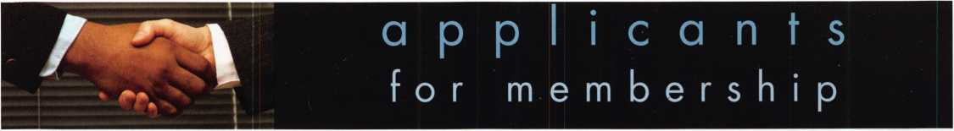

AL

Birmingham

Jonathan W. White

Sponsor: Robert J. McCormick CRL

Samuel A. Sciara Jr

Sponsor: Robert J. McCormick CRL

AZ

Phoenix

Felix A. Garza

CA

Gridley

Stan Young

**co**

Aurora

Alan B. Collins

Sponsor: Charles E. Haas CML

CT

Windsor Locks

Scott Williams

Sponsor: Melissa A. Griswold

FL

Kissimmee

Vernon E. Medlin

Sponsor: Kevin L. Armstrong

Pensacola

Danny C. Brannon

Starke

Carol A. Talsky

Sponsor: Dolores C. Talsky RL

IL

Columbia

Kenneth Ebers

Rockford

Thad M. Johnson

Chelsea M. Spinello

Sponsor: Guy M. Spinello RL

Stream wood

Patrick Sullivan

Sponsor: Fred H. Hepp Sr

IN

Portage

Gerald G. Gibson

Sponsor: William T. Beranek

Wilkinson

Wayne Sexton

Sponsor: Jeremy B. Rodocker CML CPS

LA

Shreveport

EarlJ. Munch CRL

Sponsor: Michael R. Knight CRL

MD

Capitol Heights

Curtis A. Sheelor

Sponsor: John D. Cannon CML

Laurel

Kenneth Fowler

Sponsor: Tom Foxwell Sr

Ml

Belleville

Edward A. Smith

East Lansing

Douglas Katt

Sponsor: Mark E. Blum CML,

CPS

Jerry W. Michael

Escanaba

Ricky V. Benoit

Sponsor: Thomas G. Vandersteen CML CPS

Pinckney

Redford

Gary Smith

Sponsor: Robert M. Massard

CRL AHC

Keith Fielden

Sponsor: Robert M. Massard CRL AHC

Saginaw

Mike Hamilton

Sponsor: Clifford D. Lipscomb

CML CPS

MN

Oakdale

Edward Columbus

NJ

Clifton

Ryan Stanckiewitz

Flemington

Harry Snook

Long Branch

John Crane

Sponsor: Edward J. Roskelly CML

Bronx

Steven Novellino

Sponsor: Carl F. Campbell CPL

Howard Beach Thomas Hayes

Maspeth

Craig P. Wessel

Sponsor: Thomas F. Ciangiola

Springfield Gardens

Timothy D. Morgan

Sponsor: James G. Oliveri

OH

Joshua R. Leitzy



NV

Jacob Dairy

Sponsor: Fredric P. Roberts Sr, CRL

*PA*

Levittown

Joseph L Miller

Sponsor: Robert S. Ralston

Philadelphia

Ted Dormoi

TN

Knoxville

Jeremy Arnwine

Sponsor: Kenneth T. Craft

TX

Canyon

Lee Banks

Sponsor: Bruce P. Eagan CML Plano

Ralph W. Pawson

San Marcos

Jim L Anderson

Sponsor: Kenneth C. Warden CPL

VA

Hampton

Michael D. Wallin

Sponsor: Robert L. Wallin

Lorton

Jon Clinton Perry

Sponsor: William J. Thorpe

WA

Airway Heights

Kevin Morrisey

Sponsor: Andrew A. Edmunds CML CPS

**Jody** R. Goulette

Sponsor: Andrew A. Edmunds CML CPS

Bahamas

Nassau

John Gates

Sponsor: Clinton T. Harding CPL, CPS

Drevor Rolle

Sponsor: Clinton T. Harding CPL, CPS

Canada

Orleans, ON

Robert W. Smith

Montreal, PQ

Francis Coats

Sponsor: Gary Brewer

China

Taizhou

Ke Ping Lin



Ewyas Harold, Herefor

Grant White

Sponsor: Robert Collins

London

Adam Jamieson

Sponsor: Darren Kilner

Reading

Marcus Killick

Sponsor: Ken Dale

Paisley Glasgow

Graeme Robertson

Sponsor: Ian T. Burns

Taiwan

Taipei

Kuo-Sheng Cheng

Sponsor: Chiang Chien

Philip Neumeier

Sponsor: Robert S. Ralston Bucyrus

These applicants are scheduled for clearance as members of ALOA. The names are published for member review and comment within 30 days of this Keynotes issue  
date, respectively, to ensure applicants meet standards of ALOA's Code of Ethics. Protests, if any, should be addressed to the Membership Department and must be  
signed. Active Membership applicants (a) have worked in the industry two or more years. Allied Membership (AL) applicants are not locksmiths, but work in a security-  
related field. Apprentice Membership (AP) applicants have worked in the industry less than two years.

PATRIOT

**Offer Your Customers an**

AMERICAN MADE, AMERICAN QUALITY FIRE SAFE

BODY & DOOR:

Constructed of a  
defense barrier of  
thick outer and

inner steel plates

encasing the

latest high density

fire barrier

material.

BOLTWORK:

3-way boltwork  
system includes  
six massive 1 ”  
diameter chrome-  
plated solid steel  
bolts

LOCK:

UL-listed high security Group II Sargent & Greenleaf combination lock. Drill-resistant steel hardplate protects the internal lock mechanism.

RELOCKER:

Independent spring-loaded relocker activates during burglary attack, securing the boltwork in locked position.

HINGES:

Heavy duty, adjustable solid steel block hinges provide additional security and smooth operation

OPTIONS:

Electronic digital pushbutton locks. Additional shelving available.

ADDITIONAL

FEATURES

Light gray finish  
is accented with  
black facia plate.  
Adjustable  
shelving included  
in each safe.

Safe comes  
mounted on 4  
rubber feet  
(removable)  
which raise the  
safe 1 1/8” off the  
floor. Pre-drilled  
boltdown hole.

MADE IN THE USA

**UL Class 350 1 Hour Fire & Impact Rated**

LISTED Available in three sizes, the Patriot Vault is built according to UL Class 350 standards to withstand fires up to 1700°F for 1 hour, while ensuring that the internal safe temperature does not exceed 350°F. Additionally, Patriot Vault has passed the rigorous UL Fire Impact test that simulates a safe dropping 2 stories after being exposed to extreme high heat conditions for 30 minutes,

**DEFIANT SAFE COMPANY** Dallas, Texas

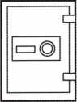

.5

PV-2015

PV-1713 PV-1512



1-800-225-2984

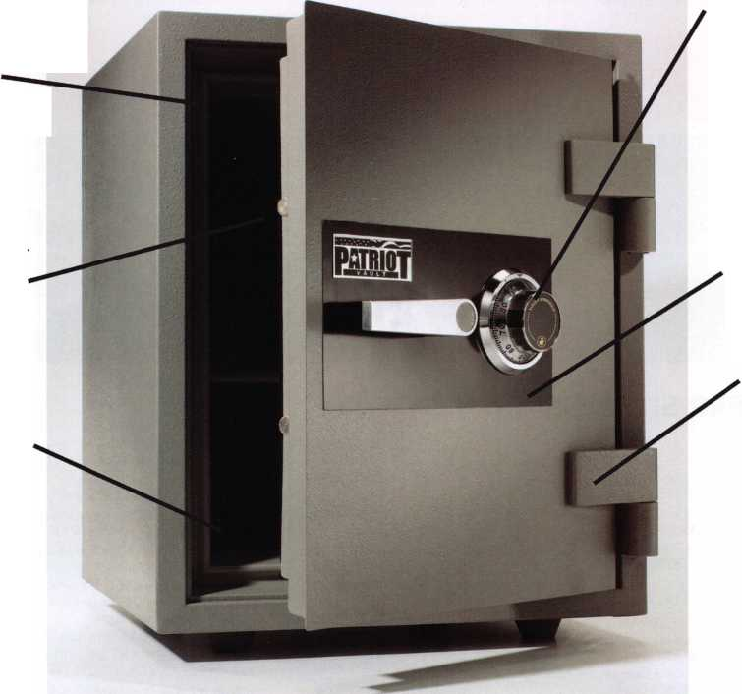

1

upcoming events

Get it Together!

ALOA Convention and Security Expo July 18-25, 2004 • Baltimore, MD

1 Minnesota Chapter of ALOA

29-3 SERLAC 2004  
Orlando, Florida  
Classes & Trade Show

UPCOMING PRP SITTINGS

|  |  |  |  |
| --- | --- | --- | --- |
| 7/8/2004 | 8:30am • Dallas, TX • ALOA  Hope Rodriguez 800-532-2562x30 | 10/9/2004 | 8:00am • Omaha, NE • MINK Convention  Bernard Dobesh 308-381-4440 |
| 7/23/2004 | 6:00pm • Baltimore, MD • ALOA2004 Convention  Hope Rodriguez 800-532-2562x30 | 10/14/2004 | 8:30am • Dallas, TX • ALOA  Hope Rodriguez 800-532-2562x30 |
| 8/12/2004 | 8:30am • Dallas, TX • ALOA  Hope Rodriguez 800-532-2562x30 | 10/15/2004 | 6:00pm • Portland, OR • Pacific Locksmiths Assn  Dan Cunningham, CRL 360-835-7131 |
| 9/9/2004 | 8:30am • Dallas, TX • ALOA  Hope Rodriguez 800-532-2562x30 | 10/23/2004 | 9:00am • Sturbridge, MA • Yankee Security Convention  Jack Hobin 800/209-8266 |
| 9/25/2004 | Saturday Houston, TX Greater Houston Locksmiths Association  Bert Wallace, CML 713-441-4376 | 10/31/2004 | 10:00am • Mt Laurel, NJ • GPLA  Robert J. Schuetrumpf, CRL 856-486-9280 |
| 10/02/2004 | 9:00am • Colorado Springs, CO  Central&Southern CO Locksmith Assn | 11/11/2004 | 8:30am • Dallas, TX • ALOA  Hope Rodriguez 800-532-2562x30 |
|  | Gordon Racine, CML 719-384-4707 | 11/20/2004 | 8:00am • Atlanta, GA • Georgia Chapter of ALOA |
| 10/3/2004 | 8:00am • Anaheim, CA • Clark Security Products |  | Kevin Wilson, CML,CPS 770-279-1161 |
| Joan Emrick 619-718-7308  UPCOMING ACE CLASSES | | 12/9/2004 | 8:30am • Dallas, TX • ALOA  Hope Rodriguez 800-532-2562x30 |
| 7/18-25/2004 | Baltimore, MD • ALOA 2004 Annual Convention  DAVID LOWELL, CML, CMST 800-532-2562 XI8 71 | 10/7-8/2004 | Omaha, NE • MINK Convention • Bernard Dobesh 308-381-4440  CPS Prep Class • [www.nebraska-locksmith.com](http://www.nebraska-locksmith.com) |
|  | ALOA ACE CLASSES and Security Expo [education@ALOA.org](mailto:education@ALOA.org) 39 Seminars and Half Day Classes | 10/12- 16/2004 | Portland, OR • Pacific Locksmiths Association  Tom Jones, CRL 503-842-2944 • 17 ACE Classes |
| 8/21 -22/2004 | Syracuse, NY • Central NY Locksmiths Association |  | <http://www.pla-pro.org/plc/index.htm> |
|  | Ron Smith, CRL, CPS • 315-782-0912  Basic Electricity, Access Control | 10/20-24/2004 | Sturbridge, MA • Yankee Security Convention  Jack Hobin 800-209-8266 • 9 ACE Classes • [www.yankeesecurity.org](http://www.yankeesecurity.org) |
| 8/22 - 28/2004 | Dallas, Texas • ALOA Continuing Education  8- Day Basic Locksmithing Course • David Lowell, CML, CMST 800-532-2562 xl8 • [education@aloa.org](mailto:education@aloa.org) | 10/25-30/2004 | APPLETON, Wl Fox Valley Technical College  Jerry Antoon P-920/735-2406 • 6 Day Basic Locksmithing Course  Fox Valley Technical College F-920/735-2414 |
| 9/11/2004 | Gulfshores, AL • Alabama Locksmiths Association  DLee Schofield • 334-832-4920 • Life Safety Codes w/L-07 PRP | 11/13/2004 | Atlanta, GA • Georgia Chapter of ALOA  Kevin Wilson, CML,CPS • 770-279-1161 • PRP Prep Class |
|  | Complete Door & Door Closers w/L-05 PRP | 11/13/2004 | Detroit, Ml • Locksmith Security Association • Robert Nobel, CPL |
| 9/11/2004 | Detroit, Ml • Locksmith Security Association • Robert Nobel, CPL |  | 810-385-9329 • Combination Lock Servicing w/L-24 PRP |
| 9/18/2004  9/25/2004 | 810-385-9329 • Tubular Key Locks w/L-12 PRP | 12/4/2004 | Birmingham, AL • Alabama Locksmiths Association |
| Atlanta, GA • Georgia Chapter of ALOA  Kevin Wilson, CML, CPS 770-279-1161 • PRP Prep Class  Casper, WY • Wyoming Locksmiths Association  Darin McFarland • 307-587-3035 • Advanced Shop Management |  | DLee Schofield • 334-832-4920 • Simplex Unican Certification |

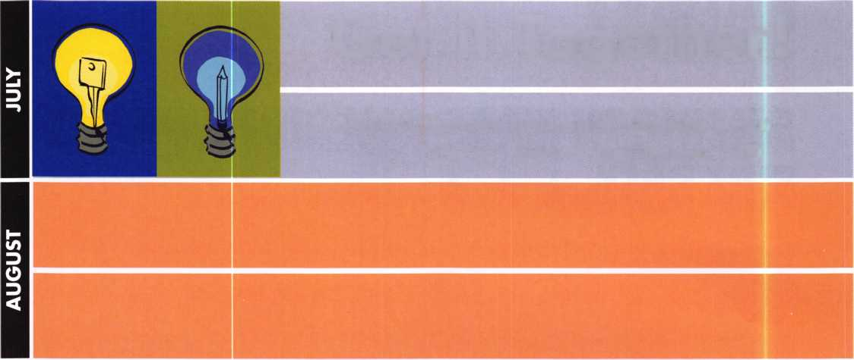

'^M^25+ Function  
Multi-Tool

**^ —** Lifetime Warranty **—**

**FOR** LOCKSMITHS ONLY

* 25 Functions
* Services Schlage, Baldwin,

Corbin/Russwin, Lori,

Adams Rite, Master  
padlocks, Medeco, Arrow,

Jackson crossbars and  
many more!

Call Toll Free... v V

888-634-LOCK

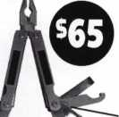

[www.lockmantools.com](http://www.lockmantools.com)

^ MasterCard

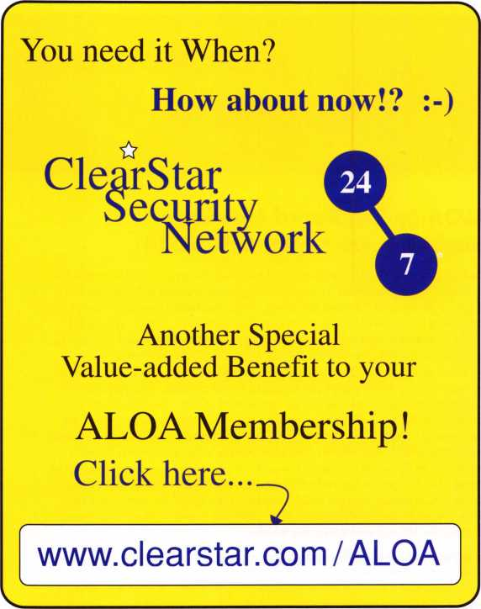

**MBA 9**

**USA., INC.**

TOOLS & TRAINING  
“THE RIGHT COMBINATION”

NOW THE EXCLUSIVE UNITED STATES DISTRIBUTOR OF

IELJUGARD

Also distributing:

**haHeye HI7**

**888-622-5495 • 859-887-0496 • fax 859-887-9491**

**[www.mbausa.com](http://www.mbausa.com)**

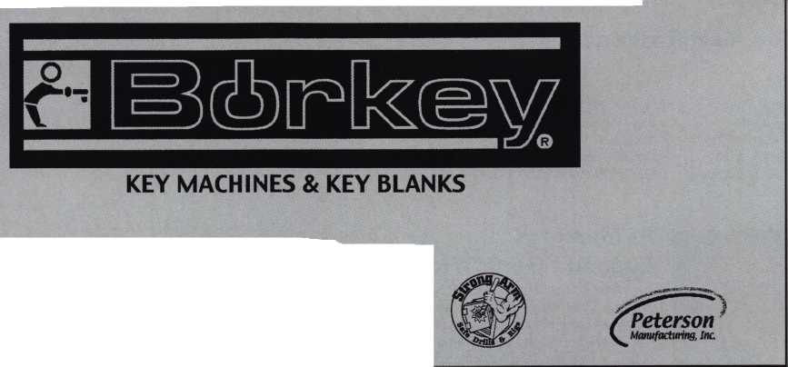

|  |  |  |  |
| --- | --- | --- | --- |
| o  *  EBkr - M9 | c o | I 1 | r e |

ALOA Spring Board Meeting -  
Nashville, TN • May 8-9, 2004

On Friday, May 8, 2004, the Board of Directors of the Associated Locksmiths Of  
America, (ALOA), convened it's regular spring board meeting in Nashville, TN  
under the direction of President Bill Young, CML. All Board members were in  
attendance but one who was excused due to a death in his family. The board  
met for two days before adjourning at 5:30 p.m. on Saturday, May 9. It is to be  
noted that at the direction of President Young, the ALOA Board had received,  
reviewed, and discussed most of it's committee reports by email prior to the meet-  
ing resulting in a much shorter and more productive meeting. This resulted in a  
substantial savings in time and money for the Association. The ALOA board is  
committed to being as efficient as possible in our meetings for the benefit of the  
membership. Reports were given, discussed, and acted on concerning the Audit  
Committee, SAVTA, ILA, NBFAA, Executive Director's Report, Business Owner's  
Group, ALOA Technical Standards Policy, ALOA Certified Security Centers, ALOA  
Model Law changes, ALOA Hall of Fame, 50th Anniversary Celebration, Dress  
Codes at Convention, and the ALOA website. New board members were elect-  
ed for the ALOA Scholarship Foundation. Staff and Board Self-Evaluations were  
done by the ALOA board during this meeting.

As is frequently the case, this ALOA board meeting was scheduled to coincide  
with a local industry event. This particular board meeting was held along with  
joint classes and a meeting of the Tennessee Organization Of Locksmiths (TOOL)  
and the Middle Tennessee Locksmith Association (MTLA), both of which are ALOA  
Affiliate Associations. On Friday night, from 6p till lOp, 2 ALOA board mem-  
bers proctored a PRP exam that was attended by 13 members. On Saturday  
evening, there was a social mixer hosted by ALOA for the class attendees and  
local and state association members. This social event was well attended by the  
ALOA board and many of the local TOOL and MTLA members.

Guests attending the meeting were Ron Snively, President of SAVTA, Ron Jewell,  
Vice-President of SAVTA, Tom Negron, President of the Institutional Locksmith  
Association, (ILA), Cecil Hogan, President of the National Burglar and Fire Alarm  
Association (NBFAA), and Eric Roberts, President of the Tennessee Organization  
Of Locksmiths (TOOL) Each of these guests gave an interesting and important  
report or address to the ALOA Board. From this meeting of Association leaders,  
comes the promise of renewed and additional interaction and cooperation  
between the various associations. All attending indicated that this was a success-  
ful meeting.

New Certifications

CRL

Leslie K. Herndon  
Earl Munch  
Michael R. Knight  
Daniel C. Rosko  
Ronald Niccum, Sr.

In Memory:

Eugene "Gene" Haywood

Long-time ALOA member, Gene Haywood passed on  
June 12, 2004. Gene resided in West Seneca, NY  
and was known to some locksmiths as an "icon".

The beloved of Norma J. (nee Adams); dearest  
Father of Paul and David (Sharlane); grandfather of  
4, brother of Robert Haywood and Mildred Thomas,  
and friend to many; Gene will be missed.

Peter L. Deutsch Paul Bentley Steve L. Berkey Jacob A. Carey Robert L. Commons

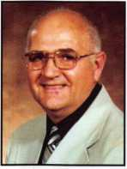

ELECTION RESULTS

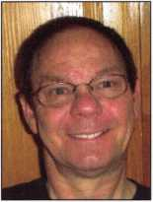

John Soderland, CML, CMST, was elected to the office of Secretary.

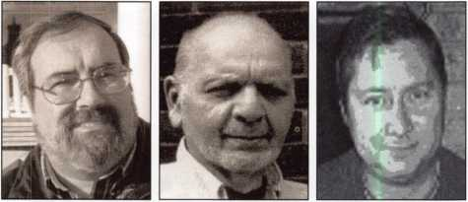

Robert Mock, Peter Sarailian, CRL, and Vernon Kelley, CPL, were elected  
to the office of Northeast Director.

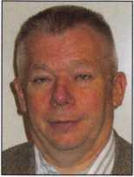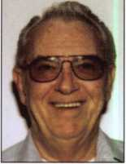

Hans Mejlshede, CML, Jim Jeffries, CPS, was was elected to the elected to the office of office of European Northwest Director.

Director.

Bylaws change #1 was PASSED.

Bylaws change #2 was PASSED.

Bylaws change #3 was PASSED.

C.D. Lipscomb, CML, CPS, will continue to serve in the office of Southcentral Director until a successor is duly elected and qualified. Joe J. Lee, CRL, will continue to serve in the office of Asian Director until a successor is duly elected and qualified. Paul Justen will continue to serve in the office of Associate Director until a successor is duly elected and qualified.

Since 1955, Lockmasters has been providing the locksmith industry  
with the highest quality and most innovative tools & training that the  
technician could ever need. Add to that our extremely  
knowledgable technical support and you have

THE COMPLETE PACKAGE

**AUTOMOTIVE TOOLS a TRAINING**

**GENERAL LOCKSMITHING TOOLS**

**GOVERNMENT PRODUCTS**

**LOCKS a PARTS**

**SAFE EQUIPMENT**

**SAFE DEPOSIT TOOLS**

**TRAINING MATERIAL**

5085 Danville Road Nicholasville, Kentucky 40356  
800.654.0637 Tel 859.885.6041 Fax 859.885.7093  
lockmasters.com lsi-lockmasters.com pureauto.com techtrainproductions.com

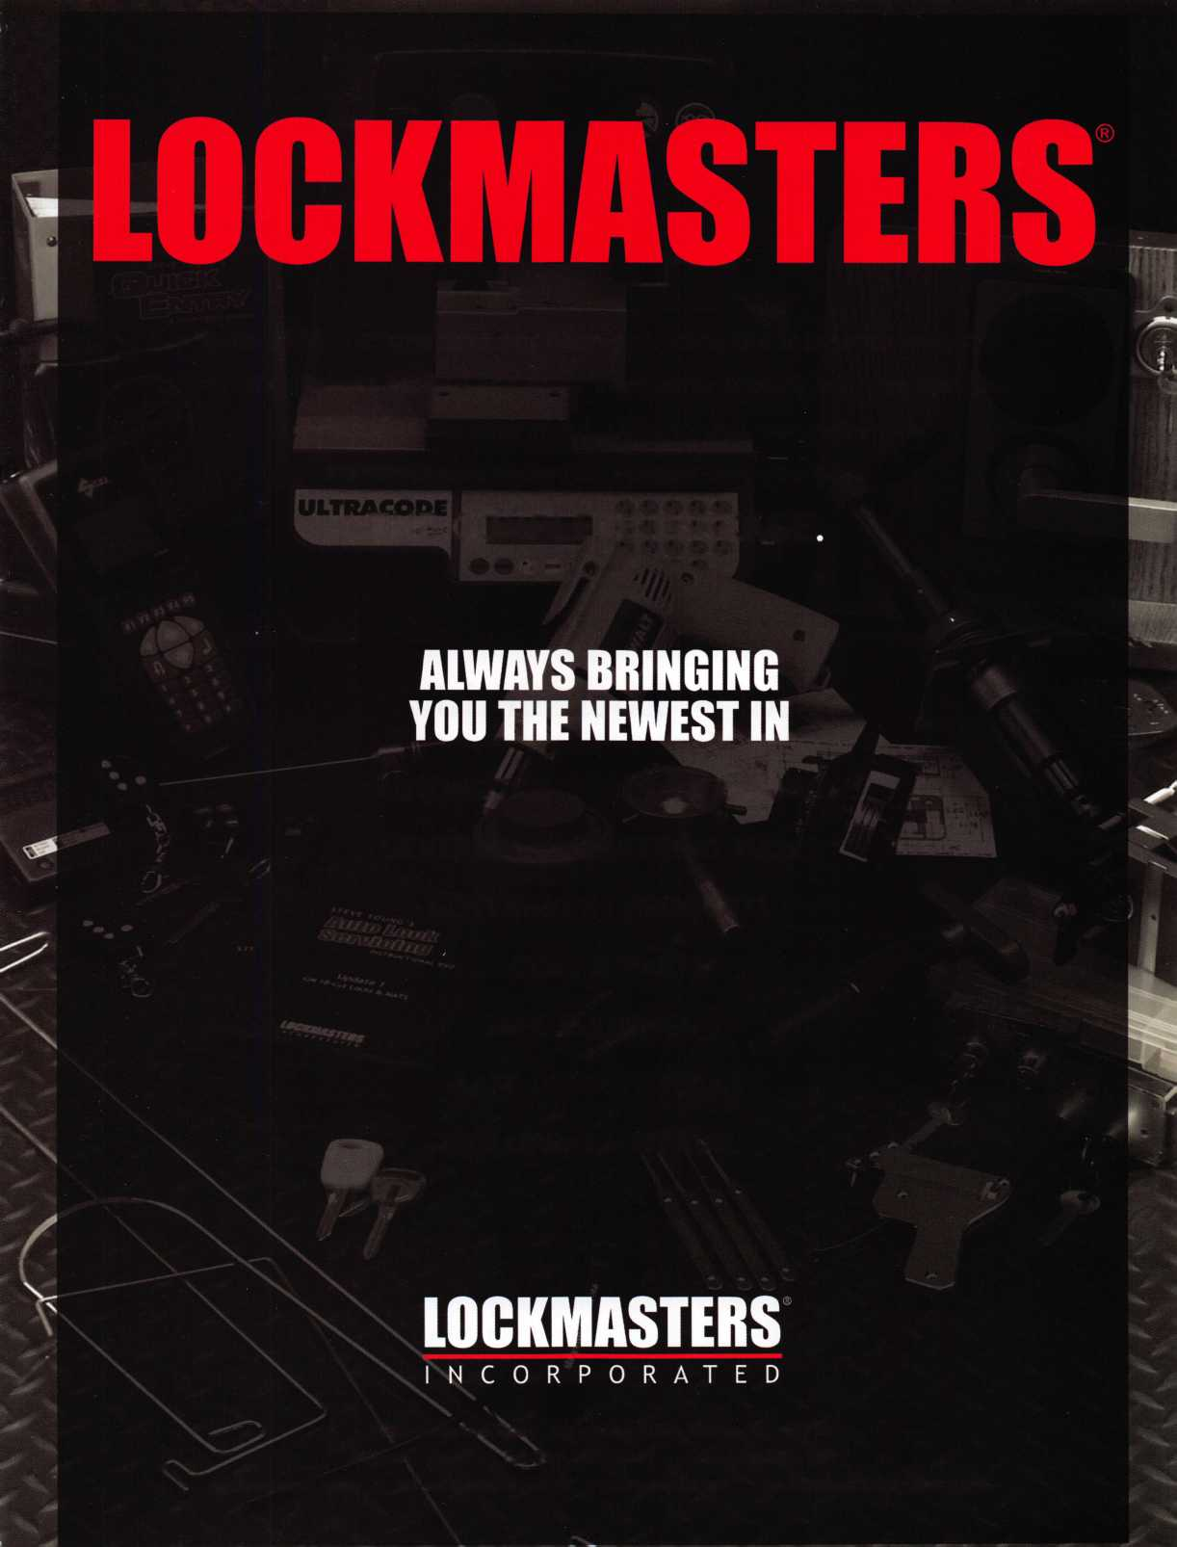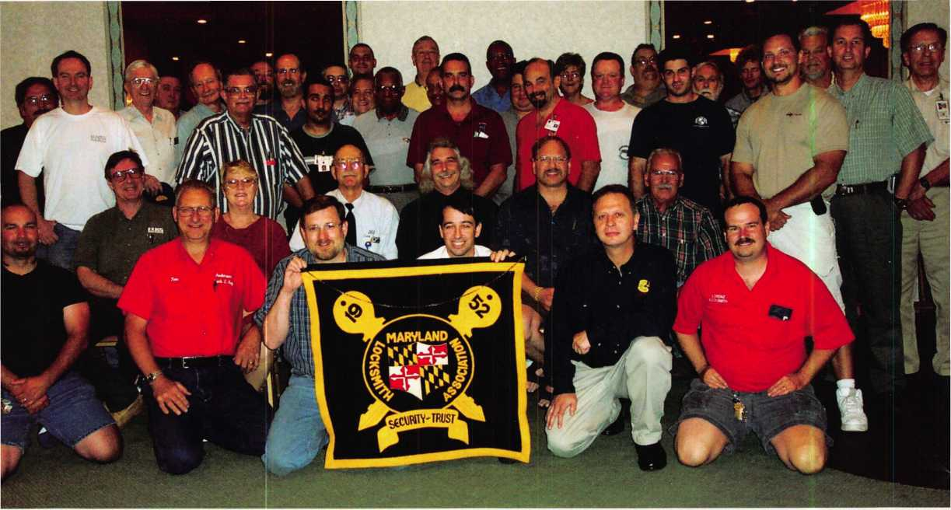

The Many Faces of Locksmithing in Maryland

By Claire Cohen, CML

Variety captures the essence of Maryland’s geography econo­my and distinct communities. Over 5 million people live and work on almost 10,000 square miles of land in Maryland. From mountain terrain to sandy beaches, Maryland is home to private industry, educational institutions, commercial facilities, Federal Government installations, military bases and much more.

Diversity also guides the many locksmith faces in Maryland. Both male and female locksmiths run the gamut of working in large, full-service shops employing many security profes­sionals and performing a variety of services, to part-time sole proprietorship operations specializing in particular niches. Despite this diversity, Maryland locksmiths share the belief that there is a bright and long-term future for those who are willing to further educate themselves and adapt in their ever- changing and evolving industry

Let’s take a look at some of the faces of locksmiths in Maryland, and see what they believe the future will bring.

“Even if we hit the lottery I will still be doing this!”

Bob DeWeese, CML, has spent almost a quarter of a century in locksmithing. Hired “off the street” by a small four person locksmith company, he spent the first week learning and observing in the shop. The following week, two days were spent with the company’s best outside service technician. What a surprise when he walked in the door one morning (after his 7-day indoctrination) to be met by his boss with a stack of service call tickets and the keys to a company service van. His boss said, “Here’s your key. There’s your truck. If you have questions, call the number on the side of the truck.” His career in locksmithing was underway!

Bob has been extremely active in the Maryland Locksmith Association (MLA), serving four terms as president. He has also served as vice president, secretary, newsletter editor, and chairman of numerous committees. Recognizing the value of continuing education, Bob is a member of SAVTA, NSO

2

Keynotes • July/August 2004

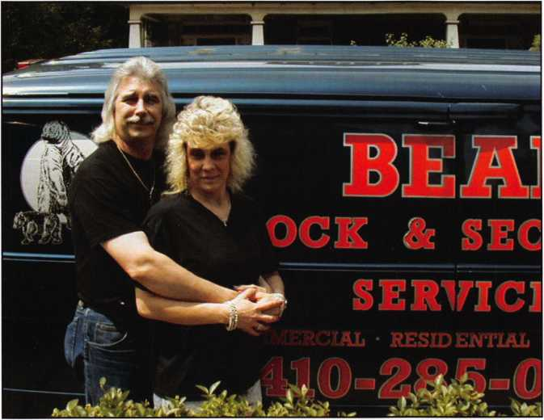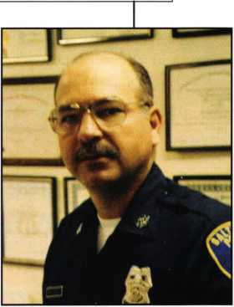

(National Safeman’s Organization) and Clearstar Security Network.

Today, Lenny is a “Locksmith  
Coordinator” at Johns Hopkins University  
in downtown Baltimore. Thousands of

“Electronics and biometrics will replace traditional locking devices”

For the past 15 years, he and his wife, Theresa, have owned and operated Bear Lock & Security Service, Inc, providing “professional” locksmithing services to Baltimore City and the Southeast Baltimore Co., MD area. Bob is a strictly mobile locksmith; Theresa handles the phones, and adminis­trative functions, while Bob handles most of the service calls. Theresa goes along on access control and bigger keying jobs. The business services both residential and commercial customers and they also handle automobile and safe work.

“We’re not the cheapest shop in town,” he said. ‘And not the most expensive. But we must be doing something right, because we’ve been in business 15 years and hope to contin­ue to be for many years. Even if we hit the lottery, I’d still

Leonard (Lenny)  
Podgorski, CFL, has been  
working with locks “on  
and off” since he started  
opening padlocks in high  
school. He is a 25-year  
veteran of the Baltimore  
City Police Department,  
where he was called upon  
to open cars. Lenny is

currently

Vice

President of The International Association  
of Investigative Locksmiths (IAIL), and is  
proud of his CFL (Certified Forensic  
Locksmith) certification. “I pursued a  
locksmithing career,” he explained,  
“because I wanted to!” Upon retirement  
from the Baltimore Police force in 1994,  
Lenny found a home as an institutional  
locksmith at Catonsville Community  
College, just a short distance from  
Baltimore, where he continued to further  
his locksmithing knowledge through addi-  
tional classes and “trial and error.”

be doing this; I don’t think I’ll ever retire. It is said that a man is truly blessed if he can make a decent living doing something he loves to do, and I am truly blessed!”

people working and attending classes at Johns Hopkins University’s Baltimore campus keep this institutional lock­smith challenged to keep up with existing demands. Lenny has seen a great deal of change in his locksmithing career. “The field has shifted from mechanical hardware to much more electronics. A greater amount of time is spent on access control systems, electronics and security-related computer applications.”

Keynotes • July/August 2004

What does this professional see as the future of locksmithing in Maryland, and how does this fit into his future? He hopes to influence the future security of his growing university by recommending even more electronic security devices. He pre­dicts biometrics will continue to enter his world where pass­words, PINs and keys no longer rule. He feels that biometrics offer secure and convenient physical access to buildings and rooms, and will continue replacing keys, codes and old card systems. Although Lenny does plan to retire from his full­time job, he sees himself as a mentor for locksmiths entering the field.

“Legislatively, locksmiths will eventually be categorized with the alarm industry”

Just a short distance from our nation’s capitol, Washington,

D. C., Jim Mullins, CPL, is president of Sure-Fit Security in Silver Spring, MD. His company is a full-service operation, specializing in commercial and residential work. Jim has come a long way from his early beginnings as a trainee in the trade. He feels fortunate that he began in a “busy shop” that had a good customer base and could service a wide variety of hard­ware. On-the-job training and numerous classes offered by local associations, ALOA and hardware manufacturers helped round out his learning experience.

Recognizing the value of industry affiliations, Jim is a mem­ber of ALOA, the Maryland Locksmith Association, Locksmith Association of Washington, D. C., and Door Hardware Institute (DHI).

When asked about his job, Jim has a short, sweet answer.

As the owner of a small business, the answer is more com­plex. As with most small business owners, there are many hats to wear. Fortunately, he has two equal partners — Phil Thom and Steve Roth — two guys who are “the best thing that could have happened to me and this business.” Even as an employee, the question has always been, “What’s best for the company?” Whatever you can do (ethically) to make the company more money is the job. The more money the com­pany makes, the more everyone should make. With his many hats, Jim said, “I can honestly say that since day one as a trainee, I have never been bored!”

Jim and his organization have been so busy, that it is some­times difficult to think about the future. “Lately, I have felt that I can’t see the forest for the trees, so seeing the future is tricky.” He believes that he and his company will see more electronic locking devices commercially and sees growth in Grade i locks and key control residentially. The most trou­bling aspect of the future is recruitment of qualified appli­cants and drawing young people to our profession.

|  |  |  |
| --- | --- | --- |
|  |  | % |
|  |  |  |
| t . | pgr , k |  |
|  |  |
|  | i* *** 9 |  |
|  | Mt M | II. J s** |
|  | , * 18m |  |

With two great partners, Steve Roth and Phil Thom, and a solid group of employees, Jim hopes to continue to refine his operation in order to be able to successfully turn it over to the next generation of locksmith/owners.

‘A continual movement to electronics”

If you are want to find a Marylander with a demanding sched­ule, look no further than Bill Fowler, CRL. Bill is a full-time teacher, employed by the Baltimore County Board of Education. In his “spare time,” he devotes his energy to run­ning The William T. Fowler Co., Inc. He started lock- smithing about 35 years ago, “playing with locks and rekeying them for neighbors.”

Networking with other locksmiths has been an important part of Bill’s transition to more sophisticated electronic hard­ware. He is a former officer of The Institutional Locksmith Association (Baltimore Chapter).

Today, he is a master electrician as well as a professional lock­smith. His company services commercial, residential and institutional customers. His work runs from simple key



Keynotes • July/August 2004

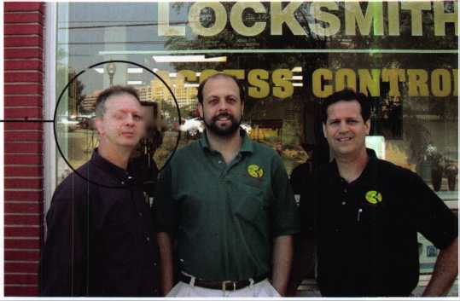

THE

**For Pro**

The Worlds Most A

Pinning Syste

dvanced

ms

**PROVIDING THE SECURITY WORLD WITH QUALITY  
Lock Tumbler Pins, Repinning Kits, Security Tools**

**700 Emmett St., Bristol CT 06010 U.S.A. 1-800-243-8242 FAX 1-860-583-7838  
Website: [www.labpins.com](http://www.labpins.com) E-Mail: [labpins@labpins.com](mailto:labpins@labpins.com)**

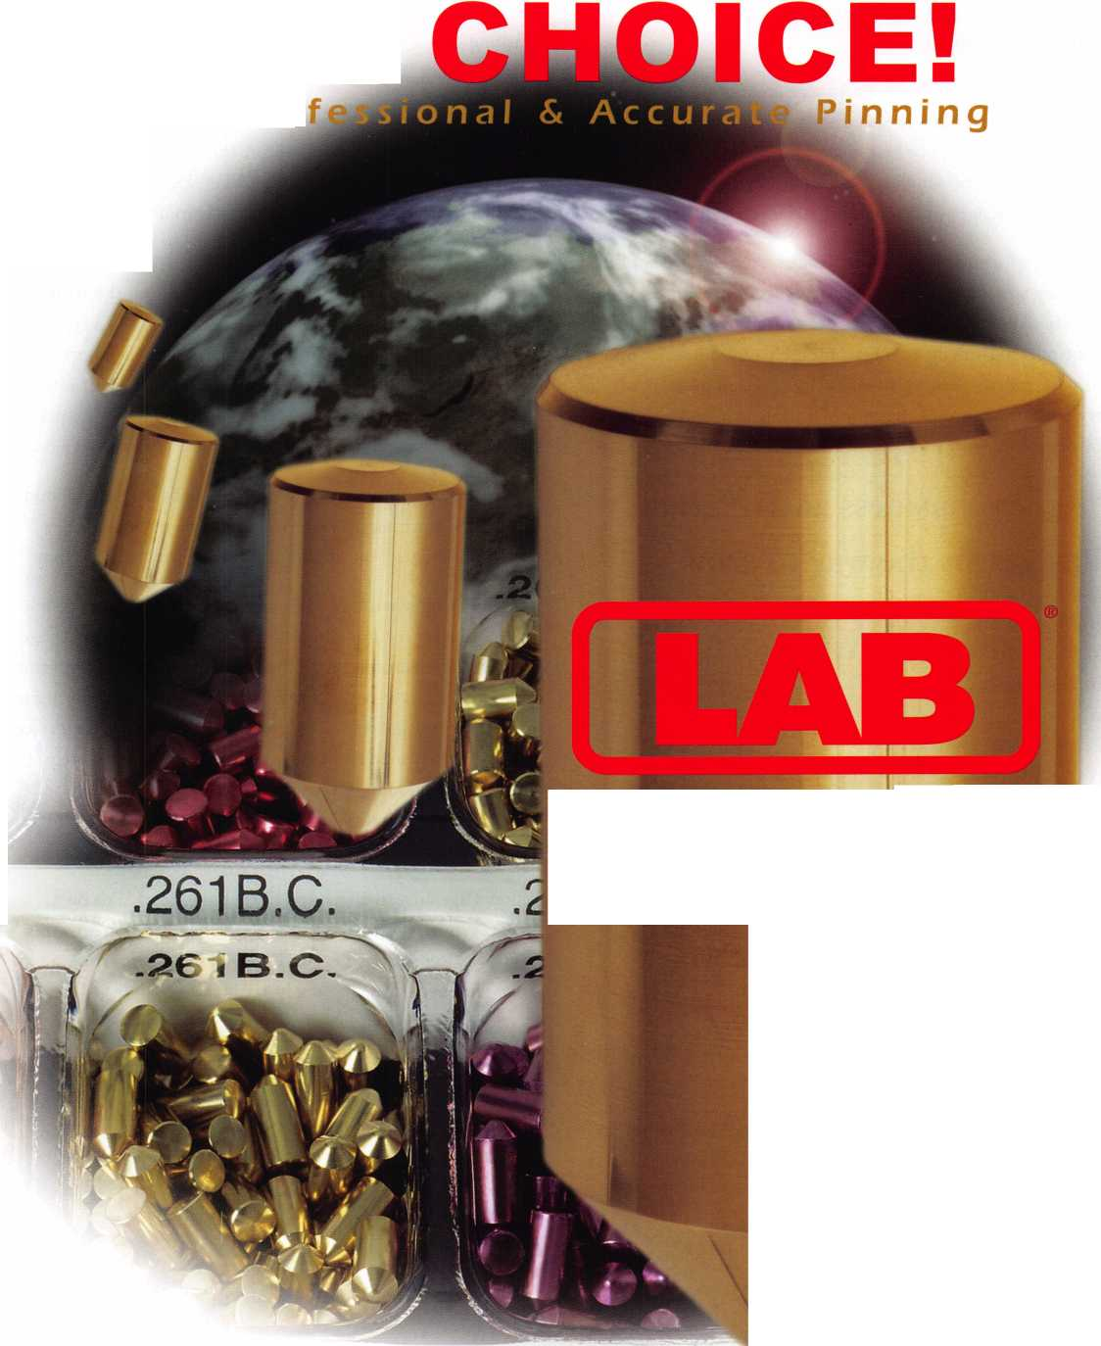

changes of 5-pin and warded locks, to stand-alone systems  
and integrated electronics.

Most of his work is in the Baltimore area; however, he does  
service areas on Maryland’s eastern shore. He is presented  
with different types of lock situations near the Atlantic  
Ocean, where the sand and salt water environment offer  
unique challenges to mechanical and electronic hardware.

As both a “security consultant” and master electrician, Bill’s  
primary area of expertise and interest is electronic locks, in a  
variety of applications. Bill sees the future of the industry as a  
continual movement to electronics. He envisions an opportu-  
nity for future work in Maryland as a consultant to the indus-  
try with primary emphasis in the installation and operation  
of electronic hardware.

“Repeat business and referral  
business is the way to grow”

Introduced to  
locksmithing  
by his brother  
who took a  
Foley Belsaw  
course,

Richard  
(Rick)

Thornley has  
come a long  
way in the  
past 26 years.

With one  
small toolbox,

working out of the back of a Chevy Vega, he began his lock-  
smithing career making keys for cars and installing deadbolts.

Today, Rick is president of Liberty Lock & Security, Inc. in  
suburban Rockville, MD. His full-service locksmith company

specializes in commercial work. Only a few minutes from Washington, D. C., Liberty does a great deal of government work, running the gamut from routine lock work, safe work and access control.

Rick has been a member of ALOA for the past 11 years, and is also a member of SAVTA and NFPA. He feels that mem­berships in professional organizations help him keep up-to- date with industry trends.

With 17 employees and eight service vehicles on the road, Rick’s work includes “a little bit of everything.” In a typical day, he performs field surveys for larger-scale jobs, meets with existing and potential customers and is quick to greet old and new customers in his shop. Of course, there are always per­sonnel and business matters that take up a part of every day.

Rick misses the “hands-on” road work. “That’s the best job in the world. People are happy to see you when you get there. They thank you, and pay you when you are done. Everyone is happy”

Remembering when he could run his business with two shoe- boxes of paper records, Liberty is now a heavily computerized company. Locksmith-related programs are utilized for master key systems, key codes and more. Business inventory systems insure that routine items sold in their store or used in service calls are replenished daily. Customer service is completely automated, including service call tickets and customer account information. With many service vans, fleet mainte­nance is also fully computerized.

Yellow Page advertising, once all that was needed to be in business in Maryland, is not the way Rick wants to grow his business. “Repeat business and referral business is the way to grow. We have cut back on advertising.”

“I’ve been fortunate enough to surround myself with great people. Our outstanding staff allows our company to be what it is today. Without their support, I couldn’t have done this. I am lucky to be surrounded by the best—and with our team at Liberty, I certainly am!”

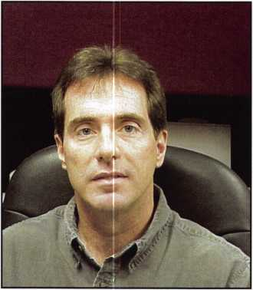

6

Keynotes • July/August 2004



ttHQOOOS

Are your doors

**SAGGING? DRAGGING?  
RUBBING?**

The Hinge Doctor will adjust them in seconds! No other tools needed.

"I used mine twice in the last week. It really impressed my  
customers that a "little girl" like myself could repair a big olfsteel door by myself! I never let them see my secret weapon,

I let them assume that I had to take the door down and do all  
sorts of work to it!" -- Melanie Long, Lock Stock & Barrel

Over 10,000

Satisfied  
Customers

**HA1 For  
Standard**

**Commercial**

**4-1/2" x 4-1/2”**

**Butt Hinges**

**HA3**

**For Ball-  
Bearing**

**Larger**

**Commercial Hinges**

**HA4**

**For Prison**

US Patent **& Institutional**

#6450003 **Hinges & Standard**

**Spring Hinges**

**HA2** model

v fits most residential  
hinges. Fully adjustable.

800-9*4-5397

[www.hingedoctor.com](http://www.hingedoctor.com)

by GKL Products

(a division of Gold Key & Lock Co. LLC)

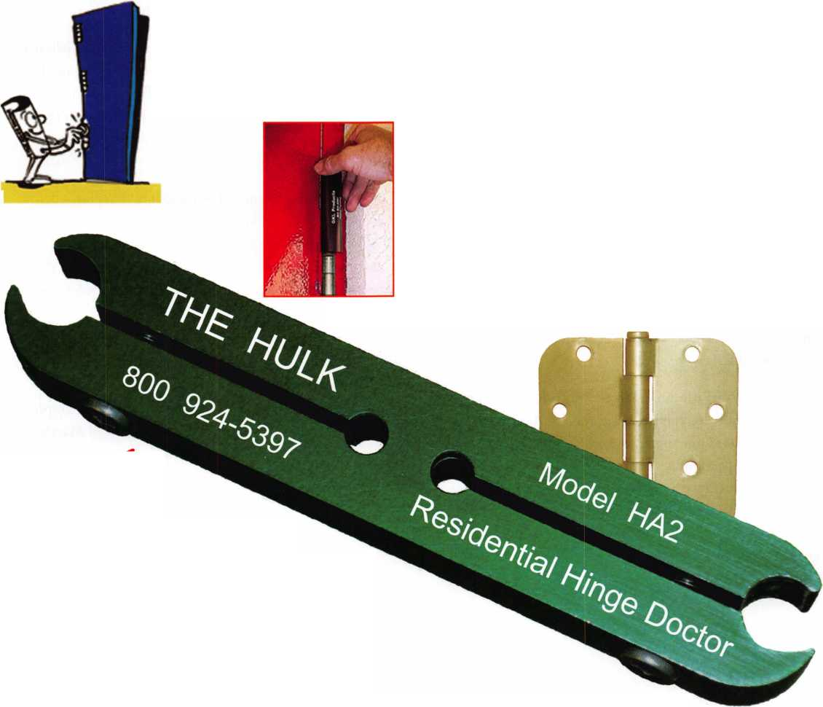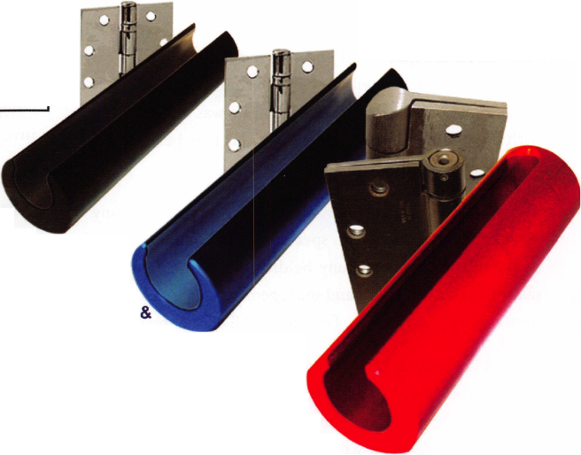

“A commitment to quality work and controlled growth”

An opportunity to take an early retirement enabled Lance Edwards to realize his dream. While working for the Washington Post, he completed a home study locksmithing course. For the next io years, he moonlighted as a part-time locksmith. Lance felt that when he retired, locksmithing might keep him busy both as his hobby and as his small busi­ness. He joined the Maryland Locksmith Association and signed up for virtually every course that was offered. “My skills and enthusiasm skyrocketed when I joined ALOA!” he said. “I learned quite a bit and realized that having my own locksmith business would one day become a reality.” That day came sooner than he expected, when he was able to retire with pay and benefits to “jump-start” his new business, Lance’s Locksmith Company

Today, Lance’s dream is a reality. His full-service company services Central Maryland, specializing in commercial work. As president of his company, he divides his time between sales, field service work and management. He loves impres- sioning. “That’s pure fun. For me, it’s all about the challenge.”

Lance’s Locksmith Company has developed a reputation for solving problems with custom solutions, and he enjoys the challenge offered by difficult jobs. “Our company is quite good at creating an answer—a security product—where there is a need for custom fabrication, welding, etc. I take pride in solving difficult security needs and enjoy the surprised look on the customers’ face when we achieve what they feared was impossible.”

Lance sees a bright future in access control and a mixture of mechanical and electronic locking systems. Legislative issues are, and will continue to be, extremely important and “will have great impact on our future.” He feels that Maryland locksmiths must take an interest in the legislative process and join together to have one voice. He is thankful, that as the legislative issues have became more complex, ALOA has given Maryland locksmiths support.

Current MLA president, Dave Fullarton, CPL, CPS, offers his perspective on the future of locksmithing in Maryland.

He believes that locksmithing is changing. To adapt to the changes and increased costs of operating, he sees more spe­cialization in specific areas of the trade. As a case in point: automotive work. The days of generating keys for a car with only a file and a pair of vise grips are gone. High security keys and transponders to today’s vehicles require a substantial investment for today’s locksmith to continue to offer these services. To justify and cover the thousands of dollars that must be invested, many locksmiths will specialize in automo­tive work only, rather than spreading themselves too thin and failing to cover their investment. He feels that the same is true for commercial hardware installation. ‘Access control is becoming the norm, rather than an expensive option.” To be competitive in this field, shops must take a considerable investment in re-tooling, product, training and licensing.

Dave believes that the impact and necessity of specialization is particularly true of the small, one-man shops. Limited man­power resources will necessitate a focus on a specific area of the industry Larger operations will still be diverse in the serv­ices and products that they offer; however, they will employ specialists in several fields.

“The trade is still strong and healthy. It is changing - or adapting — to the market forces surrounding it. While elimi­nating certain services may be difficult for many, the efficien­cy and professionalism resulting from specialization will mean increased profits, more thorough product knowledge and bet­ter customer service.”

Author’s Note: A special “thank you” to the professional locksmiths mentioned in this article for their views on future of our industry. The individuals in this article repre­sent only a small percentage of the many faces of Maryland locksmiths, who make our industry what it is today and what it will be tomorrow.

18

Keynotes • July/August 2004

* Can be master-keyed
* Fits metal, wood 6 vinyl gates
* Limited Lifetime Warranty

The Ultimate  
Security Gate Latch

rddonfar

FRONTS

Lokk*Latch'? PRO is the most sophisticated privacy and security

gate latch ever devised, It is the privacy latch that locksmiths

and security businesses have been roving abut!

This quality, patented latch can be operated  
and locked from either side of the gate!

Lakh Lakh PRO is uniquely constructed

to work effectively in hath residential

and commercial gate applications.

The “External Push-Button Access*  
component fits to the outside  
{street side] of the gale post la

provide convenient, keyTodcabJe access.

li uses a standard 6 pm key-in knob style lack cylinder. This cylinder con be keyed alike, moison keyed and master keyed, or can be replaced with a high security cylinder.

The Security Lock with Style

The Forte" Hasplock introduces a new standard in quality commercial and industrial locking security.

Forte Hospbcks (4 models) ore designed for all types of storefronl, door, gate and storage locking, either as add on security for existing locks or os primary locks.

Made from 316 grade stainless steel, the Forte Hosplock is partkdoriy ideal for use in marine or other corrosion prone environments.

Forte Hosplock is highly resistant to hacksawing, levering and oxyacetyleae cutting.

Imim m:%m$ usi§

fcittafrtify' m

m ikm



dmd **tech nolo pies**

Safety, Privacy 8 Security

DAD kchidogie (liSAI Inc., 7731 VMwid Orin. isirtncvi Bench (A 92MT  
ledt laQDj 7t6-0BS8 «1.231 fm: |8UD| 444-HiW l®al: gflewavSitltciusiicwn WA wwujibcliuai.uiai

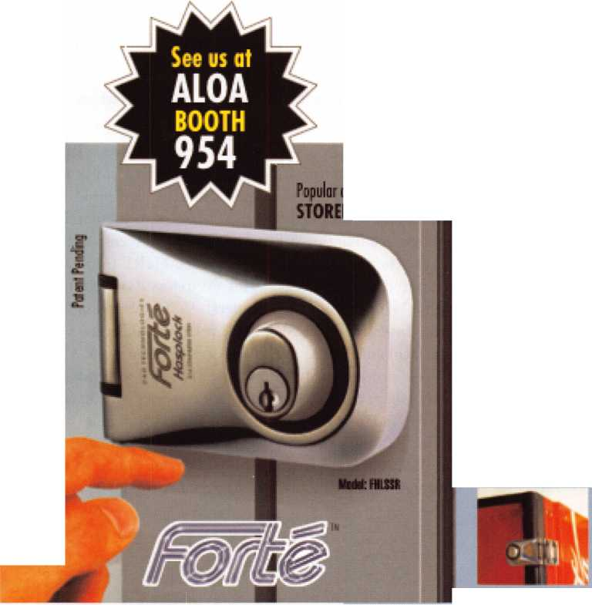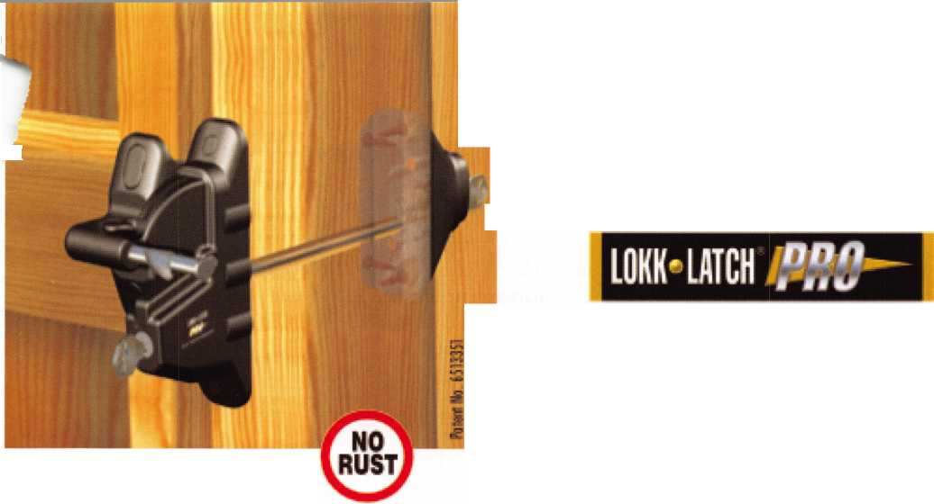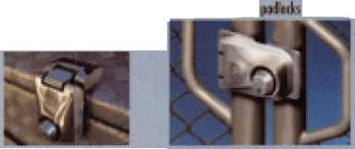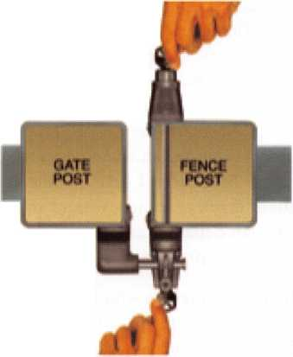

Institutional: Access Control Goes Wireless!

By Bill Neff, CML

If you were to ask a security director who purchased an access control system in their organization what the most expensive segment of the system was, most would respond that the labor was the highest line item in the overall bill. I am here to inform you of some good news: a solution called Wyreless Access, which is a product line manufacturered by a company out of Saint Charles, IL, named Recognition Source. Fred Conforti, who is currently the president of Recognition Source, is one of the pioneers of wireless products in this industry, a process that began when he started another company called First Alert. I first became aware of this company about three years ago, when I received information from an e-mail broadcast about announcing their wire­less access products.

If you ask any one who knows me, or has walked the trade expos with me, when it comes to new technology,

I am a kid in a candy store. So upon receiving the e- mail, I immediately called the company and ordered a WRI (Wireless Reader Interface), which comes in a plastic composite box that allows you to interface a Wiegand reader to any hardwire access control system without having to run the reader wire. The beauty of the WRI is that it comes in a weather-resistant enclo­sure that can operate from -35 to 66 degrees Celsius, eliminating the need to add heaters or cooling fans.

This is ideal for gate operators without incurring expen­sive trenching. The WRI can also be used in elevators, which can also be a big savings by eliminating the need for travel cables. The manufacturer is also conservative it its range; they say the WRI works up to 1000 feet, (Illustration 1) but in reality, if you have a clear open line of site, I have worked it at 2000 feet. WRI has provisions to for two readers and two dry contact relays, which can control two different output devices.

The WRI is one part of the wireless system; the other part you need is the PIM (Panel Interface Module). The PIM does just that: It interfaces with the access control panel.

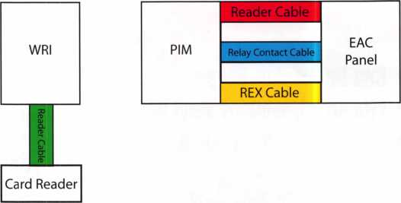

Illustration #1

Wireless Reader Interface Maximum Range 1000 Feet

In the Wyreless Access products, there is always a PIM in a 2-door, 4-door or a 16-door model. The PIM is a transceiver that takes the signal from the electronic access control panel and sends it wireless to the wireless input device like the WRI. The Wyreless Access also makes other wireless products like the MIRL (Modular Integrated Reader Lock), WET (Wireless Exit Trim), WPR (Wireless Portable Readers), WISI (Wireless Strike Interface), WUSI (Wireless Universal Strike Interface) and WCM (Wireless Contact Monitor). All of these products work at a range of 1000 feet from the PIM, except for the MIRL, which operates on batter­ies. The range of the signal of the PIM works in a radius that gives you 360 degree coverage. By placing the PIM in a strategic location you can optimize your coverage without incurring additional costs of PIMs.

2

3HM Keynotes • July/August 2004

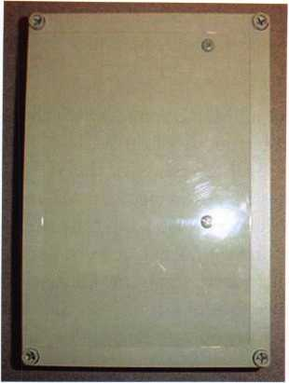

PIM (Panel Interface Module)

Terminal Blocks for controfling two output devices

Example of two door PIM notice the empty space on the right by adding  
another board it then becomes a four door PIM.

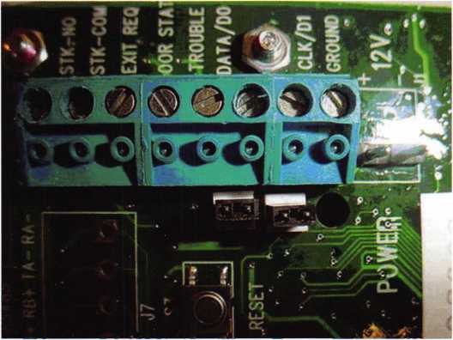

Terminal strip on PIM for controlling  
one output device.

Another product that is going strong is the MIRL, which stands for Modular Integrated Reader Lock. This battery-operated cylindrical or mortise grade one lock operates with a proximity or magnetic reader. This is ideal for college dorms, lease offices, airports, school classrooms, electrical rooms or any door where you need to control who goes where and when. What makes the MIRL better than other battery-operated locks is that it can conserve battery life because the lock has a feature in which the circuit operates on very low power. The MIRL battery conservation technology acts like a sly cat: It acts like it is asleep until an action occurs (such as the presentation of a card), then momentarily wakes up and polls the PIM for information, or when the PIM sends a signal to the MIRL. The mode to set the MIRL to talk to the PIM is called a “heartbeat.” This means you can set the lock to talk every minute, or every hour. The heartbeat can be set in one minute increments from one to 60 minutes. By having this functionality, you now can see how battery consumption is reserved. Another point is the MIRL uses either the standard HID or Indala Proximity Cards, which is great, because that is what is used in most EAC systems



SAFE CORPORATION

Viking Stainless

Fire & Burglary Protection  
State of the Art Composite Fill

Strong • Functional • Attractive



Available in 10 sizes  
to Fit Every Need

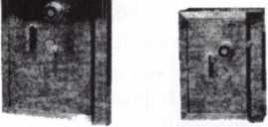

See us at [www.a-bsafecorp.com](http://www.a-bsafecorp.com)

1*-*800*-*253-1267

Fax 856-863-1208

CALL FOR YOUR CATALOG TODAY

Keynotes • July/August 2004

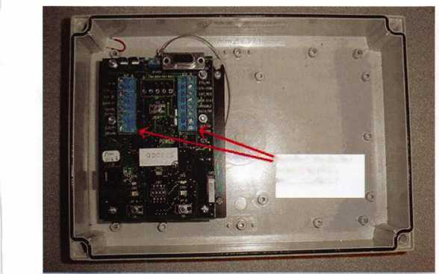

today. Another feature is the reader on the lock has an infrared eye that is looking for a change. When a card is presented, the power of the RF (reader field) is turned on to read a possible card. By using this technology, it conserves energy because the RF field of the reader does not always have to be active. Also in the MIRL, it has a door sensing contact and when you depress the inside handle, it reports an REX (Request to Exit) if wired to EAC panel.

You might ask about the security of the wireless trans­mission? Well they thought about that. The signal has a 128-bit encryption, and the signal is broadcast at ran­dom frequencies at a few milliseconds. In the simple form, it would take a multiple lifetime (or life forms) to be able to crack the signal. When I teach the EAC classes, I’m always asked how many users or how many audit trails does the MIRL have? The lock is nothing but a wireless reader with a lock attached, and the limi­tations of the Card Holder and Audit Trail capacity depends on the EAC system you are using. For example, the RS2 Technologies have a product in which you can get over 256,000 card holders with 25,000 events recording in a FIFO format at one door. Since 9/11, many companies are seeking out Physical Security Professional for solutions in controlling access in a timely cost effective manner. With many EAC systems today having Ethernet ports built right onto the panels, and with today’s wireless capabilities, a door can easily have EAC applied in about an hour. That’s a real enhancement for a security professional who needs to secure a door quickly, or to do to a security breach.

For the locksmith, the MIRL installs just like any other lock, except you need to do a few more preps for the reader and the wire leading to the lock chassis. Linking the MIRL to communicate to the PIM is very simple. On the PIM, there are two link buttons on a circuit board: one for door ‘A” and one for door “B.” Just press the “desire door link” button; in a few seconds, the LED close proximity to the button will start flashing red - green, which indicates that the PIM wants to mate with a MIRL. Now you go to the MIRL lock that you want to link and push down on the inside lever, keeping it held down while presenting a card the reader. Keep the inside lever down until you see a few LED flashes on the reader. When this occurs, you can let up on the inside lever and the LED reader will go into a steady fast flash for a few seconds. What this is doing is linking to the PIM. After the flashing LED stops and if

the proximity card is valid for that time, the lock will open. As my good friend from Labor Saving Device would say, “It’s as easy as that!”

They also offer an MIRL tester, which allows you to test the signal before you install the MIRL. The MIRL tester works at half the power of the MIRL lock, which insures a good wireless connectivity. All in all, this prod­uct line is, at the very least, a big time labor saver. If you want more information you can go to Recognition Source web site at <http://www.recognition-source.com> There they have tons of pdf files on the various products that they sell, plus you can download a demo software, which works real well with the demo kit. If you are interested in doing 16 doors on one PIM contact RS2 Technologies at this website at <http://www.rs2tech.c0m>.

If you want to see this product in action and get some hands-on experience, come take the Comprehensive Access Control Class this year at ALOA. Sign up early because every year it is a sell out, and be on time, because I do not allow any late comers do to the tons of hands-on instruction and complexity of the class.

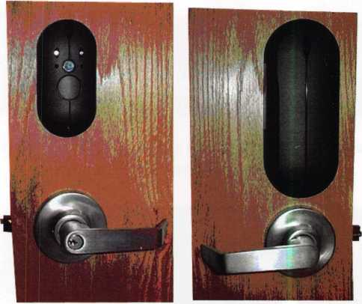

Exterior View Interior View

MIRL (Modular Integrated MIRL (Modular Integrated Reader Lock) Reader Lock)

22

Keynotes • July/August 2004

*mm*

*Now mm 26th Year!*

✓ ***13 Training Classes***

*Complete Door and Door Closers  
High Security Cylinder Servicing  
Factory Certification -  
Marks i-Que Electronic Access Control*

*Lockmasters Pure Auto Class -*

*Domestic Auto Lock Update/Vehicle Entry Fundamentals of Locksmithing Exit Devices and Exit Alarms Basic Electricity and Electronics Interchangeable Cores* - *Small Format Lockmasters Pure Auto Class - Key Generation Tubular Key Lock Servicing Keyless Mechanical Lock Servicing Removable Cores - Large Format Lockmasters Pure Auto Class - High Security Automotive*

m pppips

***Yankee Security Conference anU Trace Show***

***October20-24,2004***

* ***Two-Day Trade Show Event***
* *Over 100 Booths*
* *Many new products and toots*
* *Gift for registering*
* ***Scenic location - bring the family!***

***Sturbridge Host Hotel in Sturbridge, MA***

*The Northeasts Premier Industry Event-Register Now!*

*For additional information and registration, visit us at [www.yankeesecurity.org](http://www.yankeesecurity.org)*

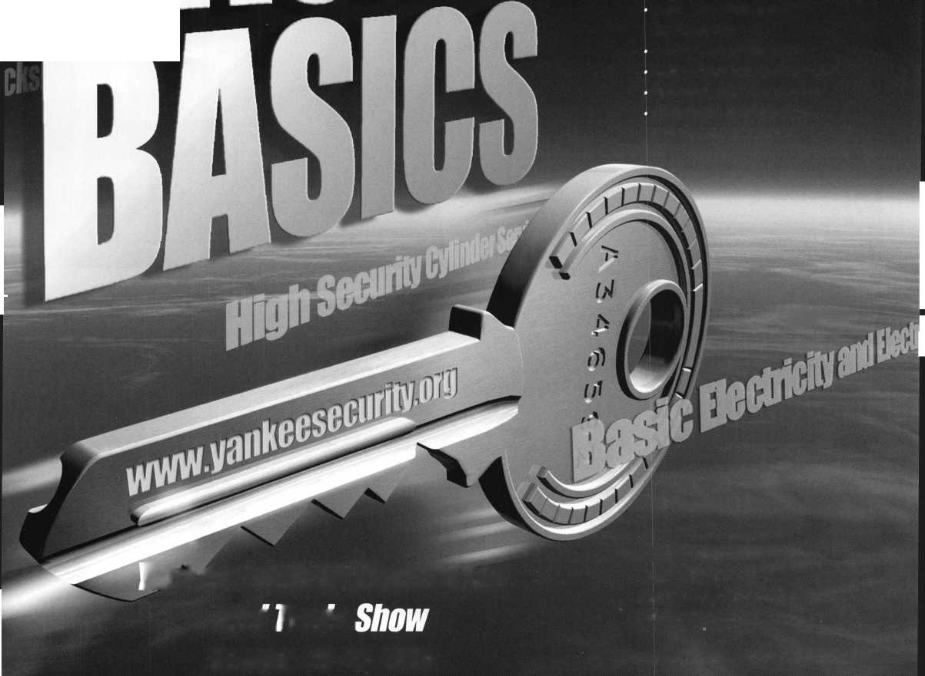

MIRL Signal Tester

PIM (Panel Interface Module) Linking Button & LED Polling Light

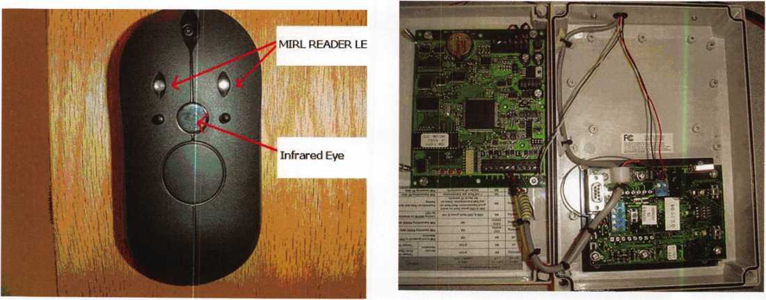

MIRL Close up of Proximity Reader

RS485 Sixteen Door PIM link to RS2 Technologies Mercury Board



Keynotes • July/August 2004

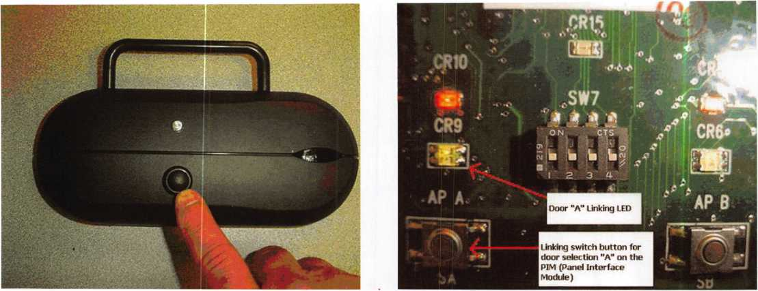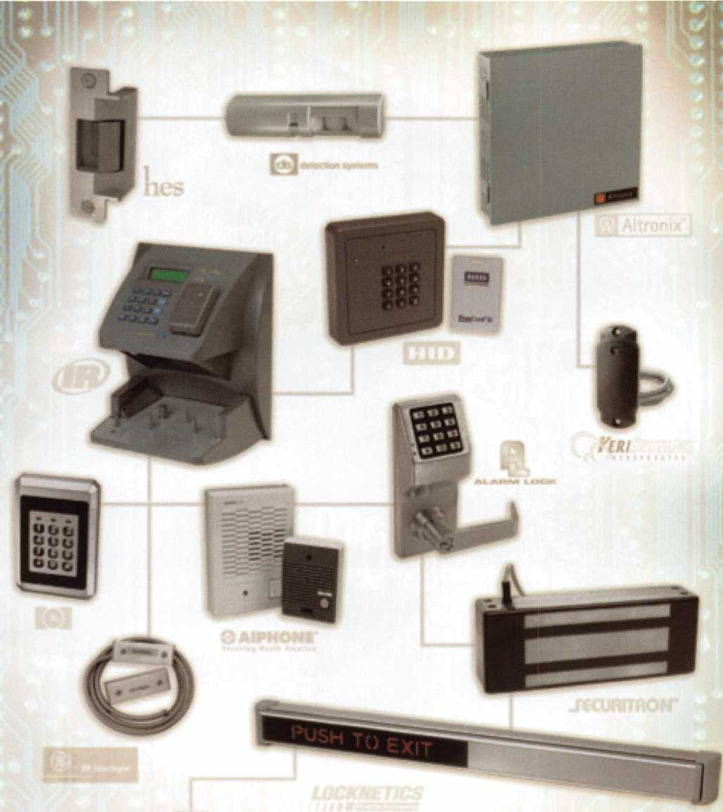

ACCESS ABILITY *Ability to get the best*

Security's Electronic Access Group can provde everything you need to design and integrate the most complex and demanding access control system - the deal components, from every major manufacturer - right down to the wiring. That's sngle-source supply, with technical knowledge and immediate availability and shipping. Rely on Security Lock Distributors and you ve got the ability to do your best.

1-800-847-5625 BS SECURITY'

_ .. . , . . ***MM*** LOCK DISTRIBUTORS

Wi%v**.^ecuri?yiocKdi*sSribulpr^.corTverr^l; ir^^aticiodcCOfin

Beslan, MA - Pompano Beach, PL - Las Vegas, NV Informed. In depth.

Locks vs. Computers -

Computer-Managed (CM) Access Control

By Adam Black, CRL

Keynotes • July/August 2004

Being a bit of a locksmith geezer,

I can remember the days when  
locksmiths laughed at computers.

“They’re a fad.”

“Maybe to play video games.”

“OK, I guess I need one to do  
the books.”

“Wow, 18 code books on one CD!”

“You mean I don’t have to write out  
a four-level master key system?!”

Computers have advanced a lot in  
the last 15 years and we, the old  
crotchety locksmiths, have had a  
hard time catching up.

Fortunately, we are trying and  
because of that, we have enjoyed  
what computers have meant to  
our industry. In electronic access  
control (EAC), it has really  
allowed us to offer a much broad-  
er group of features to our clients.  
When you show customers that  
they can lock and unlock a door  
20 miles away with a click of the  
mouse, they get the chills and we  
get the money! So this month, we  
are going to examine Computer  
Managed (CM) access control in  
two sections: Installation and  
Programming. Fire up the laptops  
and let’s go!

The last time we met in these pages, we put together a stand­alone hardwired system. We

installed a keypad, strike, release button and transformer. Now we will add a few new components and remove a cou­ple of previous ones. When we upgrade or install a system that will be maintained by a PC (personal computer), gen­erally there are three features our customers require. These features are needed for accountability purposes.

1. Timezones: Timezones allow us to regulate access through an opening.
2. Access groups: Access groups allow us to control which areas our employees enter.
3. Audit reports: Audit reports tell us who went where, when they went and for how long. (The “how long” requires extra equipment and programming.)

There are many other features unique to CM access, but these three are generally the most important. To accom­plish these three things, we have to add some extra equip­ment that a stand-alone does not have: a controller, a read­er of some sort and finally, a regulated battery back-up power supply.

Let’s reflect on our previous install. We cut in a strike that stays, mounted a keypad that goes, put in a release button that can stay or go, and finally, a plug-in transformer. See ya big guy! Our keypad was our reader and controller, and now two devices replace it. We will need to mount a controller in a secured area (preferably a telecom room or server room). Hold on folks, what’s a controller? A controller is a PC board that has relays built on it as well as reader inputs and alarm inputs. It will usually have a RAM chip and a proces­sor chip to operate the relays and inputs. This board is usu­ally in a metal box and can be mounted on a wall. So, we find a wall and mount the box and circuit board. We don’t know what to do with it, but it sure looks pretty on the wall. The reader needs to go where the keypad went on the wall by the door being operated. This reader can be a key­pad, a card swipe or bar code, proximity, smart card, Dallas touch key, biometrics, etc. The industry’s most common device is a proximity reader with a 26-Bit Wiegand format.

Now I could tell you what the 26-Bit Wiegand format is, but then I’d have to kill you! No seriously, if you want to know what 26-Bit Wiegand format is you will have to buy my book. (Well, as soon as I write it!) Basically, it’s a num­bering format, 26 in all. They automatically make the card and reader work. Clear as mud. The format is not nearly as important as the fact that it is what is most common.

There are several other bit formats: 32, 37, 39, etc., but these are usually proprietary to a specific system, (i.e. Keri). So after all that, we decide on a 26-Bit Weigand proximity card reader. We mount it on the wall and there you go.

Keynotes • July/August 2004

2

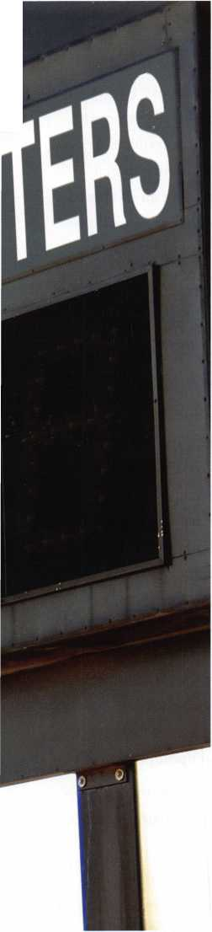

Not quite. There are six wires coming out of the reader and a drain wire to boot. Unfortunately, we need those wires to communicate back to the panel. Two for power, two for communication and two for LEDs and Piezo buzzers. This means we need to run six-conductor shielded wire to the controller, and an 18-2 as well, from our strike. All of the controls from a stand-alone keypad are now back in our new box, so we use our existing wire as a pull and take over the two new cables to the controller box. We would also need to run the wire from the remote release back to the controller. With all of our wire run and connected at the reader and strike...wait, wait! To connect the strike wires remember RED to positive, BLACK to negative and cross the two with a diode, MOV or transorb for surge protection.

(Diodes are polarity sensitive; MOVs and transorbs are not.) For the reader, connect color-for-color and crimp with a connector. Now we need to make terminations in the panel. Most access panels are pretty clear about connections. Read the manuals and make sure the terminal posts are tight. The jumper trick we used last time can be used again from the in-power over to the relay and incoming lock wire. The last three steps are installing a power supply, installing a commu­nication cable to the PC, and grounding the panel. I know what you are thinking, and no, I don’t mean sending the panel to its room! Let’s ground first.

Manufacturers would love for us to run a ground wire to an eight-foot brass stake and drive it into the earth. Yeah, right. Take a ground (usually a single 16 or 18 gauge wire) from the panel to the same ground the phone system uses. Do not hook ground wire to a high voltage ground. After the ground, mount the power supply on the wall next to our panel. Bring a power cable from the low voltage DC out of the supply to the low voltage DC input of the panel. (Some panels have an AC in for power.) You will need high voltage brought into your power supply can. This will require a licensed electrician. I recommend hard wiring from a circuit to the power supply, but a short plug-in cable will work.

Finally, we add a communication cable from the panel to the computer. Most systems will allow for a direct connec­tion from the panel to the PC using an RS485 or RS232 cable with a 25 or 9-pin (serial) cable to the PC. However, RS232 can only run 50-150 feet max and if the phone room is 300 feet away, we have a problem. We use a RS485 cable

with a converter, which solves the problem. Or we move the panel and PC closer if the system doesn’t use RS485. Having said all of this, the increasingly more common way of communication is over the Ethernet. This requires a TC-PIP converter box, an open port, a modem cable, a static IP address and a network guy to explain all of this to you at the job site. It actually is pretty easy, but we will go into it in greater depth at a later date. Once all of these items have been installed, turn on the power, present a card to it, look and listen for a read to test the reader. If it beeps and flashes, good job; if not, then re-check the wiring.

Once it reads OK, then you’re ready to hook up to the computer and start “talking” to the panel.

Install your access software on the PC and set up the basic parameters. This involves passwords, site information and communication set-up. I am going to go over the basic fea­tures that are in most access software packages. (I am going to stay away from a specific brand so the factory representa­tive of your choice can woo you with their latest and great­est.) When you set up communication, you need to choose the corn-port that your cable is plugged into or the IP address your system is set with. (Remember...“network guy”) You need to configure your controller(s) so the software sees the panel and then set up what type of reader is connected to it. This is usually done in an administrative tab/window. Once the settings for communication are set, the system will either automatically connect or do so upon prompting.

Let’s look at the features available in most systems and how they work. Newer systems have icons of the major features and this allows for easier use.

Users - This is where our card user’s information is kept. The name, group, card number, etc. Some systems let you batch enroll cards for quicker initial enrollment.

Timezones - A block of time that is used to either allow access by a user or allow a door to be kept in an unlocked state. These can be set for a single day, group of days or everyday. (Example: Timezone, Monday-Friday, 8 a.m. to 5 p.m.) This feature lets management control when people go through doors.

Holiday - A specific day or days that can prevent a user from entering or a door from unlocking. Hint: Sometimes you can use holiday schedule for other things such as lock­outs for emergency occasions or shortened day schedules.

Keynotes • July/August 2004

Access groups - Access groups are groups of users that have the same rights within that group. These rights will include which doors they may access and at what time they may access them. For example, let s have an Employee A Group. This group can go in Doors i, 2 and 3 from 8 a.m. to 5 p.m., Monday through Friday and Door 4 from 6 a.m. to 8 p.m., Sunday through Saturday These groups allow you to quick­ly and easily assign users to a particular set of parameters without setting each person up individually

Alarms/Events - Some systems give you a window that shows live alarms and events. This is helpful only if the sys­tem is monitored on a regular or full-time basis. If not, it can be seen in the history log.

Reports/History log - This is where we find the informa­tion regarding who went where and when. You can also get copies of all your set-ups and user lists by access groups or alphabetically. This is the main reason customers want a PC run system.

There are many other features available in most systems, and with a good foundation of knowledge and continued training, you will understand all of the features available to

you. Some peripherals that can be added to these systems are door-position contacts, request-to-exit devices, prop door alarms and readers for exit. Each of these requires an additional wire back to the panel, but will allow for an even more controlled access point. Options for these systems are quite extensive and flexible to meet the customer’s needs. Your client’s understanding of the system’s capability is dependent upon your communication skills in conveying these features to the client. Besides, it’s really impressive!

Computers have come a long way, and we are trying to catch up. The good news is that our kids are already way ahead of the game. We just need to keep them in the busi­ness! Next time, we will talk about Enterprise Systems, what Wiegand is and why he’s got 26 bits.

Special Note: For those of you in a state that proudly car­ries the union label, your electricians will need to run the low voltage wire as well. I suggest be-friending the local union chapter and getting them involved in the process from the beginning. Their knowledge will be invaluable; plus, nobody wants to wear concrete shoes!

CyberLock Access Control for Your Entire Facility

See us at ALOA,

Booth 949

[www.videx.com/lock47](http://www.videx.com/lock47)

CyberLocks replace standard mechnical locks and cylinders CyberLocks install without wiring CyberKeys® cannot be duplicated CyberLocks cannot be picked CyberKeys work only when you want them to

■

**Denied**

East Entrance

Joe Wilson

Abby Chaney

West Entrance

Pete Sussman

John Michaels

Evejyn Lefler

Juanita Banks

Andy Dunsmore

Records Room

**Computer Room**

**West Entrance**

**Computer Room**

**Computer Room**

03/20/2000 06:14:22 AM

03/20/2000 07:28:03 AM

03/20/2000 07:59:15 AM

03/20/2000 08:00:03 AM

03/20/2000 08:12:16 AM

03/20/2000 08:18:52 AM

03/20/2000 08:27:12AM

**Key Authorized**

Out of Schedule

**Key Authorized**

**Key Authorized**

**Key Authorized**

Denied



**•** Audit report of every authorized  
and denied entry

541-758-0521 • [sales@videx.com](mailto:sales@videx.com)

GC01663



Keynotes • July/August 2004

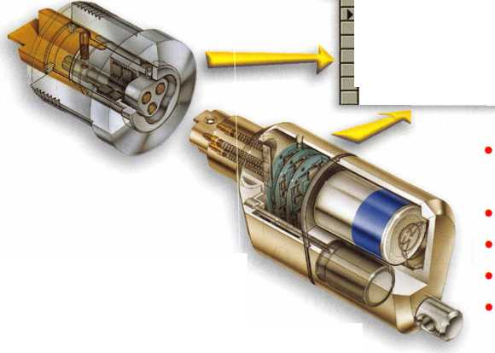

Master Lock Company has added a King Pin lock to the list  
of items available for the locksmith.

Designed for the King Pin on semi-trailers, RVs and other  
fifth-wheel trailers, it is a solid cast-aluminum construction  
lock that uses a number 5 or a number 25 laminated Master  
Padlock in the model number 387. If you have the need to key

into an SFIC system, order the number 3871 and it will come

with a padlock body ready to accept your core.

The bright red color and the included flag on the

handle make it easy to spot from a distance to  
be assured it has been installed. If you have

existing laminated padlocks for the rest of

the trailer, it’s an easy thing to order a  
King Pin KA to the same combination.

Operation is as simple as possible.

There is a slide bolt that

attaches the lock to the  
King Pin and the body  
of the locked padlock  
keeps the slide bolt in

position. A roll pin holds  
the interactive slide bolt and  
padlock into the lock, and it

may be driven out to change the  
padlock when required, but the pad-

lock will need to be unlocked to make that  
exchange.

This lock is made available KA, KD and MK’d, and if the  
number 25 lock is used, it can be supplied with our 15, 17, 81  
and 600 keyways. Attempts to use padlocks other than the

number 5 and number 25, or the special SFIC version, will not  
retain the slide bolt in the proper position. The King Pin  
lock may be ordered without the padlock, (387WCS), and you  
can use your own number 5 or number 25 with it.

Master also has a built-in locker lock, which has a new look and  
feel today to help schools and institutions meet

their handicap needs. The dial has been

redesigned to allow single hand

opening and operation.

The new dial has a  
larger diameter at the  
end of the dial with a  
ridge to help use the  
dial to pull on the door.  
The recessed center  
portion of the dial knob  
now has tactile bumps

to assist your turning grip.

Available in a plastic or a metal

version, the new dial is a good

option for the 1600 series built-in

locks. It may also be ordered as the

dial only. To upgrade existing locks, use part

number 1652-0313 for the plastic version, or

1652-0313MD for the metal dial.

A new key bow adapter is also available for the keys

used with the 1710 and 1714 locks. To get the handicap  
key bow, just add an ADA as a suffix to the part number.

The key adapters are also sold separately as part number 1710-43959.

New and Upgraded Master Lock Products

By Billy Edwards Jr., CML

Keynotes • July/August 2004

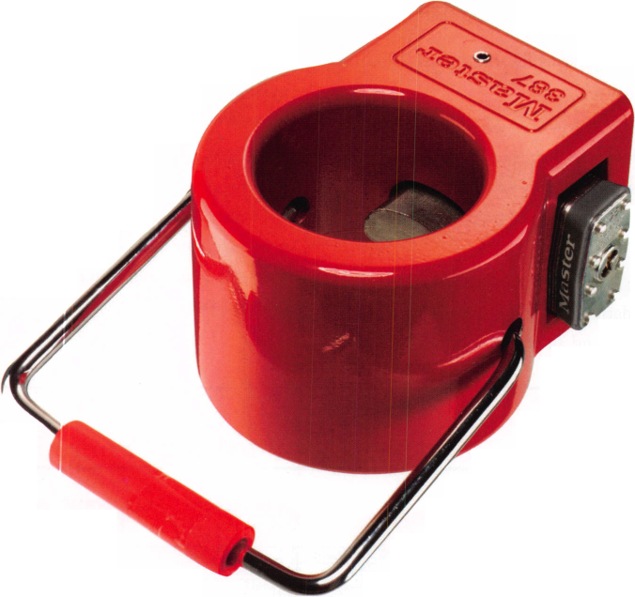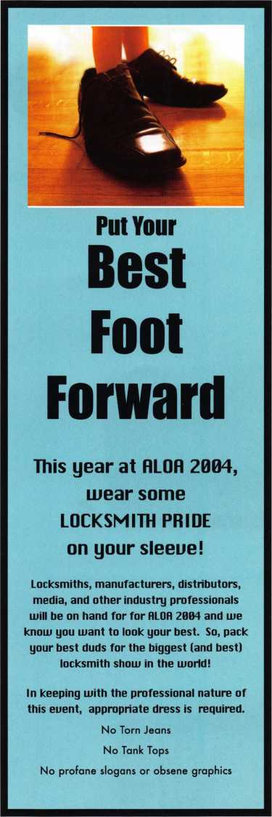

New from Adesco.  
The Latest Technology  
at Affordable Prices!

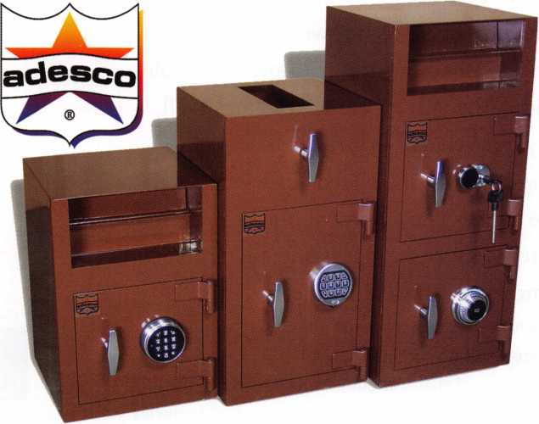

**Special Introductory Pricing and  
Promotions Available Now.**

Introducing the all new Business Deposit Safes from  
Adesco. Safes feature precision plasma cut doors and  
solid 1/2" monoframe faceplates. Door jams are reinforced  
and tied to safe sides. Postal drops offer our famous  
recessed baffle technology. *LaGard’s all new Group 2M

combination locks and spy-proof dials in  
at no additional cost. All these features  
and more at an economy price!

Call your Adesco distributor today.

*When available

(800) 694-9340 • [www.adesco.com](http://www.adesco.com) • [safes@adesco.com](mailto:safes@adesco.com)



Electronic Safe Locks: Motors and Solenoids

by Brian Costley, CML, CMST  
In the world of electronic safe locks,  
there is a confusing plethora of features  
and functions, but the job of physically  
blocking the safe’s boltwork is usually  
accomplished by either a motor or a sole-  
noid. Why two blocking systems? Well,  
why were there both roller fences and  
drop levers in the heyday of mechanical  
safe locks? The answer is obvious. Each  
system has its strengths and each offers

something different to the end user.

Sargent & Greenleaf’s initial attempt at producing an  
electronic safe lock resulted in the ECL. It used a  
large solenoid that was connected directly to the lock  
bolt. It was very dependable, but consumed batteries  
rapidly The ECL required eight AA batteries that  
needed to be replaced frequently Also, the solenoid  
mechanism was very sensitive to bolt side pressure.

As a result, the lock design was scrapped in favor of  
development of a motordriven mechanism that  
became the , introduced in .

The motorized design was less susceptible to bolt  
side pressure than the earlier solenoid lock, and con-  
sumed significantly less power, allowing it to be oper-  
ated thousands of cycles on a pair of alkaline volt bat-  
teries, conveniently housed under the keypad. Mind  
you, the still was finicky in the presence of bolt side  
pressure, but the effects were noticeably reduced.  
These two advancements made the motordriven  
design the mechanism of choice at that time.

In the intervening ten years, the has undergone a  
host of engineering revisions, the most sweeping  
some three years ago. The most significant change in

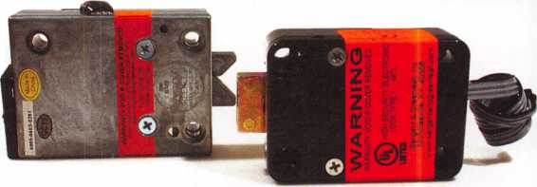

S&G’s new Rotarybolt Z02 lock on the left, and the current model of the 6120

on the right.

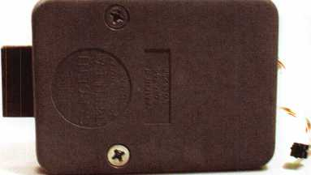

The very first production model of the Sargent & Greenleaf 6120.

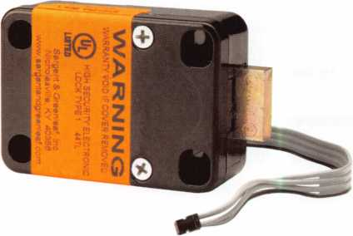

A current model 6120. Note the bolt-through cover. This model incorporates a  
deadlocking bolt.

Keynotes • July/August 2004

the history of the product was implemented at that time. It involved the addition of a deadlocking sys­tem to increase the lock’s security and protect the drive mechanism from damage caused by mechanical shock, end pressure, and less than perfect installa­tions. It marked a major stride in increasing the per­formance and durability of the . Also benefiting from the enhancement was the model, which shares the same mechanical design, but incorporates more sophisticated electronics to provide for more pro­gramming capabilities.

Ten years after the introduction of the , Sargent & Greenleaf has released the Z Rotarybolt™ lock. Technically, we can’t say it’s S&G’s first solenoid lock, even though it’s the first lock of this design offered for sale by the company.

The Z is, in many ways, a radical departure from the other locks in S&G’s line. The obvious difference, of course, is the use of a solenoid mechanism to block the bolt. The lock bolt is designed along the same lines as the latch found on better grades of mortise door locks. Once the solenoid is released by entering the correct code for the lock, pressure of the safe’s boltwork against one component of the lock bolt causes the other component to move into the lock case. This arrangement leads to very smooth opera­tion and extended life.

The solenoid design is very efficient. It lets the Z operate for approximately , cycles on a single alkaline volt battery. In comparison, the will open and close about, times on a pair of volts. In both case, the cycle figures are for locks that do not utilize time delays. This feature draws additional power, and the increased draw is a function of the time delay dura­tion. In other words, longer time delays eat up more battery life.

Due to the bolt design, the Z is a handled lock, and is available in both lefthand and righthand models. The following diagrams explain which is required for the four standard mounting configurations that are used in all safes currently manufactured.

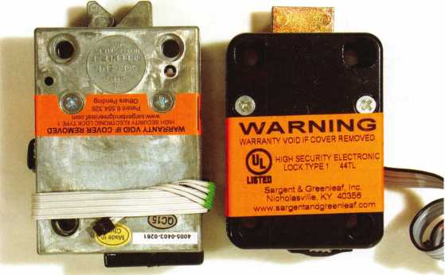

The new Rotarybolt Z02 compared to a current production 6120 lock.

«H6>3

MHO

Covers have been removed to reveal the inner workings of both locks. Note the  
solenoid in the Z02 and the motor mechanism of the 6120.

Keynotes • July/August 2004

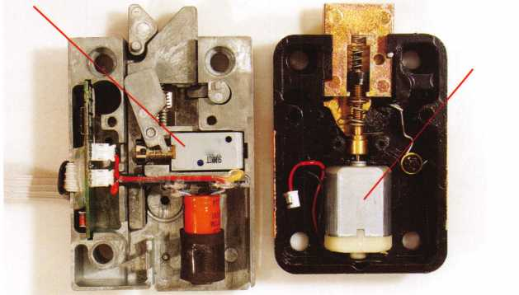

**Us** lout kxlsim^i&iti^yaias rt imams fefftai fmeisl 'Msl 2B02 3G0 Roftnyrl®). Ikfaiisframiii era of if» four mofuatiBQ

posisK.CKhfidipidiBdasiiiDuidksfisnlivlDo^aSliHibodc {raids} of tesohiioa.

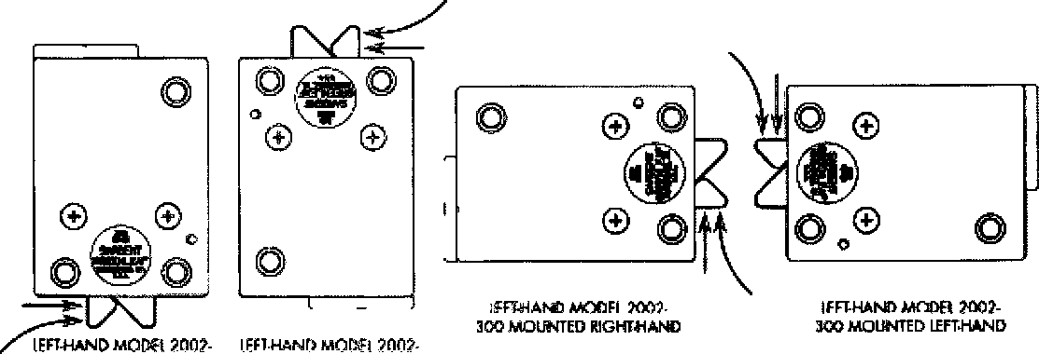

**SOD MQUNIH) VOTCAL 3CO MOUNTED verticalup**

The four locks immediately below are dl (he same ripht-hand model (Model 2002-200 Rotary bolt Z™}. Eadh is shown in one of the bur standard mounting positions. Each is depicted as it would be semi by looking at the bade (inside) of the safe door.

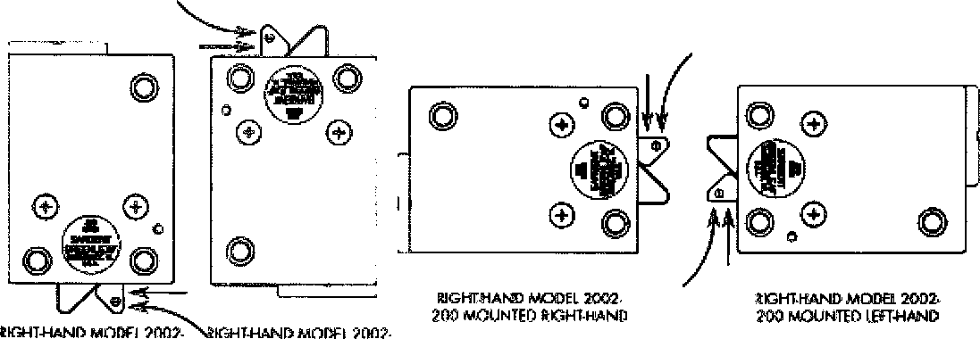

200 MOUNTED VERTICAL 200 MOUNTED VERT1CALUP DOWN

34

Keynotes • July/August 2004

The Rotarybolt Z can be used with any keypad cur-  
rently used with the and , which includes both  
onebattery and twobattery models. The onebattery  
keypad is a natural for the Z because of the lock’s low  
current draw In this application, the keypad offers a  
couple of important consumer advantages. First, it  
makes changing the battery extremely easy and quick.  
Just pull out the battery compartment, drop out the  
depleted battery, install a fresh one, then slide the  
compartment back into the keypad’s base. The entire  
process takes less than five seconds.

The other advantage and it’s a big one is that the end  
user has no access to the lock cable. This eliminates  
the possibility of cable damage during battery  
changes.

The Z footprint is just slightly larger than that of the  
and S&G’s standard mechanical safe locks, so it’s an  
easy retrofit in most safes. Also, the three mounting  
screw locations conform to S&G’s Magic Module  
concept. That means that a safe’s mounting plate  
which has been prepared for a or will also accommo-  
date a Z without drilling and tapping new mounting  
screw holes. Metric M and / X mounting screws are  
provided with the lock.

When it comes to software features, the Z is loaded.  
It’s programming is exactly like that of the S&G  
motorized safe lock. Features include:

* Management Reset Code—Each lock is shipped  
  with a preprogrammed MRC so that control of  
  the lock can be regained if the master code is lost  
  or forgotten.
* Lockout Penalty Timer—Random code entry  
  attempts are discouraged by a five minute lockout  
  timer that activates if four or more incorrect  
  codes are entered in a row
* Master Code—Performs all programming of the  
  lock without the need for any external devices.
* Supervisor CodeSets, changes, and deletes user  
  codes, but cannot tamper with time delay fea-  
  tures or the Master Code.
* Five User Codes—Holders of these codes can  
  open the safe and can change their own codes.

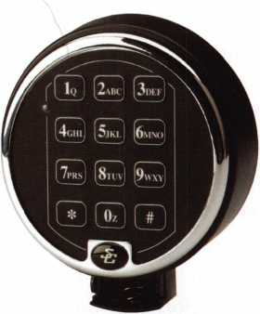

The one-battery keypad with slide-out battery compartment.

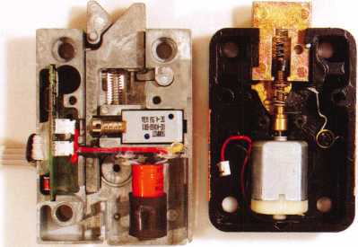

Here, the anti-shock component of the Rotarybolt Z02 has been removed to  
provide a clearer view of the solenoid plunger.

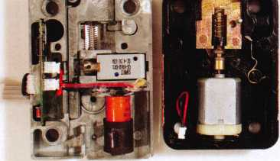

The solenoid of the Z02 has been moved to the unlocked position, and the  
6120’s bolt has been fully retracted.

Keynotes • July/August 2004

* Time Delay Override Code^This special code is  
  not subject to time delays, and can be programmed  
  to work in a supervised or unsupervised manner.
* Three Modes of Operation—Single User Mode

requires any single code to open the lock, Dual  
User Mode requires two valid codes to open the  
lock, and Supervisor/Subordinate Mode some-  
times referred to as Manager/Employee Mode  
requires the lock to be activated by the Master or  
Supervisor Code before User Code holder can

open the safe. Similarly, the lock can be deactivat- The Rotarybolt Z02 paired with S&G’s one-battery keypad,

ed by the Master or Supervisor Code holders.

* Time Delay—Delays of up to 99 minutes can be  
  set, and the Time Delay Opening Window can be  
  set from two to nine minutes.

The latest addition to S&G’s lineup of electronic safe  
locks offers yet another choice in the profitable quest  
to give customers what they wantthe convenience  
and power of electronic safe locks.

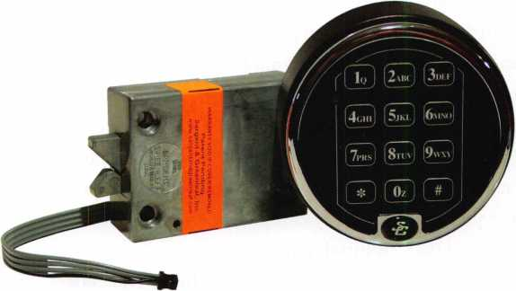

|  |  |  |  |  |  |  |  |
| --- | --- | --- | --- | --- | --- | --- | --- |
|  |  |  |  |  |  |  |  |
|  | Ad Index |  |  |  |  |  |  |
|  | 1 st in Hardware | ..73 | Hickok Back Cover | | Pacific Locksmiths Assoc | ...42 |  |
|  | A&B Safe Corporation 21, 73 | | Hinge Doctor | 17 | Professional Business Products... | ...47 |  |
|  | Aable | ..43 | Kaba llco Inside Back Cover | | S&G | ...37 |  |
|  | Adesco | ..31 | Keedex | 67 | Security Lock Distributors | ...25 |  |
|  | ALOA 2005 | ..65 | LAB | 15 | Strattec Inside Front Cover | |  |
|  | CCL Security Products | ..49 | LaGard | 69 | TimeMaster, Inc | ...41 |  |
|  | ClearStar | ....9 | Locke raft | 73 | Top Notch Dist | 3 |  |
|  | Corporate Safe Specialists | ..59 | Lockman Tools | 9 | Turn 10 | ...67 |  |
|  | D&D Technologies | ..19 | Lockmasters | 11, 55 | Videx | ...29 |  |
|  | Defiant Safe | ....7 | MBA USA, Inc | 9 | Yankee Security Convention | ...23 |  |
|  | Fox Valley Technical College .... | ..48 |  |  |  |  |  |
| L |  |  |  |  |  |  | A |



Keynotes • July/August 2004

/

Before.

After.

**With our latest electronic locks, it's what you can't see that really counts.**

**Continuous improvement and smart design are a way of life at S&G. Improvements like our new deadlocking capability that provide an even higher level of security and durability in boltwork blocking applications.**

**And all of our electronic locks offer innovative features that make them more reliable, secure, and easy to use. Features like our advanced, motor-driven design that guard against bouncing and vibration attacks. Simple, yet clever innovations like putting our keypad connector outside the safe for convenient servicing. And the unique advantage of easily programming our locks using only the keypad.**

**Our electronic lock family is the broadest in the industry.**

**And it’s built tough and designed to fit most any commercial- grade application you may encounter. But most important, they’re all backed by the S&G customer service and support that’s always there when you need it.**

**So, if you haven’t tried one of our electronic locks lately, contact your S&G Distributor and see the difference.**

A lock on security.

**See our latest electronic locks at ALOA-Booth 443.**

*(§)*

**SARGENTANDGREENLEAF**

**[www.sargentandgreenleaf.com](http://www.sargentandgreenleaf.com)**

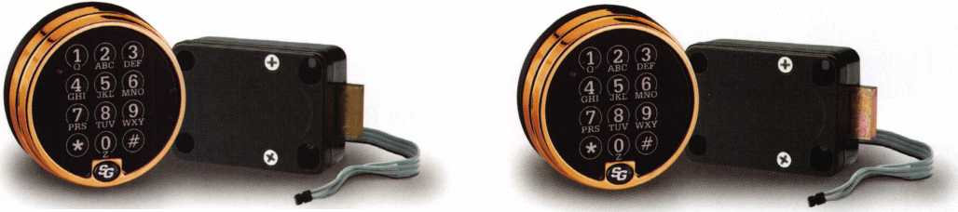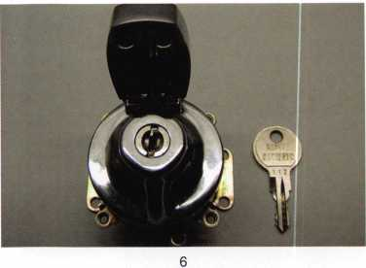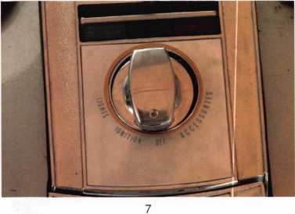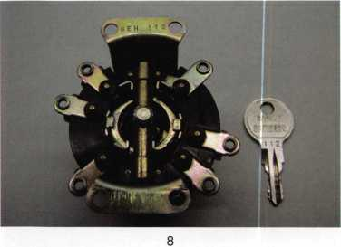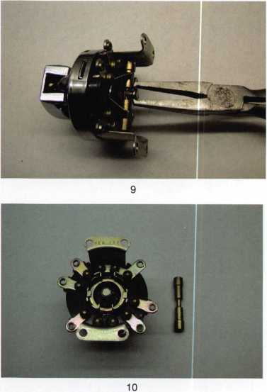

Cycle Chronicles:

ioo years of Harley-Davidson

PART 2

by Ray D’Adamo, CML

In our last installment of Cycle Chronicles, we documented mainstream key systems found on Harley Davidson motorcycles from the company’s infancy in the early 1900s through the 1980s. In this issue, we will start at the beginning of the post- AMF period (app. 1981) and finish at the beginning of the 21st Century.

1981-Early 1990s Code Series: FLT11-127 Key blank: HYD1-11

Though Harley-Davidson was bought back from AMF in 1981, the company continued to procure locks from offshore suppliers. This system is similar to the previous system in many ways. (See Cycle Chronicles’ “The AMF Period” from June 2004 Keynotes.) The bike may utilize other locks, which are keyed to the igni­tion, typically at least a gas tank lock.

Code Series: 000 - ???

Late 1980s - Early 1990s Key blank: HYD12

This lock and series are Japanese. Both lock and key are double bitted. Photo #6 displays this series cylinder in a tank mount ignition switch. Photo #7 displays how it is installed over the gas tank of a 1990 FLSTF. As seen in photo #8, the key code is stamped into the bottom flange of the lock’s mounting bracket. The code 112 is contained within an alpha-numeric sequence, in this case 8EH112. Aftermarket replacements are not coded and may not use the stock key blank. Before picking this lock, it is wise to disconnect the battery. I’ll show you why as we disassem­ble this switch (Photo 9 andio). First locate the center post at the back of the housing and, using a suitable tool, extend it against spring pressure until the brass cross bar can be removed; then remove the cross bar (Photo 11). Lift out the terminal plate (Photo 12). Lift out the insulator, insulator support bracket and



Keynotes • July/August 2004

clear plastic washer (Photo 13). Remove the assembly mounting bracket with the dead bar in place, lift out the cylinder and sepa­rate the plug from the casing. Reassemble in the reverse order.

Remember when I said earlier that it is wise to first disconnect the battery before trying to pick this lock? Taking a closer look at photo 11, note that the cylinder plug is open at the back. This opening is directly over the center post of the electric switch, which is hooked to the cross bar, the part that distributes elec­tricity to the various circuits. If the tip of your pick should extend out the back of the cylinder plug too far to accidentally touch the center post of the electric switch, you may end up arc welding the key cylinder and your pick to the center post.

Code Series: A-Z Early to Mid 1990s Key blank: HYD13

Photos 14 and 15 display a typical ignition switch, which utilizes this key system. The switch contains a single bitted plug with six discs. The first five are combination discs and the sixth is the plug retainer disc. The key is double bitted, and two steps are used, a cut and a no cut. The assembly is mounted to the side of the bike, about knee high. The plug can be pulled from the cas­ing in any of all three positions by inserting a pick through the keyhole, depressing the plug retainer disc and pulling on the plug with the pick.

Code Series: 0000HD - ????HD Mid 1990S+

Key blank: 1137B

This series utilizes locks that match Chicago & Fort Lock Company’s seven-pin tubular lock specifications. Depending on the model, the ignition lock could be a tank mount (photo 16) or side mount (photo 17). It could also lock the fork (as in photo 18), or the fork lock could exist as a separate lock. Usually, the core set of locks is keyed alike. Luggage compartment locks can also be keyed to the core set of locks. Key codes are found on a black tag accompanying the original keys, or on a sticky tag.

In our last edition of Cycle Chronicles (Keynotes March 2004), we looked in detail at the tank mount version of this system. In that article, the finer details of the cylinder were revealed. Here we will take a close look at the fork locking ignition switch. Photo 18 displays the fork locking ignition switch lock, as mounted in the console of a 1997 Ultra Classic Electra Glide.

For demonstration purposes, we will first remove the entire igni­tion assembly from the bike and take it to the workbench.

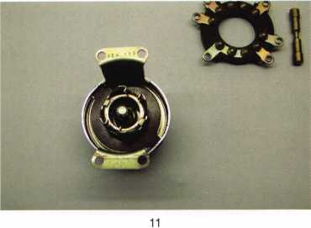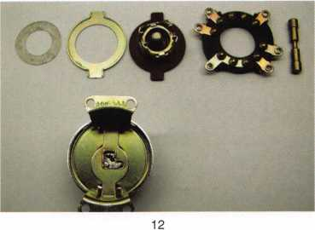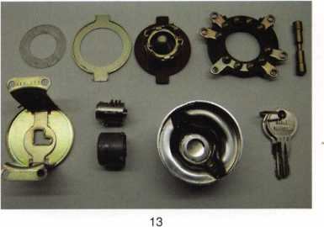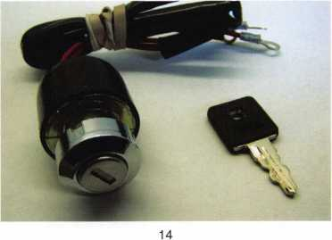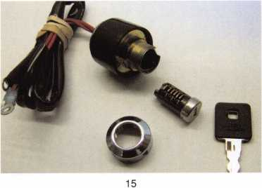

Keynotes • July/August 2004

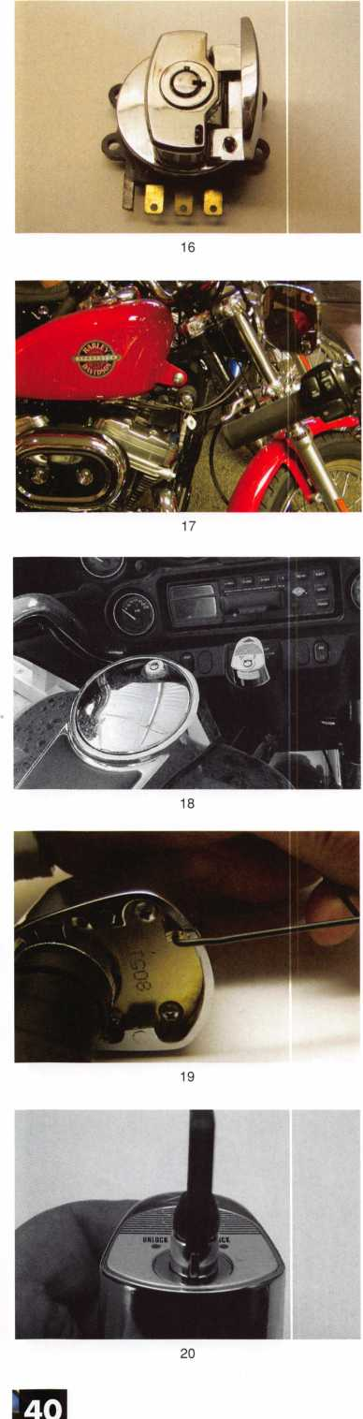

To remove the turn knob from the assembly, make a tool. Take hardened steel wire of about .060 in diameter and bend the end 90 degrees. From the inside corner of the bend, the bent leg should be no longer than .100. Insert the bent leg of the tool between the bottom of the turn knob and the console below it, with the bent leg facing forward in line with the word “Unlock” on the turn knob decal and the tool handle pointing straight up (Photo 19). Rotate the tool handle downward while lifting up the bent leg against the turn knob release pin. While holding up the release pin against spring pressure, insert the operating key, rotate it counterclockwise, (Photo 20) and park the nose of the key pointing at the rear center of the turn knob. Remove pres­sure to the release pin and remove the tool from beneath the turn knob. Rotate the turn knob fully clockwise and lift off the turn knob from the bolt housing.

To remove the cylinder from the turn knob, first gently lift off the aluminum turn knob decal. The decal indicates the lock’s positions and is glued to top of the turn knob with rubber cement. A razor works well, while care is taken to not crease the thin metal decal (Photo 21). Next, locate the cylinder retainer screw on the upper right side of the cylinder. Clean out the poured material blocking access to the hex screw socket and remove the screw. Beneath the screw, you will find a horizontal pin, which penetrates the side of the cylinder casing. The retainer screw secures the horizontal pin in place, and the horizontal pin secures the cylinder in place (Photo 22). Lift out the retainer pin and cylinder together (Photo 23). To disassemble the cylinder, pull out the retainer pin, which is not staked into the cylinder. Photo 24 displays the disassembled cylinder.

During the course of its history, Harley-Davidson experienced very good times as well as very bad times. But it takes the ability of enduring both the good and the bad times to become some­thing or someone truly remarkable, and through it all, the Harley-Davidson motorcycle has emerged as the icon of the American motorcycle.

(Photo 24) If you don’t get to Milwaukee Wisconsin very often, where the Harley-Davidson Museum is located, perhaps you will get a chance to visit the Harley-Davidson Mobile Museum right in your home town. The museum travels to Harley-Davidson dealerships and cycle events worldwide. To find out where the mobile museum will be rolling up next, log onto Harley- Davidson’s web site at [www.harley-davidson.com](http://www.harley-davidson.com).

See you next time for another exciting installment of Cycle Chronicles.

Keynotes • July/August 2004

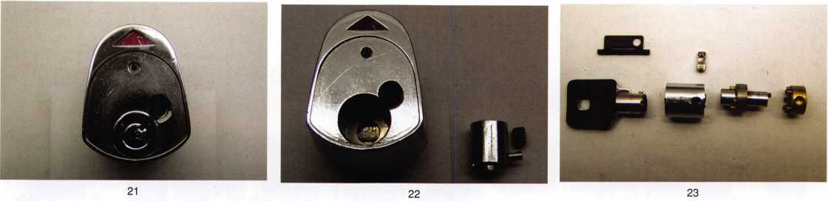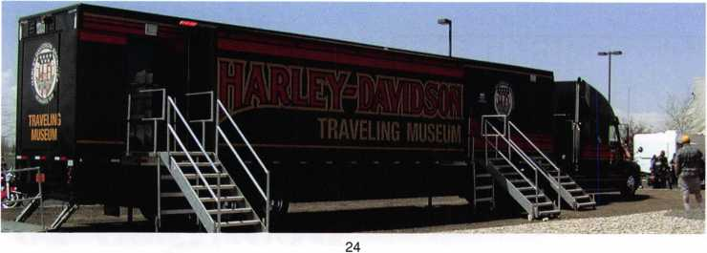

Great

Customer Service  
is an Art.

Call the Master.

***[www.Time-Master.com](http://www.Time-Master.com)***

eMaster ,

***Supplying the Security Industry with Quality***

*888 798 8465* ■ *fax 800 798 8463*

*157 Venture Court Suite 9*

*Lexington Kentucky 40511*

Don't Miss the 2004

ALOA OPEN

GolfTournament

Thursday, July 22,2004

Cross Creek Golf Club  
Beltsville, MD.

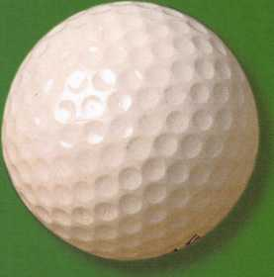

Sponsored By:

AMSEC

Lucky Line Products

Strattec Security, Inc.

Assa High Security  
Locks

YSG Door Security  
Consultants, Inc.

Keynotes • July/August 2004

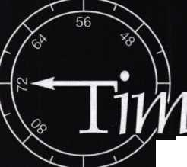

'



**Stan Hauer, Chairman Tom Jones, Education**

**(503) 325-6003 (Phone/Fax) Chairman**

**[hauer@pacific.com](mailto:hauer@pacific.com) (503) 842-2044**

**[tjlock@oregoncoast.com](mailto:tjlock@oregoncoast.com)**

ARE YOU  
READY TO  
TAKE YOUR  
BUSINESS TO  
THE

NEXT

LEVEL?

October 12-16, 2004  
Portland, Oregon  
Holiday Inn  
(Airport Location)

* Classes
* Seminars
* PRP Exam
* Trade Show

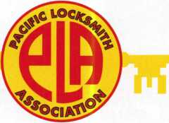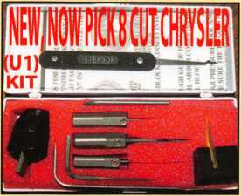

Universal Ford Flush-Mounted/Chrysler 8-Cut Ignition Removal Kit #U1 (patented)

Use this tool on all Ford flush mount ignitions, with or without side bar, large and small diameter face, all types of focus locks. With adapter, you can do virtually all Chrysler, Dodge, and Jeep 8-cut ignitions with no damage to lock. Similar kits sell for over $100.00 and only do Chrysler. Fit key and replace. In less than 5 minutes, you will have them out. Kit includes: 1 force tool (to remove face); 3 drill & arbors; 3 drill guides for all access holes; side B AR pressure tool; turn wrench; tumbler holding tool (to assemble and disassemble). No other tool needed with this kit. SHOW SPECIAL: get free adapter for Chrysler, Dodge and Jeep with each kit. $155.00 +$6.00 S&H

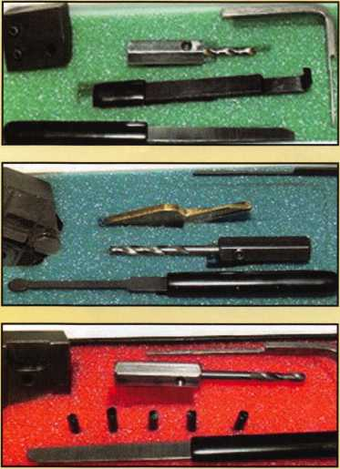

1998 Up G.M. In-Dash Ignition Removal Kit (patent 5454245)

Remove plastic ring and chrome cap in seconds. Make access hole to pick side bar. Turns cylinder to ACC position to remove lock in less than 5 minutes with no damage to lock. Your first job will pay for this kit. $70.00 + $6.00 S&H

1996 Up Ford 8 Tumbler Ignition Removal Kit and Side Bar Breaker Tool

(patent 5701773)

Use force tool to turn ignition to “on” position in less than 60 seconds. To start car or for fast ignition lock removal or use kit to push side bar in, turn cylinder to “on” position for fast removal without any damage. Fit key, replace same lock. $90.00 + $6.00 S&H

1994 Up G.M. 9 Tumbler Ignition Removal Kit (patent 5454245)

The locks have longer side bars than the older type and must be in the “on” position to remove. This kit will do that with no damage to the lock. Fit key and install same lock. Does all types, vats, mrd, top hat, module, etc. Your first job will more than pay for this kit. New with update to do module locks, blazers, suburbans, pick-ups, etc. $80.00 +$6.00 S&H

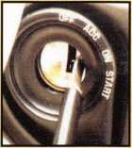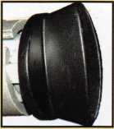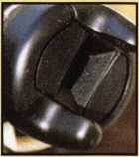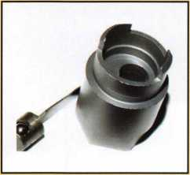

Ford “Quick-On” (patent 5454245)

Now turn all 10-cut ignition cylinders to the “on” position for fast removal-in less than 60 seconds. Sable, Taurus, all styles even those with airbags. No damage to housing.

$65.00 + $6.00 S&H

No-Nonsense Squeeze Lock Plug Remover

(patent 5165158)

Now you can remove all squeeze lock plugs in 15 seconds or less from all GM, Ford, Chrysler, AMC, and Jeep. No more fumbling, gadgets, cut fingers, broken tabs, or the need for 3 hands! It’s so easy you can do it in the dark while it’s still in the glove box.

$50.00 + $6.00 S&H

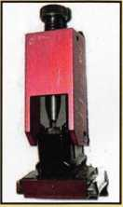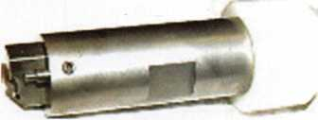

The G.M. Trunk & Door Persuader

The unique tool will open virtually all GM trunks and doors through the current year when tool fits into the cylinder core cavity in less than 50 seconds. No drilling, pulling, picking, special tools or electricity needed. When customer’s key does not open trunk because: Problem 1: spring retainer popped up into outer shell; Problem 2: One side of side bar sprung off. Side bar does not retract; Problem 3: key or cylinder worn. Side bar does not retract; Problem 4: Key jammed in lock at "turned” position, etc. With The Persuader you will open these locks in less than 50 seconds with no damage to lock. Just repair and replace. There is nothing to wear out. Yes, if needed, it will open with no key. Note: Because of The Persuader’s capabilities, it will be sold to locksmith only. $45.00 + $6.00 S&H

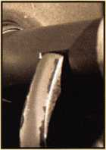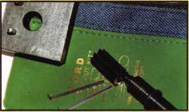

Ford “Disc-Out” Kit (patent 4682308)

This kit will remove those stubborn Ford pin ignitions from 1976 to present in less than 5 minutes. These locks incorpo­rate 2 locking devices and a hard steel disc across the shear line. They must be turned to “on” position to release both locking devices so as not to damage the housing. $60.00 + $6.00 S&H

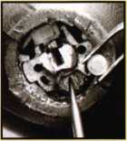

Frank Markisello guarantees all his products to do as stated.

[www.aablelocksmiths.com](http://www.aablelocksmiths.com) • 47 Marlboro Dr. • Milford, CT 06460 • (718)848-8000 • fax (203)882-0600

Stop By Booth #1129  
And see all new products!

PROGRAMMING AN ACURA 3.5 R

with TRANSPONDER MODULE, part 2

By Jeff Trepanier, RL



Keynotes • July/August 2004

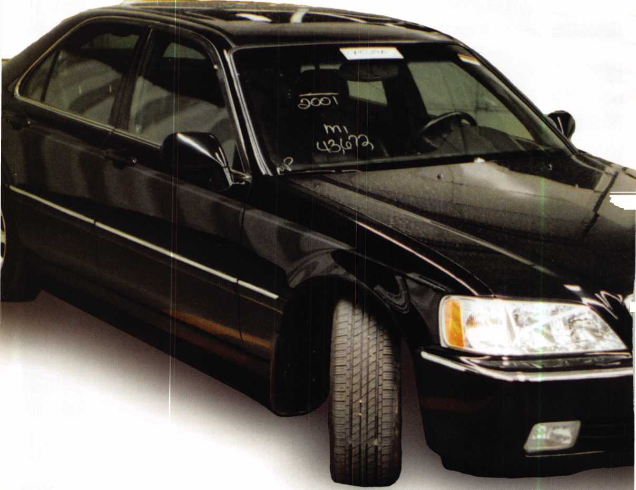

In the first part of this series, we looked at the Acura 3.5R, a great example of a Honda transponder-equipped vehi­cle that uses read/write keys and is a little more involved than just programming a transponder key Locksmiths need to be aware of read/write keys and know how to clone them, which is what we will focus on in this article. Let’s take a look:



**04809-SZ3-A04**

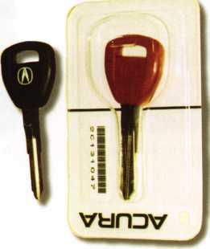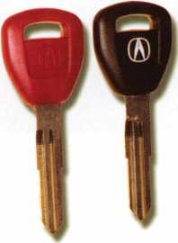

2. The red learning key and the black pro- 3. The red and black programming keys, gramming key, which is now the original key. These keys come uncut, and you cut them specifically for the vehicle you are working on at the time. It is best to cut a mechanical test key first, before you cut the red and black program keys.

2500101 659 “CANADA”

HONDA LOCK MFC. CO..LTI). MODEL HLI510 ISC:RSS/CNR210 .

**IfCC ID: MLBSZ**31

| THIS DEVICE COMPLIES WITH PART 15 OF THE I FCC RULES OPERATION IS SUBJECT TO THE I FOIL WINGS TWO CONDITIONS! 1ITHIS DEVICE I MAY NOT CAUSE HARMFUL INTERFERENCE. AND I (2ITHIS DEVICE MUST ACCEPT ANY INTERFERE- L 1 NCE RECEIVED. INCLUDING INTERFERENCE THAT I I MAY CAUSE UNDESIRED OPERATION. 1

i vipr. rn i **tiyi**

4. The module that needs to be replaced; it is located on the top left side of the steering column. Held in place by two 10 mm bolts, it has two plugs attached to it. To access this module, you gently pull on the left side of the knee bolster. It is snapped in place. Do not pull too fast, because there are other wires attached to it. You can now see the module and replace it.

Once the keys are cut, you’ll be ready to program.

Keynotes • July/August 2004

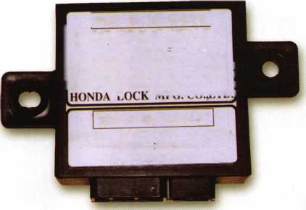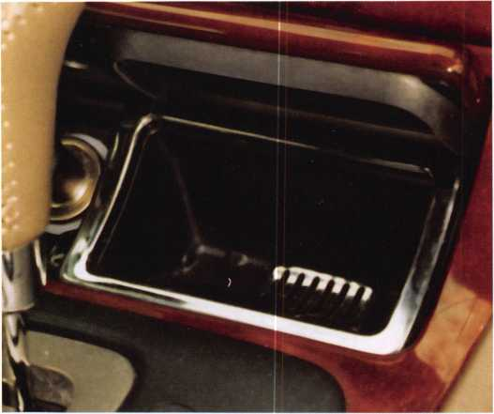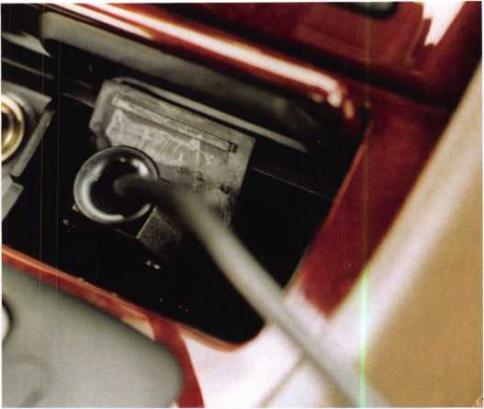

5. The location of the OBD# port plug in, which is located under the ashtray. Remove the ashtray, lift up the rubber flap and plug in.

6. The CodeSeeker, plugged in.

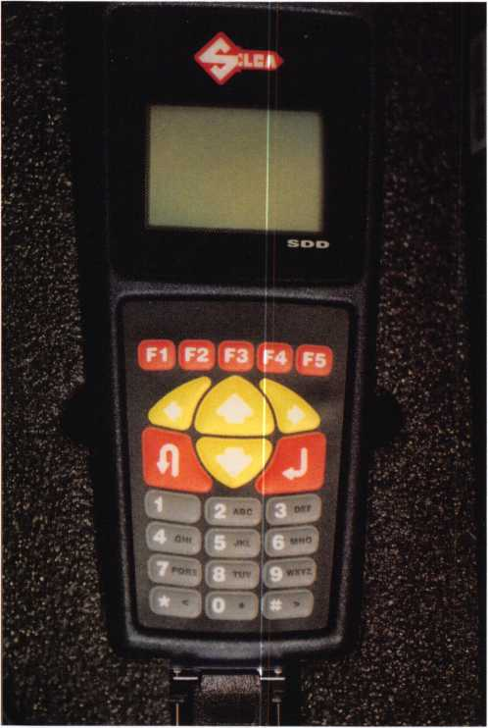

7. A second choice for programming. You can also use a T-code.

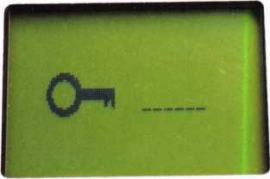

8. The second screen that comes up. When you first plug in the

CodeSeeker, you have to select the contrast you desire and press ENTER. Now enter your six-digit security pass code, and press ENTER.

CODE-SEEKER

I ENTER)

9. The face of the CodeSeeker; 10. The Honda adaptor attached; this press ENTER to continue. adaptor is needed to program

Hondas and Acuras.



Keynotes • July/August 2004

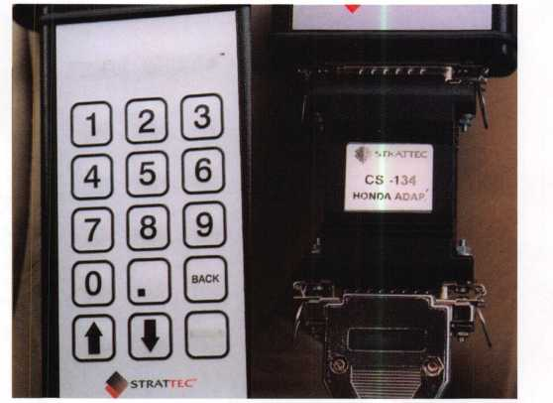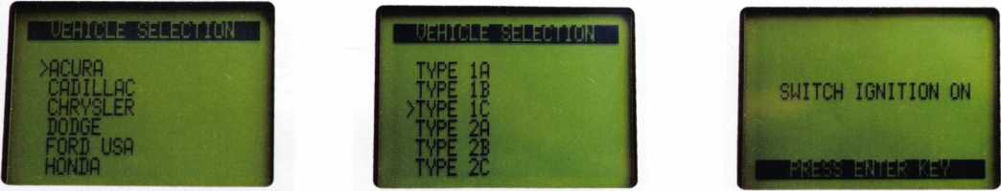

11. Vehicles selection already comes up on Acura — press ENTER.

12. The next screen; select the type that you need for the vehicle you are working on (for me it was type 1C).

13. The next step on the screen. Programming is easy; just follow the step-by-step instructions, switch ignition ON.

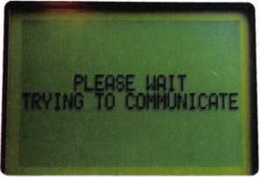

>ECU identification

SPECIAL FUNCTIONS

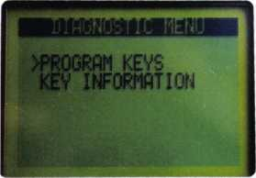

14. Please wait; trying to communicate. 15. Select SPECIAL FUNCTIONS and press ENTER. 16. The PROGRAM KEYS screen - press ENTER.

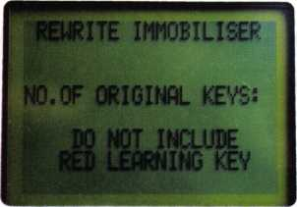

17. The next screen. The number of original keys would be one, the black programming key that came with the key and module package.

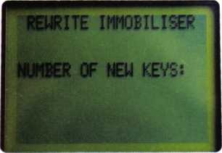

18. The next screen: Enter the number of new keys. I entered 1. New keys can be cut on llco keys #(HD106-pt). Be careful when using llco key #(HD106-pt5); this is a read-write key, and has to be cloned. Strattec keys are also available in read-write key #692057.

Advertise with Weatherproof Safety Labels!

**Lockout your  
competition**

by placing your  
calling card on  
every door you  
service! Keep

your name in front  
of every customer  
with these **Durable,  
Affordable Labels**Call & Order Today  
**1-800-355-6322**

(Actual Label Size 1 1/2x4 1/2)

Professional Business Products

ALOA Associate Member

BUYING FROM NEBS? We offer lower prices on Invoices, Checks, Business Cards, Repair Tags, Magnets, Key Tags, Pens and Labels. Come see us in Baltimore at the ALOA Security Expo Booth 854

wwiv.pbp2000.com



Keynotes • July/August 2004

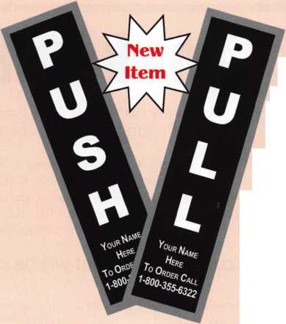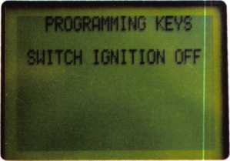

19. The next screen - switch ignition OFF.

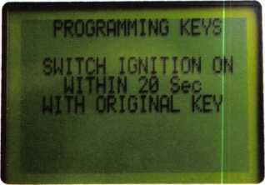

22. Again, follow the screen prompts. This is not the complete step-by-step because I was not pro­gramming this vehicle. I have done several Acuras already.

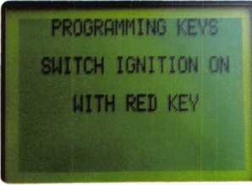

20. Next step; pressing ENTER is not always needed. Watch the screen and follow the screen prompts. Switch ignition ON with red key.

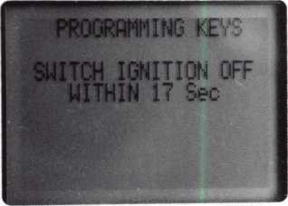

21. The next step.

When you are done programming, you can use the original black programming  
key and your new key Hope you enjoyed this little Honda transponder series.  
Remember that those read/write keys need to be cloned, and you should be fine  
Until next time ...

locksmith Training

Sponsored by Fox Valley Technical College • 1825 N. Bluemound Dr. • Appleton, Wl 54912-2277

6-Day Program • Career Change in One Week • October 25-30, 2004

This is a basic locksmithing training course sponsored by FVTC’s Security and Crime Prevention  
Department and conducted by ALOA ACE instructors. Designed for the locksmith shop owner

who would like to provide entry-level training for new apprentice locksmiths as well as those who would like to receive professional  
training that will enable employment with a professional locksmith. The course will allow the student to gain enough knowledge to  
make them a starting apprentice in an existing shop. Job placement locations will be made available at the time of the class.

To maintain quality the course enrollment will be capped at 12 students. Enroll early!

Curriculum includes:

Key Blank Identification and Duplication Lockset Servicing, Functions, Finishes Pin and Disc Cylinder Servicing Door Closers

Key Codes and Code Equipment Life Safety Codes Key lmPressionin9 Lockset Installation

Basic Master Keying Lock Pick Opening Techniques Lock By'Bass Techniques Cabinet, Furniture, Mailbox Locks

Exit Hardware



All tools and equipment will be made available for use during training. Class Hours: 8:30 am to 5:00 pm every day

Class Attire: Shop clothes

Course Tuition: $995.00

**Course Enrollment: See Susan Egnoski in the Criminal Justice Center**

or call 920-831-4393

Note: Enrollment deadline is Friday, September 24, 2004



Keynotes • July/August 2004

Know Who Searched Your Belongings

HR

**CCL Security Products' new SearchAlert™**

RE-SETTABLE COMBINATION LOCK WAS DESIGNED WITH A SECURITY FEATURE WHICH ALLOWS TSA AGENTS, USING A SECURED ACCESS DEVICE, TO OPEN THE

**SearchAlert lock without destroying the lock.**

**The new SearchAlert Security window changes**

COLOR FROM **GREEN** TO **RED** WHEN THE TSA SECURED ACCESS DEVICE IS USED TO OPEN THE LOCK, OR WHEN AN UNAUTHORIZED PERSON HAS OPENED THE LOCK USING A COUNTERFEIT OPENING DEVICE.

**SearchAlert**

**Re-settable combination**

LOCKS ARE STRONGLY RECOMMENDED FOR ALL CHECKED LUGGAGE

**Available in 4 colors:**

**Black: Model #7400PSB White: Model #7400PW Bright Nickel: Model #7400BN Pewter: Model #7400PTR**

**SearchAlert, U.S. Patents Pending**

**Travelers will now know when their SearchAlert**

**LOCKS HAVE BEEN OPENED, AND WHETHER THEIR BAGS HAVE BEEN SEARCHED BY A TSA AGENT, OR VIOLATED BY AN UNKNOWN PERSON.**

**TRAVEL SENTRY**

CERTIFIED

Security Products

301 West Hintz Road • Wheeling, IL 60090  
Telephone: 800.733.8588 • Fax: 847.537.1881  
[www.cclsecurity.com](http://www.cclsecurity.com)

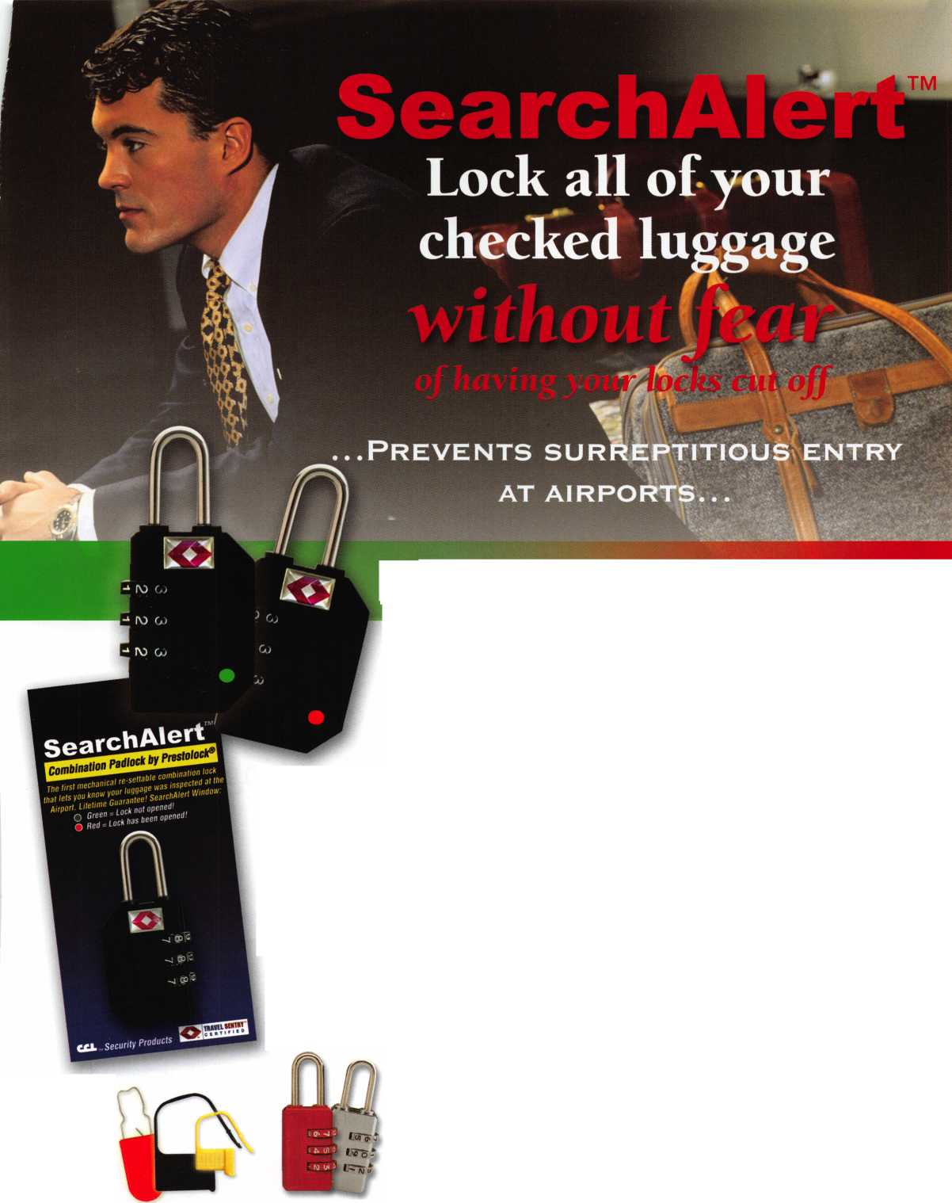

Navigating the Whitewaters  
of Pass-Through Programming

By Tom Seroogy

The future of automotive locksmithing may seem dim to some; to others, it’s an exciting ride on the whitewaters of new technology. Recent news has covered the Controller Area Network, or CAN system, that all manufacturers are moving towards. This article covers another technology, briefly discussed in earlier articles, and the new direction in vehicle programming: Pass-Through programming.

Beginning this last year, the Environmental Protection Agency (EPA) has required that all automotive manufactur­ers make available a web-based solution for providing tech­nical information, training and tools to the aftermarket.

Most have complied, although to varying degrees. Of these solutions, the most intriguing is one referred to as Pass- Through programming - sometimes spelled “Pass-Thru.”

The concept of this technology is actually quite simple - a single diagnostic tool capable of programming any manu­facturer’s vehicle. That’s right - one tool that is capable of programming Ford, GM, Chrysler, Toyota, Mitsubishi, Mercedes, BMW, etc. Needless to say, this concept consti­tutes the dream-tool for aftermarket automotive techni­cians and locksmiths alike. (See illustration i.)

Keynotes • July/August 2004

INTERNET

CarDAQ2534

1. The locksmith’s dream-tool - one does all! With the new EPA directed Pass-Through program ming, by connecting to the internet, a technician should “theoretically” be able to program any vehicle on the road.

Still, this leaves the daunting task of bringing together diagnostic tool manufacturers and automobile manufactur­ers for the sole purpose of creating a single tool-software solution that fits the interests of all parties involved. To facilitate the progress of this technology, the EPA adopted the SAE J2534 standards. By adhering to these standards, all tools built to the specifications of the standard will program vehicles using any O.E. Manufacturer’s software that is written to the same standard. Not surprisingly, the concept is easy, but the execution and delivery are a little harder to achieve.

Despite current limitations, in anticipation of the day that this dream becomes a reality, this writer-locksmith took this new technology to task, setting off to field test the fledgling technology in today’s current market. First on the agenda was locating the perfect tool and then a few manufacturer programs for doing the test drive.

Although currently all manufacturers are required to offer web-based technical assistance to the aftermarket, none openly promote Pass-Thru. When found, the descriptions on the capabilities of their Pass-Thru software are so vague as to require a technician to first subscribe and try the software before realizing its capabilities and limitations.

Another hurdle in pursuing this new technology is knowing in which Pass-Thru tool to invest. Although by EPA requirements, any diagnostic tool produced to J2534 stan­dards should operate with any manufacturers’ software written to the same standard, it becomes quite apparent that each manufacturer has a “preferred” tool. In all likeli­hood, most all tools will work to one degree or another.

However, because it would be  
unrealistic for every automobile  
manufacturer to test their soft-  
ware with each Pass-Thru tool in  
production (nor is it incumbent  
upon them to test their software  
with any tool), each selects a spe-  
cific tool with which to write, test  
and validate their software.

For the locksmith, the final hurdle  
in the decision-making process is  
finding a manufacturer that  
includes the key programming  
functions in the software. A curso-  
ry view of most manufacturer sites

show that key programming and/or any security-related  
function is not available to the aftermarket. In fact, of  
those sites viewed, only a few offered any type of solution  
for immobilizer and key programming. And in the  
instances of Honda and Mitsubishi, the solution involves  
leasing the O.E.M. diagnostic tool!

For this locksmith, the solution for both key programming  
and a preferred Pass-Thru device came from Ford’s  
Motorcraft Technical Resources web site. Although buried  
deep within the site, Ford offers Pass-Thru programming  
under their Ford Module Programming subscription. Of  
course, the feature that sealed the deal was the fact that  
the software includes the capability to program PATS sys-  
tem keys. The recommended Pass-Thru device? The  
CarDAQ2534 by Drew Technologies. (See photograph 2.)

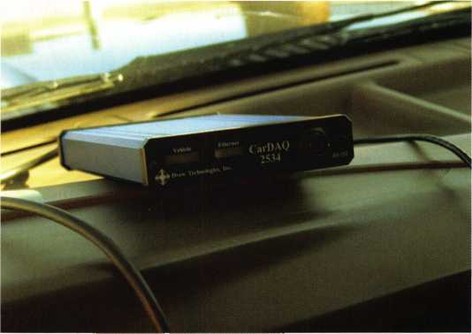

Ford offers the key programming functions as well as a recom­mended Pass-Through device from their site. The Drew Technologies CarDAQ2534 is Ford’s tool of choice.

Keynotes • July/August 2004

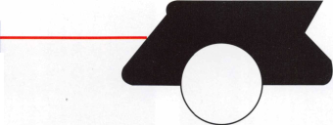

Before jumping into the game, there are a few prerequisites that need mentioning. Each is critical to fast and effective programming.

4. A good laptop with the latest version of Windows made for a flawless hardware and software configuration.

In fact, the only obstacle encountered was that the CarDAQ2534 driver and test software are provided on a 3.5- inch floppy disk, and the computer used for this article is not equipped with that drive. Transferring the drivers and test program to a CD quickly solved this problem. Aside from this little bump, XP quickly accepted the drivers and found the CarDAQ2534 device.

More problematic than configuring the hardware is finding a method for connecting to the internet. Needless to say, most programming will be performed in the field, far from access to a phone line or cable connection. As such, finding a method to for making a wireless web connection is criti­cal. This writer looked at several wireless options and found a number of possibilities, each offering an array of service packages, transfer speeds, and price ranges.

Although there are several companies offering wireless web service (including Sprint), Nextel was readily available for testing during the time of this article, and offers an extremely wide range of options for both the small and large business. Carefully check out the various plans in your service before jumping onboard with any specific carrier. If you find later that your service plan is not adequate, it can be quiet a problem and possibly costly to change services.

Nextel offers a wide variety of wireless web hardware and software options. For the purposes of the general lock­smith, the iMuoo Wireless Modem Card and the Packet stream Gold package are more than enough to work the web from the field; offering a 56K modem for $350 and unlimited downloading for around $55 per month.

3. Having the correct equipment is critical to successful program­ming. A good laptop computer with an Ethernet or serial connec­tion and a wireless modem are needed. This author used a Sony VAIO PCG-GRT250P with Ethernet connection and a Nextel phone for wireless web access.

Requirements:

The following components and software are necessary for successful programming (See photograph 3.):

1. Laptop computer with the following:
2. Windows 98SE, 2000, or XP operating system.
3. An open Ethernet port or serial port.
4. Wireless Modem Connection
5. Drew Technologies CarDAQ2534 Device. The device includes both a network and serial cable. An OBDII compliant cable for connecting the tool to the vehicle OBDII data link connector is required and purchased separately.
6. Motorcraft’s Ford Module Programming subscription.

Laptop

Although the CarDAQ2534 allows for a wide variety of soft­ware and hardware configurations, this writer found that the Sony VAIO PCG-GRT250P laptop using Windows XP Pro and an Ethernet connection offered fast and flawless instal­lation and programming. (See photograph 4.)

Keynotes • July/August 2004

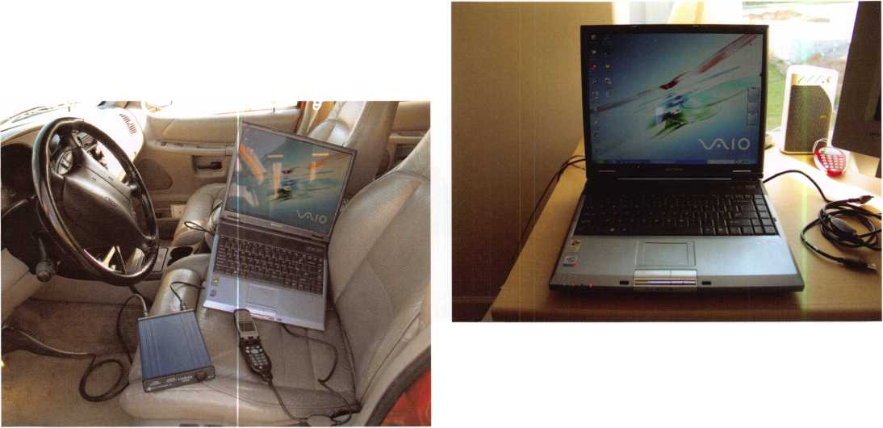

A slightly less expensive option is forgetting the modem card and using a connection kit, your Nextel phone and the Packetstream Gold package. The connection kit - essentially either a serial or USB cable that connects the Nextel phone to a computer, and costing about $25 - allows the Nextel phone to be used as a modem for connecting to the web. While the connection speed appears to be a much more humble 19.2Kbps, the Packetstream Gold data compression scheme allows for virtual connection speeds of 56Kbps.

Next in the scale of economies is the Total Connect pro­gram offered by Nextel. This program offers a number of plans based on the amount of expected monthly down­loaded data. Following is a table of the various options avail­able at the writing of this article. According to Nextel Customer Support, this option offers connection speeds of roughly 33Kbps. A careful review of the table indicates that the user should consider the Packetstream Gold package if monthly download totals of more than 50 MB are expected.

In our research, though brief, if using the Total Connect option, it is best to first pay for a subscription and down­load and install the Ford Module Programming software from your standard web connection. Use the Total Connection option only for connecting while in the field during the programming of the vehicle. Using this method, we found that the typical vehicle key programming func­tion used less than 1 MB of data download.

Total Connect Plans

About the most economic package, and the one chosen by this writer, is Nextel’s Dial-Up Service. This package is only an additional $10 per month added onto your current Nextel subscription and utilizes the Nextel connection kit as well. Once the connection kit is in hand and the net

service is activated, simply download and install the free connection software (for Windows 98, NT, and 2000). XP users can access the drivers by downloading the Dashboard software free and available under the Packetstream Gold site page. (Contact Nextel Customer Service for more information on configuring the Nextel phone for wireless web with your computer.)

Once installed and connected, you can use your Nextel phone to connect to the web from just about anyplace.

And although the connection speed is a mere 9.6Kbps, and lousy for downloading the O.E. Manufacturer’s application interface or software package, it is ample enough for run­ning the Ford Module Programming application while in the field.

Due to the low download speeds, however, it is recom­mended that subscribing and downloading the initial pro­gramming software be done at the shop or home location where faster hardwire - modem, DSL or Cable or network - connections are available. Like the Total Connection options, once this is complete and the software loaded, the slower Dial-Up Service connection can be used for pro­gramming from the field. It should be also noted that with this minimum package, your data connection time is charged against the allotted monthly minutes of your phone service package. (See photograph 5.)

In our sampling, although we found the Dial-Up service to be adequate, there were times that the slower connection speed impeded the programming process and it was necessary to close the programming session for the vehicle and begin a new one. As expected, whatever wireless web connection option is chosen, the true connection speed that you are able to obtain depends not only on the package you’ve purchased, but also on the strength of the Nextel connection.

**Total Connect Plans**

|  |  |  |  |  |  |
| --- | --- | --- | --- | --- | --- |
|  | Included MB (Kb) | | Price per month | With public IP address | Overage per KB |
| Total Connect As-You-Go |  | - 0 - | $2.99 | NA | $0.05 |
| Total Connect 1 MB | 1 (1024) | | $9.99 | $12.99 | $0.01 |
| Total Connect 5 MB | 5 (5120) | | $19.99 | $22.99 | $0,009 |
| Total Connect 10 MB | 10 (10240) | | $29.99 | $32.99 | $0,008 |
| Total Connect 50 MB | 50 (51200) | | $59.99 | $62.99 | $0,005 |
| Total Connect 100 MB | 100 (102400) | | $99.99 | $102.99 | $0,003 |



Keynotes • July/August 2004

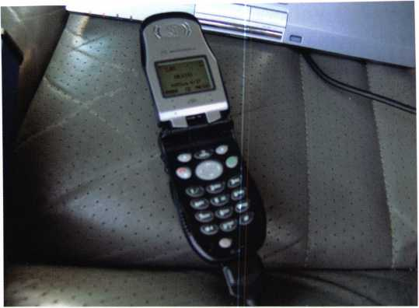

1. The Nextel Dial-Up Service is an economical wireless web solu­tion for gaining access to all the automobile manufacturer’s Pass- Through software.

Although this author did not test programming with the Packetstream Gold package, our tests with the Total Connection and Dial-Up Connection packages offered by Nextel served fine for working with the Ford Module Programming software.

The driver loaded without incident. However, the driver is only a driver, allowing the computer to communicate to the device, and does not include a user interface for viewing or operating the device. Instead, the software provided by the O.E. Manufacturer provides the interface or screen and menus for programming the vehicle.

To test the connection prior to subscribing and obtaining the O.E. Manufacturer software, a test program is provided from Drew Technologies. After loading the driver, simply connect one side of the CarDAQ2534 to your computer and the other side to the vehicle. Then run the test program to verify proper communication between the vehicle and the CarDAQ2534.

This writer took advantage of the Ethernet cable for con­necting to the laptop. Combined with the XP operating system, the CarDAQ2534 was quickly identified and com­munication with the vehicle began seamlessly.

Ford’s Motorcraft Module Programming Subscription

CarDAQ2534 Device

The CarDAQ2534 is provided with both serial and Ethernet cables for connecting to your computer. A sepa­rate OBDII Data Link Cable must be purchased for con­necting the device to the vehicle. The drivers and test pro­gram are also provided, but can be downloaded as well.

(See photograph 6.)

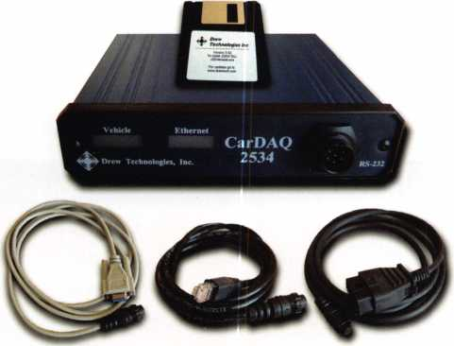

1. The CarDAQ2534 Pass-Through device includes the cables and software necessary for connecting to a computer. The OBDII cable is available but purchased separately.



Motorcraft® Home Technical Resources Home

Online Sales

Single VthicU/Singl* Model Y»«r

Single Vehicle/Multiple Model Yeer* ;

All Vehklej/AII Model Vein

Technicil Service Bulletins Vehicle Specific Information Diagnostics

Ford Module Programming Technical Training Body Repair Manuals

My Shopping Cart

Ford Module Programming

Download software necessary to program electronic modules to the latest calibration lev and perform PATS functions on Ford, Lincoln and Mercury vehicles.

Note: An SAE J2534 pass-thru device is required and is not included with the subscription.

|  |  |  |  |  |
| --- | --- | --- | --- | --- |
|  | Short Term v  Month  Year |  | |  |
| Ford Module Programming (short term)  Stock f FCS-WEBFLASH-V1-D | | | $24.95 | Add to C*rt | Checkout ► | |

Privacy ■ Return Policy ■ Contact Us . Halo ■ Terms and Conditions

1. The final step is subscribing to Motorcraft’s Ford Module

Programming and downloading and installing the Ford software.

The final piece to this puzzle is the Pass-Thru software pro­vided by the automobile manufacturer. This is the software that allows the technician to actually program and service the vehicle.

The biggest advantage in using the web-based Pass-Thru is the software is written by the O.E. Manufacturer and is always up to date. In essence, a technician should run into very few glitches when programming a vehicle, including the new CAN-equipped models.



Keynotes • July/August 2004

The Ford software, although limited from a diagnostic per­spective, offers the entire key programming capabilities of all the other O.E. tools, including the Unlimited Key Programming functions that are part of the later model Fords. The current subscriptions offered for this service are $24.95 f°r one day, $59.95 per month, or $599.95 per year. (See illustration 7.)

Of course, the subscription chosen is dependant on the eco­nomics of your business. Once payment has been accepted, it is necessary to download and install the Ford Module Programming software. Due to the size of this file, however, a high-speed internet connection is recommended for down­load. Once installed, the program does not need to be down­loaded or installed again. Other software downloads are avail­able for those technicians performing module calibration.

This is not necessary for the key programming functions.

Although installing and using the software is a bit quirky (and will be covered more thoroughly in a later article), this writer successfully programmed all Ford vehicles without incident. This includes several of the newer CAN-equipped models. All programming features were available, including (see photograph 8):

IGNITION KEY CODE PROGRAM IGNITION KEY CODE ERASE SPARE KEY SWITCH ENABLE SPARE KEY SWITCH DISABLE PARAMETER RESET SET UNLIMITED TRANSPONDER UNLIMITED TRANSPONDER ENABLE UNLIMITED TRANSPONDER DISABLE

**3 <http://buy.motorcraftservice1.com/pro_det2.asp?group=grp7&title=Ford> Module Programming&term=Sh Microsoft fnt**

File Edit View Favorites Tools Help

©Back * Q Q [

P Search ^Favorites Media ^ i ’ □ 4 0

**Motorcraft® Home**

Technical Resources Ford Module Programming

Home Warn

All V»hlcl«*/AII Modtl V««r«

Technic*! Service

Technic*! Tnining

Body R*p*ir Manuals

j **My Shopping Cart**

Download software necessary to program electronic modules to the latest calibration lev and perform PATS functions on Ford, Lincoln and Mercury vehicles.

Note: An SAE J2S34 pass-thru device is required and is not included with the subscription.

Ford Module Programming

Ford Module Programming (short term)

Stock # FCS-WEBFLASH-V1-D

**Privacy** • **Return Policy** • **Contact Us** ■ Help • **Terms and Conditions**

8. All key programming functions available to the chosen vehicle are available to the technician. Because this vehicle does not include the Unlimited Transponder Key option, those functions are not included in the menu.

In our future articles on Pass-Thru programming we’ll demonstrate in more detail the setup and use of the CarDAQ2534 and the Ford Motorcraft Module Programming software for programming keys into a Ford vehicle.

Tom Seroogy is currently running independent field-testing on the CarDAQ2534, methods of wireless web access, and Pass-Through options from various automobile manufactur­ers. For more information on the CarDAQ2534 or Motorcraft Ford Module Program subscription contact Tom Seroogy at [tgseroogy@hotmail.com](mailto:tgseroogy@hotmail.com). To purchase the CarDAQ2534 contact Tom Seroogy at [tgseroogy@hotmail.com](mailto:tgseroogy@hotmail.com).

*anil* NASCAR

Lockmasters' PUREAuto  
Automotive Weekends  
is proud to add a  
NASCAR Race Package  
to our October Pit Stop  
this year.

2004 Pit Stops

May 22-2f- Buffalo, NY  
Oct. 1-3 - Talladega, AL  
Nov. 6-7 - Las Vegas, NV

Learn From The  
Industry Experts

Track 1 - Domestic Automotive  
Track 2 - Import Automotive  
Track 3 - High Security Automotive  
Track 4 - Automotive Transponders  
Track 5 - Key Generation  
Track 6 - Mechanical Safe Lock  
Track 7 - Electronic Safe Lock

Check out pureauto.com for  
complete track info & a  
registration form. Register  
early for discounts and assure  
your seat before they sell out.

800.654.0637

pureauto.com

Keynotes • July/August 2004

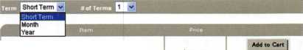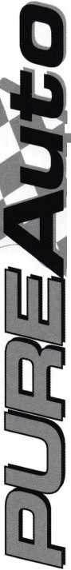

Two years ago, in the November 2002 issue of Keynotes, I went over the then brand new Kaba Mas X-09. Since that time, I’ve installed many, opened dozens with a deadblow hammer and a couple with a drill. The X-09 is currently the only lock approved under FFL2740, a government specifica­tion for storing classified materials. The X-09 and its prede­cessors (the X-07 and X-08) have provided a good source of income for those safe technicians lucky enough to perform work for the government. Let’s take a look at how this lock has performed, look at opening techniques and contrast it with the X-07 and X-08 in a few areas.

First, let’s look at some of the problems I’ve encountered.

The most common problem seen with this lock is the motor. Shortly after I wrote the first article, Kaba Mas had a silent recall of the motor. The problem was the lock; after dialing, the combination would display the “OP,” indicating open with the right arrow. Turning the dial right, however, would not open the lock. The problem? The motor would not “fire,” or engage. Fortunately, the solution was easy: a soft face dead-

blow hammer beating on the face of the door would jar the motor into operating. I’ve even had a customer use her shoe to get the safe to open until I could replace the motor. Kaba Mas replaced the motors, adding a blue or green dot to both the motor’s mounting plates and the lock cases to indicate the new style motor. This seems to have solved the problem with the motor, although I recently had to replace the motor in a new lock.

The next problem I’ve seen with the lock is the cam pawl lock. It was added to the lock body to provide a method of holding the drive cam as the nut was turned. This was needed because of the clutch mechanism inside the dial. Holding the dial and turning the cam nut to disassemble the lock would often result in the clutch slipping instead of the nut coming loose. The cam pawl lock has since been removed from the locks leaving the factory. Kaba Mas also recommends remov­ing the cam pawl locks from locks in the field. The problem is the floating nature of the cam pawl lock. If the X-09 is unlocked and the container is jarred enough, the cam pawl

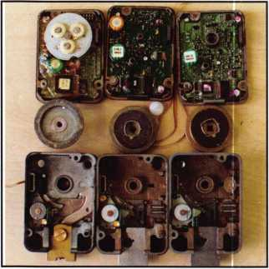

Photo 1: Here are the 3 versions side by side. On the left is an X-07, middle X-08 and on the right is an X-09. The X-08 and X-09 look very similar with the X-08 having an additional super capacitor and little different gear and rack. The addi­tional super capacitor, according to Joe Cortie is why the X-08 requires so many turns to power up.

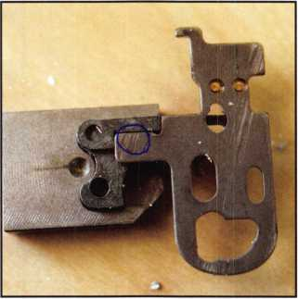

Photo 2: This is the area of the slide to be drilled. It is out of the lock and you can see how the slide blocks the rack from moving. The parts are obviously removed from the lock, on the job you will only be able to see through the hole you drilled.

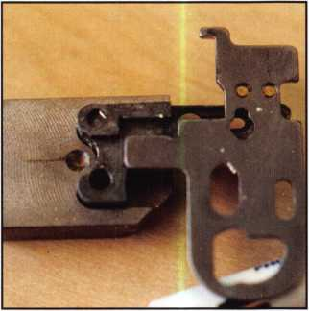

Photo 3: This how the inside of the slide and rack should look after you move the slide over. Remember the slide is spring loaded so you need to hold it in position as you then move the rack towards the drive cam.

Revisiting the Kaba Mas X-09

By Greg Perry, CML, CPS



Keynotes • July/August 2004

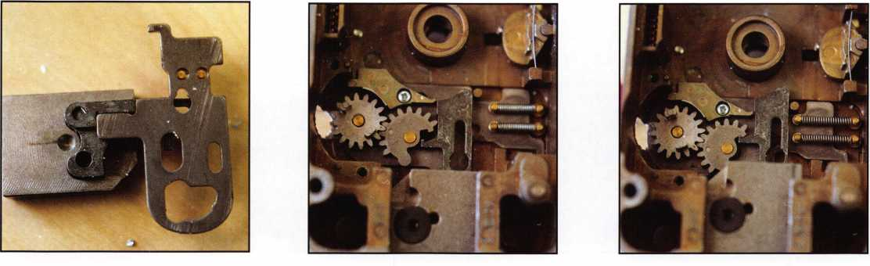

Photo 4: This is how the rack and slide should look when the lock is open.

Photo 5: This is the view from the back­side of the rack and gear in the normal locked position.

Photo 6: Here the rack is slid up and the hook on the rack is being caught by the gear hook preventing further retraction without breaking the hook. Use a sharp awl to pry the rack and break the hook.

lock can engage, preventing the dial from turning. The best solution is to remove the cam pawl lock before having a problem. If you should still find one with the cam pawl lock in place and locked into the drive cam, you may be able to rock it loose, or you may need to drill the LOBC pin and remove the back cover to free it. How do you remove the cam nut without the cam pawl lock? Easy; IVe used three different methods. First, the dial clutch may provide enough holding power to allow the nut be unscrewed. Second, hold the drive cam with your fingers. Third, the factory-recom­mended method is to turn the drive cam until you see the gear teeth on the underside, and use a Philips screwdriver wedged between the lock case and drive cam to hold it.

Bolt end pressure can be a problem; in some cases, it may prevent bolt retraction if the force exceeds the dial clutch. This is generally an external problem from the lock, although it translates in to an internal problem. The best solution is to relieve the source of bolt end pressure. If your efforts to relieve the external problem fail, then the dial needs to be pulled to provide turning pressure without the clutch.

The next two problems seen are similar in their solution.

First is catastrophic lock failure; the second is catastrophic memory failure, or in others words, lost or forgotten combi­nation (meaning drill time). This author knows only two drill points for the X-09. First is to drill for the slide. It is located on a couple of plates created for the StrongArm Mini-Rig. It is located 1 O inches toward the lock bolt, then 1 inch CW, or to the left on a VD lock. The other plate from StrongArm was originally designed for the X-08 lock. It was designed for us with an opening tool from Kaba Mas. The hole location on this plate is 1 inch to the right, or CCW. If you own this

plate, simply turn it over to place the hole at the correct location for the X-09.

This location works for both the X-08 and the X-09. Care must be taken to not go too deep after entering the lock case. I use an end mill or one of the flat-milled drill bits from Northwest Safe and Vault to enter the lock case. Next, on the X-08, simply move the slide over to reach the rack and retract the bolt by prying with a probe. The X-09 requires the same step, with the addition of breaking the hook on the gear or rack to retract the bolt. This is destructive, but the “easiest” location to drill an X-09. The other location is the same for three X-o series locks. I hinted at it my original article. The location is the stepper motor gear. It is a little more advanced or tricky to drill at this location. The meas­urement, I believe first published by Joe Cortie, CML,

CMST, is 15/16 inch toward the bolt, then 1 3/16 inches CCW, or to the right on a VD-mounted lock. Drilling into the lock case requires great care, since drilling too deep will require you to abandon this hole and drill for the slide. After your hole is into the lock case, use a T-30 Torx driver to push the gear toward the back of the lock. Next, turn it slightly to engage the motor gear with the drive cam to retract the lock bolt. Use care as you turn the dial since the drive cam may pick up at the wrong location. If this happens, extend the bolt and move the dial to a different starting location.

The X-09 has a few variations in the software from both the X-07 and the X-08 in the penalty mode. The X-07 locked you out, our stops displaying numbers after 10 wrong attempts for a period of two minutes. You could then try 10 more combinations before being placed in penalty mode again for two minutes. The X-08, after 15 wrong combina-

Keynotes • July/August 2004

**5**

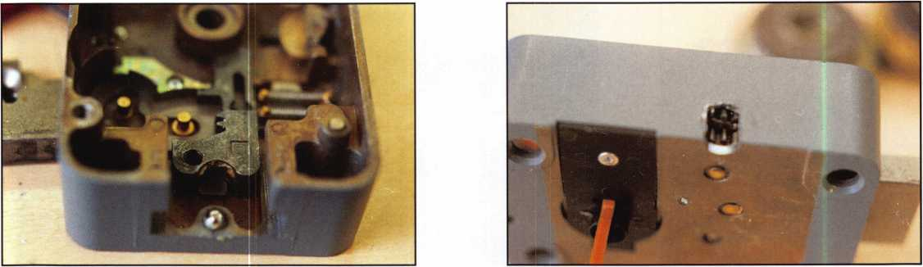

Photo 7: The lock bolt is removed and you can see the slide Photo 8: This is the location to drill for the motor gear. I personally

beneath the rack. have only drilled in this location in my shop with the lock out of the

container. Although it is doable I don’t like the flex in the motor shield and prefer the more sure location of the slide.

tions, would go into “SA” mode. This means that the reset combination needs to be dialed, then the correct combina­tion or the correct combination five times in a row without the lock powering down. The moment the lightening bolt is displayed, turn back to the left and dial the combination again. After it is open, the lockout or “SA” condition still needs to be reset. After io wrong combinations, the X-09 requires three minutes of continuous power to the display before the correct combination may be entered to open the lock. This continues to be the case for combination tries number 11 through 14. After 15 incorrect combination tries, the time increases to four minutes of continuous power up before the lock will accept the correct combination and open. This means if you power the lock for two minutes and stop letting the lock power down even for several hours, or even days, one or two additional minutes of power must be

provided to the lock before it will allow the correct combina­tion to open the lock.

Overall, the Kaba Mas X-09 is a great improvement over the X-08. With the exception of the motor problem, the lock seems to be holding up well. Out of a few hundred, I’ve seen only a couple of lock failures and one dialing problem I believe was caused by the customer. (They claimed the com­bination was being entered properly but it logged 25 failed attempts before I got there.) After keeping the lock powered without trying to enter the combination, the customer tried the combination and it opened. They wanted the lock replaced on the chance it was a lock problem.

Working next to a Navy base has provided me with an oppor­tunity to work on all of the X-o locks. The X-09, with the

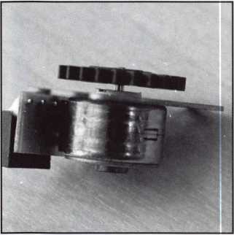

Photo 9: This is the motor in the relaxed state. It locks into a piece in the lock body to prevent it from turning.

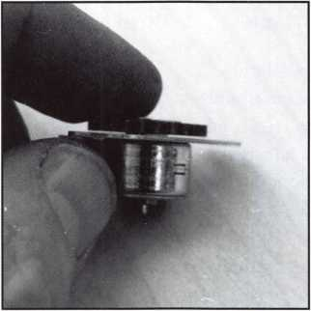

Photo 10: Once power is applied to the motor the shaft of the motor moves towards the back of the lock allowing it to turn. Drilling for the motor gears requires you to push against this gear prior to being able to start it turning.

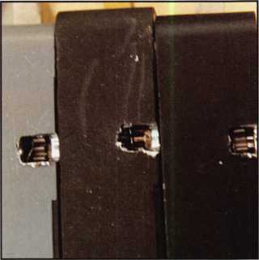

Photo 11: Here are the 3 different locks stacked next to each other. This time the X-07 is on the right and X-09 is on the left with the X-08 in the middle. This shows the drill location is the same for the motor gear on all 3 locks.

Keynotes • July/August 2004

Photo 12: This is a close up of an X-07 lock drilled at the motor gear location. Because the gear does not move in and out it’s a little easier to drill through the motor shield.

Photo 13: This shows a new shield over the drilled hole. Because it is stainless steel and the motor gear is plastic it is tough to get the right amount force to cut through the shield without damaging the gear.

exception of the (fixable) motor problem seems to be the best of the trio. If you work, on or anticipate working on these locks, read all you can, and invest in the certification classes available from Kaba Mas at the ALOA, SAVTA or regional conventions. You can also take classes from Lockmasters or MBA. MBA also offers a new book written

by Joe Cortie, CMST, titled “Things I Know About The X- 07, X-08 and X-09.” It’s an excellent source of information in a single location; Joe formally worked for Kaba Mas and outside the factory is probably the world’s foremost expert on X-o locks. Until next time, have a great show. Hope to see you in Baltimore!

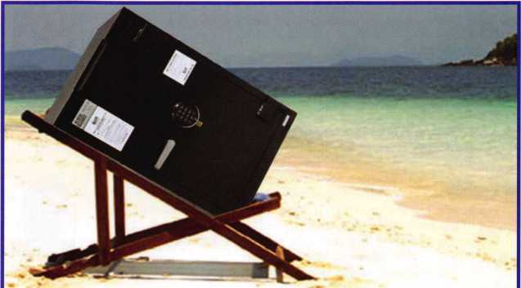

The

f-faujaiicm Oea£

You ga/e *ua* you/r  
*Aafe* o/tde/r of 43000**  
o/r luo/te cmd use *Ae$*d*you and a f/rieud~tb

£/await!

**Limited offer for safe resellers only!  
Call for or log on to [www.safe-help.com](http://www.safe-help.com)

for more details.

*SZafe ou~tUe BeacU*

S!ee *ua* oTtoe 2004 ALOA Boottk*t2t4

CORPORATE SAFE

**SPECIALISTS** Learn more bv calling 800.342.3033 ext. 200

Offer Expires 12/1/04

**[www.safe-help.com](http://www.safe-help.com)**



Keynotes • July/August 2004

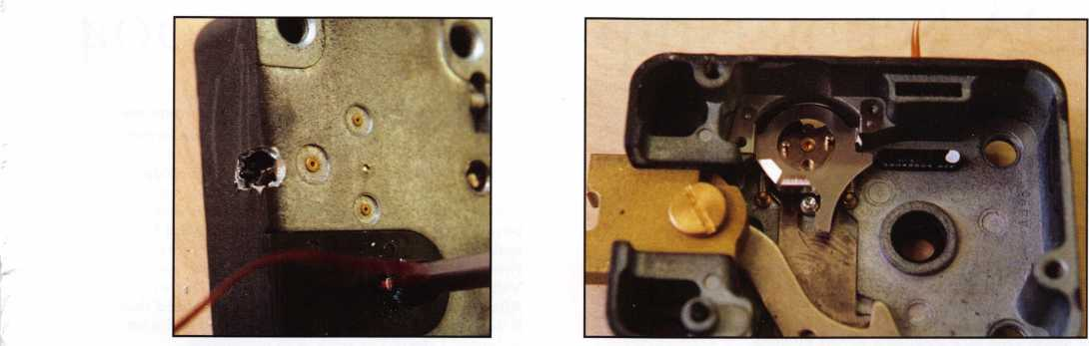

ALOA Scholarship Recipients 2004

Glen V. Armstrong I am an apprentice

■

locksmith at Colorado State Safe and Lock, in

Colorado Springs, CO. I have been in the locksmith trade for three months and find it very interesting. I would love to expand my knowledge in this field and plan on making it my future career. This con­vention would be a great opportunity for me.

Samuel Barba I am excited about applying for the ALOA Convention and Security Expo 2004 scholarship. I have been working at the University of Santa Cruz lock shop as a Senior Building Maintenance Worker since January 16, 2000. I assist the locksmiths in making keys and other tasks. I also do the preventive maintenance on campus and I've learned a lot about hardware. I enjoy working at the lock shop; and I've learned a lot about the trade. However, I lack training that is necessary for me to advance in the field. In addi­tion to working at the lock shop, I attended two classes last summer in Reno, Nevada for Clark Security Products. I also took two classes with Ingersoll-Rand for servicing Schlage D cylindrical and Schlage mortise L locks. Last year I joined California Locksmiths Association and attended a Basic Simplex lock servicing class. I am currently taking the Foley-Belsaw Professional Locksmith cor­respondence course. I joined the Associated Locksmiths of America and also attended a class offered by Ingersoll-Rand covering Von Duprin exit devices. Although I'm making a living as a Senior Building Maintenance Worker, my salary doesn't enable me to afford the additional training that will **jM** allow me to further my career. I've devoted many A ~ In hours in training and research to attain more knowl- **>1** edge of the trade. And I'm enthusiastic about this opportunity to continue to grow and expand my

John Campbell In 2003 I had to change my



occupation due to a shortage of work in my former  
career. My employer was experiencing reductions  
in work orders and was forced to lay off employ-  
ees. My older brother was in the locksmith profes-  
sion and he encouraged me to take classes and  
become a locksmith. At my brother's direction I  
looked for classes in my area for several years.  
Finally, a week long course was offered at Fox  
Valley Technical College, so I enrolled in the class.  
After I completed the week-long class I realized that  
it was only an introduction and there was still a lot  
to learn. I started to work with my brother.  
Unfortunately, two months later he passed away at  
the age of 57. Now I am learning alone. I attended  
last year's convention. However, I could not afford  
many classes. I was grateful to learn that there  
were scholarships available to take more classes.  
The convention was very helpful. Having current  
locksmiths willing to answer my questions was  
priceless. I have been a member of ALOA since I  
graduated from the locksmith program at Fox Valley  
Technical College in the spring of 2003. Thank you  
for allowing me to apply for this scholarship and for  
your consideration in this matter.

Rich Gonyo I am applying for this scholarship

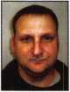

because I feel that the locksmith trade has greatly  
helped me in my field of expertise. I am a subcon-  
tractor in a health care facility. Everyday I work on  
doors and locks, either repairing or installing them. I  
have taken a few classes including Basic  
Locksmithing, Lock Picking, Impressioning and certi-  
fication classes for Con Duprin and Adams Rite. I  
really love every part of the locksmithing trade and  
would like to expand my knowledge in all aspects  
of the field. I feel ALOA 2004 is a great opportunity  
to learn and benefit my future.

Tyler Blanks I have been active in lock­



smithing for almost three years now. Currently I am working at Tri-City Security Inc. in Ft. Collins, Colorado. There is a lot out there that I've been striving to learn in this industry and it isn't always easy. Around here you can only learn what you see, which is quite a lot. However, I am not always able to retain information because I am so busy moving to the next job. I have attended conferences in the past but ever since I started locksmithing. I've wanted to go to the convention to learn and meet others in the industry. With a scholarship in hand I will find a way to get to Baltimore and make the best of the opportunity.

Ron Gunter I have been in the locksmithing



business since 1980 (24 years). During this time I have had the opportunity to attend several local locksmith conventions which have always been ben­eficial. However, the fact that I live in Canada with it's unfavorable exchange rate on the dollar, makes it very difficult to attend the ALOA Convention and Security Expo. I am a career locksmith/safe tech who has always had a great desire to attend an ALOA convention to increase my knowledge and ability in my profession. Thank you for your consideration.

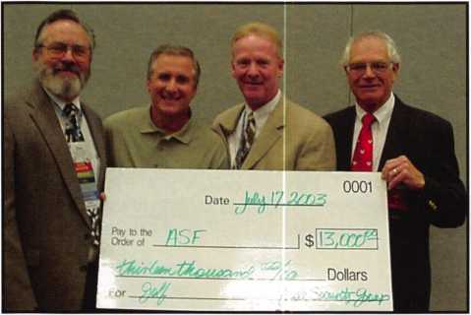

The ALOA Scholarship Foundation is an independent 501(c)(3) educational, tax  
exempt corporation established in 1993 to encourage and provide for educational servic-  
es, programs and materials concerning locksmithing and security devices and procedures;  
develop scholarship and assistance programs for persons interested in pursuing a career  
in the security and locksmithing field; to provide and to receive funds in implement the  
purposes of the Foundation; and to perform and do any and all such other acts as are nec-  
essary, convenient and proper for the attainment of these objectives.

We invite and encourage you to join the effort to provide funds for education and  
training of locksmiths to help secure our future. For more information, to make a fully  
tax-deductible contribution, or to volunteer your ideas and talents, please contact us at  
through our headquarters at: ALOA Scholarship Foundation, 3003 Live Oak St, Dallas  
TX 75204 or phone us (800) 532-2562. Your support of education, training and develop-  
ment of locksmiths can provide security for our future.

ALOA Scholarship Recipients 2004

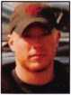

Mike Krueger I am applying for this scholar­ship to extend my knowledge in the field of lock- smithing. By doing so, I will be able to provide more services to the community and be more confi­dent with my job. I would also like to gain as much knowledge as possible so I may one day take over the business when the current owner retires. I worked as a locksmith part-time for the summer while attending college and eventually began work­ing full-time. I have now been a locksmith for close to two years. I enjoy my job because of the hands- on work and the problem solving that is involved. What I enjoy most is waking up in the morning and actually wanting to go to work. Thank you very much for considering my acceptance.



Patricia Lee I am a 35-year-old Hispanic woman. I never imagined how exciting Locksmithing could be as a career until I married a locksmith. I watched my husband as he opened and repaired locks and enjoyed seeing the rewards of a job well done. I began to help in the business and eventually decided that a career in locksmithing was for me. This scholarship will help me broaden my horizons as a locksmith and help me to better serve my cus­tomers. Being bilingual, I can offer services to the Hispanic community in the Phoenix area.



William Lee I have spent the past 27 years in the security field. For most of this time, I have been an ALOA member. For the past 5 years, I have been a member of the ALOA President's Club. For the past 10 years, I have worked at A.S.L. Security in Phoenix, Arizona. My specialty is safes, autos and electronics. Also, for the past 6 years, I have served as an instructor at the Arizona School of Locksmithing. This year, I would like to focus on Forensic Locksmithing. As an ALOA member, I know that taking ACE classes at ALOA 2004 is the first step in the right direction for meeting my goals.

^ Alan Paredes I am presently a part-time lock-

smith agent in Tagumpay, Rizal, Phillipines. In view of my desire to make locksmithing my career, I am sig- **WL** 3 nifying my interest in attending ALOA 2004. Should ■plpIS my training and experience merit the award of a 1 scholarship, I would be grateful and appreciative.

Carol Peterson I am applying for this schol­



arship because I recently have been given the oppor­tunity to re-enter the locksmithing field. I am work­ing part-time at a locksmith shop and also part-time as a pharmacy technician. I would rather do lock­smithing full time but I don't have enough knowl­edge. I am unable to pay my own way and hotel expenses as I am getting divorced and supporting my one year old daughter alone. With the knowl­edge I gain through this scholarship I will be able to take on more of the jobs and responsibilities required to be productive in this field. I enjoy help­ing people with their security needs. I want a career in locksmithing. Thank you for your consideration.

Louis Phillips I have been a member of ALOA



since 2000. I started my locksmithing business in 1999 and specialize in automobile locks. My hope was to support my wife in her wish to stay at home with our children. However, due to the sagging economy and limited earnings, my business income has decreased. I am interested in learning other aspects of locksmithing. The articles in Keynotes magazine have encouraged me to continue my edu­cation so my skills will grow and the business will flourish. After attending the ALOA convention in 2001, I found that the ALOA show is absolutely the best way for me to acquire the knowledge I need. Being away from home allows me to focus my ener­gy on the lessons and studies. I also benefitted greatly from making contacts and meeting others who can offer knowledge and advice. Thank you for considering me for the scholarship. I will do my best to prove that the funds were well invested.

Kristie Szarmach I am new in the area of



locksmithing and was first introduced to it by a good friend, Ed Woods. I am currently a Senior in high school, but will graduate from the Indiana Academy, a residential gifted and talented high school on the campus of Ball State University, this May. Though I do not have much experience in locksmithing, I wish to apply for this scholarship to broaden my knowl­edge of locks and master-key systems. As I will be entering college this upcoming fall I wish to have obtained enough understanding of locks to secure a job in the lock shop of my campus. I completed a two week apprenticeship last May with Ed Woods which increased my interest. If granted the opportu­nity to attend your classes at the 2004 convention I would like to learn more of master-key systems and experience what a convention is like. Thank you for your time and consideration.



|  |  |  |
| --- | --- | --- |
| AM- -I! | ass | o c i a t e |
| k> M Ti t | m e | mbers |

Distributor

**1 st In Hardware, Inc.**

Phone: 866-397-9900 Fax: 866-646-0045 www. 1 stinhardware.com

**ADI Inc.**

Phone: 631-692-1000 Fax: 631-692-3011

**Accredited Lock Supply Co.**

Phone: 800-652-2835 Fax: 201-865-0030 [www.acclock.com](http://www.acclock.com)

**Ace Lock & Security Supply**

Phone: 800-223-5625 Fax: 908-688-2442 [www.acelock.com](http://www.acelock.com)

**Andrews Wholesale Lock Supply**

Phone: 717-272-7422 Fax: 717-274-8659 [www.andrewslock.com](http://www.andrewslock.com)

**Boyle & Chase Inc.**

Phone: 800-325-2530 Fax: 800-205-3500 [www.boyleandchase.com](http://www.boyleandchase.com)

**Chinrose International**

Phone: 503-357-7553 Fax: 503-357-5522 [www.chinrose.com](http://www.chinrose.com)

**Clark Security Products**

Phone: 888-784-1311 Fax: 619-718-7333 [www.clarksecurity.com](http://www.clarksecurity.com)

**Cook's Building Specialties**

Phone: 505-883-5701 Fax: 505-883-5704

**Dire's Lock & Key Company**

Phone: 303-294-0176 Fax: 303-294-0198

**Direct Security Supply, Inc.**

Phone: 800-252-5757 Fax: 800-452-8600

**Discount Key Machines.Com/Busch**

Phone: 800-332-8724 Fax: 407-363-4666

**Doyle Security Products**

Phone: 800-333-6953 Fax: 612-521-0166 [www.doylesecurity.com](http://www.doylesecurity.com)

**Dugmore and Duncan, Inc.**

Phone: 888-384-6673 Fax: 888-329-3846

**E. L. Reinhardt Co., Inc.**

Phone: 800-328-1311 Fax: 651-481-0166 [www.elreinhardt.com](http://www.elreinhardt.com)

**Ewert Wholesale Hardware**

Phone: 800-451-0200 Fax: 708-597-0881

**Fairway Supply, Inc.**

Phone: 214-350-0021 Fax: 214-352-4299 [www.fairwaysupply.com](http://www.fairwaysupply.com)

**Foley-Belsaw Company**

Phone: 800-821-3452 Fax: 816-483-5010 [www.foley-belsaw.com](http://www.foley-belsaw.com)

**Fried Brothers Inc.**

Phone: 800-523-2924 Fax: 215-592-1255 [www.fbisecurity.com](http://www.fbisecurity.com)

**Hans iohnsen Company**

Phone: 214-879-1550 Fax: 214-879-1530 [www.hjc.com](http://www.hjc.com)

**Hardware Agencies, Ltd.**

Phone: 416-462-1921 [www.hardwareagencies.com](http://www.hardwareagencies.com)

**IDN Incorporated**

Phone: 817-421-5470 Fax: 817-421-5468 [www.idn-inc.com](http://www.idn-inc.com)

**Intermountain Lock & Supply**

Phone: 800-453-5386 Fax: 801-485-7205 [www.intermountainlock.com](http://www.intermountainlock.com)

**Jo Van Distributors**

Phone: 416-752-2238 Fax: 416-752-7282 [www.jovanlock.com](http://www.jovanlock.com)

**Lockmasters, Inc.**

Phone: 859-885-6041 Fax: 859-885-7093 [www.lockmasters.com](http://www.lockmasters.com)

**Locks Company**

Phone: 800-288-0801 Fax: 305-949-3619

**Locksmith Ledger International**

Phone: 770-886-0800 Fax: 770-889-7703 [www.lledger.com](http://www.lledger.com)

**M. Zion Company**

Phone: 212-349-8677 Fax: 212-964-0495 [www.mzion.com](http://www.mzion.com)

**McDonald Dash Locksmith Supply**

Phone: 800-238-7541 Fax: 901-366-0005 [www.mcdonalddash.com](http://www.mcdonalddash.com)

**Monaco Lock Co.**

Phone: 800-526-6094 Fax: 800-845-5625 [www.monacolock.com](http://www.monacolock.com)

**Omaha Wholesale Hardware**

Phone: 800-238-4566 Fax: 402-444-1664 [www.omahawh.com](http://www.omahawh.com)

**RA-Lock Company**

Phone: 972-775-6301 Fax: 972-775-6316 [www.ralock.com](http://www.ralock.com)

**Security House**

Phone: 905-669-5300 Fax: 905-660-6313 [www.securityhouselock.com](http://www.securityhouselock.com)

**Security Lock Distributors**

Phone: 800-847-5625

Fax: 800-878-6400

[www.securitylockdistributors.com](http://www.securitylockdistributors.com)

**Southern Lock and Supply Co.**

Phone: 727-541-5536 Fax: 727-544-8278 [www.southernlock.com](http://www.southernlock.com)

**Stone & Berg Wholesale**

Phone: 800-225-7405 Fax: 800-535-5625

**The Locksmith Store Inc.**

Phone: 847-364-5111 Fax: 847-364-5125 [www.locksmithstore.com](http://www.locksmithstore.com)

**Timemaster Inc.**

Phone: 859-259-1878 Fax: 859-255-0298 [www.time-master.com](http://www.time-master.com)

**Top Notch Distributors, Inc.**

Phone: 800-233-4210 Fax: 800-854-4146 [www.topnotch.bz](http://www.topnotch.bz)

**Turn 10 Wholesale**

Phone: 800-848-9790 Fax: 800-391-4553

**U.S. Lock Corp.**

Phone: 800-925-5000 Fax: 800-338-5625 [www.uslock.com](http://www.uslock.com)

**A & B Safe Corporation**

Phone: 800-253-1267 Fax: 856-863-1208 [www.a-bsafecorp.com](http://www.a-bsafecorp.com)

**ABUS Lock Company**

Phone: 800-352-2287 Fax: 602-516-9934 [www.abus.com](http://www.abus.com)

**Adams Rite Mfg Company**

Phone: 800-872-3267 Fax: 800-232-7329 [www.adamsrite.com](http://www.adamsrite.com)

**Adesco Safe Mfg. Company**

Phone: 800-694-9340 Fax: 562-408-6427 [www.adesco.com](http://www.adesco.com)

**Adrian Steel Company**

Phone: 800-677-2726

Fax:517-265-5834

[www.adriansteel.com](http://www.adriansteel.com)

**All Five Tool Company, Inc.**

Phone: 860-583-1691 Fax: 860-583-4516 [www.all5tool.com](http://www.all5tool.com)

**American Lock Company**

Phone: 708-534-2000 Fax: 708-534-0531 [www.armericanlock.com](http://www.armericanlock.com)

**American Security Products**

Phone: 909-685-9680X1083 Fax: 909-685-9685 [www.amsecusa.com](http://www.amsecusa.com)

**Bianchi USA, Inc.**

Phone: 800-891-2118 Fax: 216-803-0202

**Buddy Products**

Phone: 800-886-8688 Fax: 312-733-8356 [www.buddyproducts.com](http://www.buddyproducts.com)

Manufacturer

g

**2**

Keynotes • July/August 2004

|  |  |  |  |  |
| --- | --- | --- | --- | --- |
|  | a s s o  mem | c i a t  b e r s | e |  |
| BWD Lockcraft | HPC, Inc. | Lucky Line Products, Inc. |  | Security Door Controls |
| 1612 Union Valley Road | Phone: 847-671-6280 | Phone: 858-549-6699 |  | Phone: 805-494-0622 |
| West Milford, NJ 07480 | Fax: 847-671-6343 | Fax: 858-549-3241 |  | Fax: 805-494-8861 |
| 973-728-3707 | [www.hpcworld.com](http://www.hpcworld.com) | [www.luckyline.com](http://www.luckyline.com) |  | [www.sdcsecurity.com](http://www.sdcsecurity.com) |
| CCL Security Products | HY-KO Products Co. | M.A.G. Security |  | Security Solutions |
| Phone: 800-733-8588 | Phone: 440-232-8223X3095 | Phone: 714-891-5100 |  | Phone: 405-376-1600 |
| Fax: 847-537-1800 | Fax: 440-232-8227 | Fax: 714-892-6845 |  | Fax: 405-376-6870 |
| COMPX Security Products | Hammerhead Industries, Inc. | [www.magsecurity.com](http://www.magsecurity.com) |  | [www.securitysolutions-usa.com](http://www.securitysolutions-usa.com) |
| Phone: 864-297-6655 | Phone: 805-658-9922 | MUL-T-LOCK USA, Inc. |  | Townsteel, Inc. |
| Fax: 864-297-9987 | Fax: 805-658-8833 | Phone: 800-562-3511 |  | Phone: 626-858-5080 |
| [www.nclnet.com](http://www.nclnet.com) | [www.gearkeeper.com](http://www.gearkeeper.com) | Fax: 973-778-4007 |  | Fax: 626-858-3393 |
| D&D Technologies (USA), Inc. | Ingersoll Rand SSA | [www.mul-t-lock.com](http://www.mul-t-lock.com) |  | [www.townsteel.com](http://www.townsteel.com) |
| Phone: 714-677-1300X292 | Phone: 317-613-8025 | Medeco Security Locks |  | Trine Access Technology |
| Fax: 714-677-1299 | Fax: 317-613-8068 | Phone: 540-380-5000 |  | Phone: 718-829-2332 |
| [www.ddtechusa.com](http://www.ddtechusa.com) | [www.schlagelock.com](http://www.schlagelock.com) | Fax: 540-380-5010 |  | Fax: 718-829-6405 |
| DETEX Corp. | Jet Hardware Mfg., Co. | [www.medeco.com](http://www.medeco.com) |  | [www.trineonline.com](http://www.trineonline.com) |
| Phone: 800-729-3839 | Phone: 718-257-9600 | ROFU International Corp. |  | Videx Inc. |
| Fax: 830-620-6711 | Fax: 718-257-0973 | Phone: 800-255-7638 |  | Phone: 541-758-0521 |
| [www.detex.com](http://www.detex.com) | [www.jetkeys.com](http://www.jetkeys.com) | Fax: 253-922-1728 |  | Fax: 541-752-5285 |
| DORMA Architectural Hardware | KABA ILCO Corp. | [www.rofu.com](http://www.rofu.com) |  | [www.videx.com](http://www.videx.com) |
| Phone: 717-336-3881 | Phone: 252-446-3321 | Rutherford Controls Int'l Co. |  | YSG Door Security Consultants, Inc. |
| Fax: 717-336-2106 | Fax: 252-446-4702 | Phone: 757-427-1230 |  | Phone: 800-438-1951 |
| [www.dorma-usa.com](http://www.dorma-usa.com) | [www.kaba-ilco.com](http://www.kaba-ilco.com) | Fax: 757-427-9549 |  | Fax: 800-338-0965 |
| Datakey Electronics | KEY-BAK/West Coast Chain Mfg. | [www.rutherfordcontrols.com](http://www.rutherfordcontrols.com) |  |  |

Phone: 952-746-4066X323 Fax: 866-289-4212 [www.datakeyelectronics.com](http://www.datakeyelectronics.com)

**Don-Jo Manufacturing, Inc.**

Phone: 978-422-3213 Fax: 978-422-3467 [www.don-jo.com](http://www.don-jo.com)

**Door Controls International**

Phone: 800-742-3634 Fax: 800-742-0410 [www.doorcontrols.com](http://www.doorcontrols.com)

**ESP Lock Products Inc.**

Phone: 800-434-8960 Fax: 978-562-9859

**FireKing Security Products**

Phone: 800-457-2424 Fax: 800-896-6606 [www.fkisecuritygroup.com](http://www.fkisecuritygroup.com)

**Framon Manufacturing Company Inc**

Phone: 989-354-5623 Fax: 989-354-4238 [www.framon.com](http://www.framon.com)

Phone: 909-923-7800 Fax: 909-923-0024 [www.keybak.com](http://www.keybak.com)

**Keri Systems Inc.**

Phone: 408-451-2520 Fax: 408-441-0309 [www.kerisys.com](http://www.kerisys.com)

**Knaack Manufacturing Co.**

Phone: 800-456-7865 Fax: 815-459-9097 [www.weatherguard.com](http://www.weatherguard.com)

**LAB Security**

Phone: 800-243-8242 Fax: 860-583-7838 [www.labpins.com](http://www.labpins.com)

**La Gard Inc.**

Phone: 310-325-5670 Fax: 310-325-5615 [www.lagard.com](http://www.lagard.com)

**Lock America, Inc.**

**Dba L.A.I. Group**

Phone: 714-373-2993 Fax: 714-373-2998 [www.laigroup.com](http://www.laigroup.com)

**STRATTEC Security Corp.**

Phone:414-247-3415

Fax:414-247-3692

[www.strattec.com](http://www.strattec.com)

**Sargent & Greenleaf, Inc.**

Phone: 800-826-7652X201 Fax: 859-885-3063 [www.sargentandgreenleaf.com](http://www.sargentandgreenleaf.com)

**Sargent Manufacturing Co.**

Phone: 800-727-5477 Fax: 888-863-5054 [www.sargentlock.com](http://www.sargentlock.com)

**Schwab Corp.**

Phone: 765-447-9470 Fax: 765-447-8278 [www.schwabcorp.com](http://www.schwabcorp.com)

**Securitron Magnalock Corp.**

Phone: 775-355-5625 Fax: 775-355-5636 [www.securitron.com](http://www.securitron.com)

Service

Organization

**Allstate Insurance Company**

Phone: 800-859-0247 Fax: 847-326-7509 [www.allstate.com](http://www.allstate.com)

**Cross Country Automotive Services**

Phone: 800-541-2262 Fax: 781-393-0256 [www.argosi.com](http://www.argosi.com)

**Massglass & Door Service**

Phone: 888-742-8837 Fax: 805-497-2255 [www.massglass.com](http://www.massglass.com)

**Webster Safe & Lock Co., Inc.**

Phone: 901-332-2911 Fax: 901-332-2878 [www.webstersinc.com](http://www.webstersinc.com)



Keynotes • July/August 2004

j

Britt, James L., RL Brust, Herman B, Jr, RL Dietzel, Edwin Dziuba, John, RL Gort, Harold Kenton, William C.

Love, James F Maty, Philip A Maffey, Constant 0, RL McGinnis, Arthur E Mdnerney, William D, RL, AHC, CPP Moncur, Roman G Nelson, Jay, RL Paradise, Roger J., RL Ricciuto, Ernest J Spenard, Don J, Sr, RL Stapel, Carl A, RL Stein, Herbert Sussina, SJ, RL Taylor, James L, RL Walters, George E

1957

Haney, Stanley C, CPL Kroll, Harry J.

Smith, Joseph T, Sr

1958

Buchanan, Lawrence P, RL Cooper, Charles M, RL Greenberg, William J., RL Jones, Edgar L, Jr, RL Leimbach, Fredrick P, RL Lockman, Richard M., RL McCown, Robert C., RL

Petrie, George A  
Pfeil, Edward A, CML  
Weberman, Louis, RL

Anmuth, Joseph S, RL Charm, Sam, RL Dobs, Donald G., RL Fish, Aaron Max McLaughlin, Tom E., RL Stiering, Walter H., RL Troy, Kenneth J, RL Veniero, Joseph A

1960

Dube, Joseph A, CML Malinowski, John R., CML Mangione, Gerard E Williams, David M, Sr

1961

Beggs, Raymond E., CML Freed, Robert W., RL Heaton, Warren G, RL McManus, John Merlin, Ramon F, RL Shaffer, Jerry C Sontag, Robert E., RL Thomas, Charles W., CML

1962

Ellis, Dan C, CPL Griffing, Timothy G., Jr, RL

LaGreco, Louis N, CPL

Ambrosi, Nick D., CPL Hatfield, Maurice W., RL McAfee, Alfred C, CML Meilan, Jerry, RL Miller, Arthur C, RL Miller, Walter L Minick, Thomas E., CPS Sass, Harvey W.

Trouland, George J., RL Wentz, Karl C, RL Winne, Gene S, RL Wolferseder, Milton F, RL

1964

Angelroth, Charles M., RL Berg, John H, RL Condil, James C.

Delphia, Edward J, RL Frey, George F Hersh, Yehuda M Jones, Ernest Phillips, Edwin L, RL Pinson, George Stelzer, Alan P.

1965

Anderson, Eugene R, RL, CPP, AHC

Crossman, Edward R, CRL Esthus, George I, RL Iffrig, George A.

Keefe, John N, RL Lascar, Walter W., RL Roseborough, Sandy D Schultz, William G.

Crider, Garvis E.

DeCosta, John, Jr, CML Fowler, Carl A, RL Gunkel, Patsy, RL Johnson, Stuart W.

Kotler, Edward, RL Leeper, David E., RL Mozisek, James, CML Skobrak, Charles E., Sr,

RL, CPS

Walter, John W, CPP Walters, Marion J, CRL

1967

Alessandrini, Lewis A, RL Barrett, Lawrence I, Sr, RL Cook, B W.

Cutler, Michael F, CML Fullmer, Richard E, Jr, CPL Hutchison, Ronald E. Jackson, John E, RL Killip, David J., CML Kline, Roger D., RL Knecht, Raymond P. Ralston, Larry B, RL Shandy, John L., CML Taormina, Paul C, RL Wasilenko, Walter R, RL Watkins, Arby R Weaver, Ronald W.

Wills, Harold J.

1968

Buck, Arlin E, RL Dedge, Arthur L, CRL DeSalvo, Nicholas, RL

Eigenbrod, Alan K., RL Kilgore, Jack W., RL Lewis, Keith R., CML McCoy, Robert A., RL Moxley, Reginald W., CPL Perkins, Merritt L., RL Schmitt, Ralph J, RL Tellerico, Frank W Townsend, Albert S., CML Ward, Norman F.

Wright, Leo F, RL

1969

Adams, Thomas A., CPL Anderson, Barry L Anthony, Cheryl R, RL Bares, Herbert R, RL Byer, Robert J.

Clifford, Starlin M., Jr, CML

Detzel, Robert A, RL Drake, John E, RL Ellman, Kenneth Golden, Paul S, RL Greenwood, Richard H., RL

Harmon, Clarence Karch, Michael S., CPL, CPP

Mester, George A., CPL Sanders, Elizabeth M., RL Sartain, John F, RL Tibbitts, Harold I., CML Vos, James J., CML

!■ :

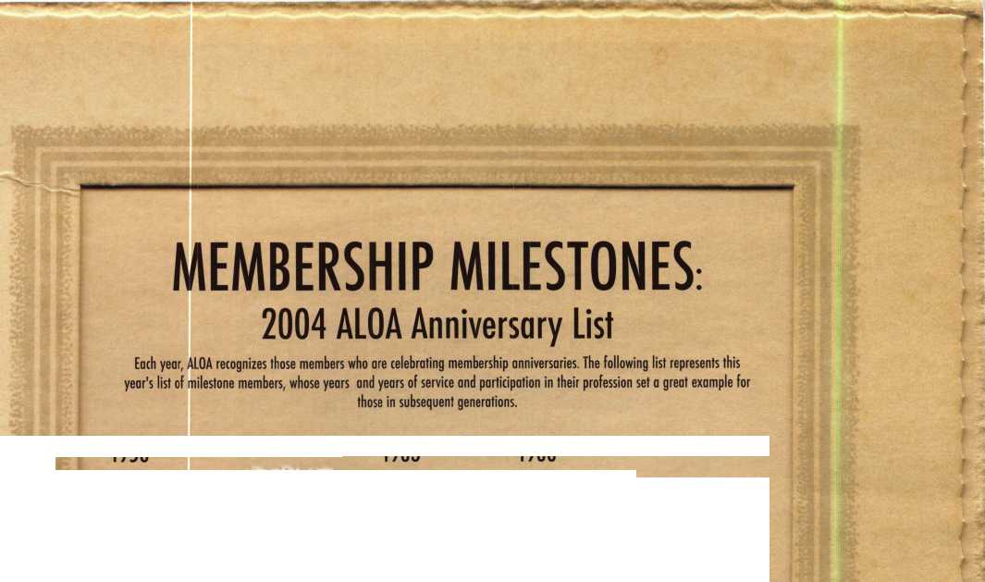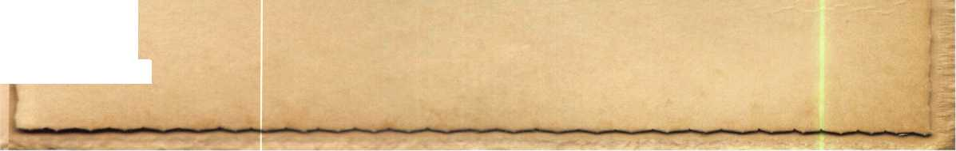

Get Ready for RLOR 2005 , a powerful resource to explore innouation and form industry alliances. This year we’ue thouyht of euerything from an exciting location, comfort­able accommodations and a conuention center that is equipped to handle your euery need.

Located just minutes from downtown  
Chicago, Rosemont, II. is the  
perfect “business uillage”, designed specifically  
to make your stay conuenient, comfortable  
and aboue all, successful!

The RLOR Conuention and Security Expo offers  
top-notch classes, workshops, networking  
opportunities and cutting-edge technology.

Rnd don’t miss out on the fine dining and enter-  
tainment options that Chicago has to offer. Shop  
at the world-famous Magnificent Mile. Eat at  
Morton’s of Chicago or Harry Carry’s Italian  
Restaurant. Uisit the Nauy Pier or catch a ball  
game. The options are endless when you register  
today for the single-most important euent in  
the locksmithing industry.

Baby, you knout you want to yo!

**The RLOfl**

**Conuention**

**and Security Expo July 17-24, 2005**

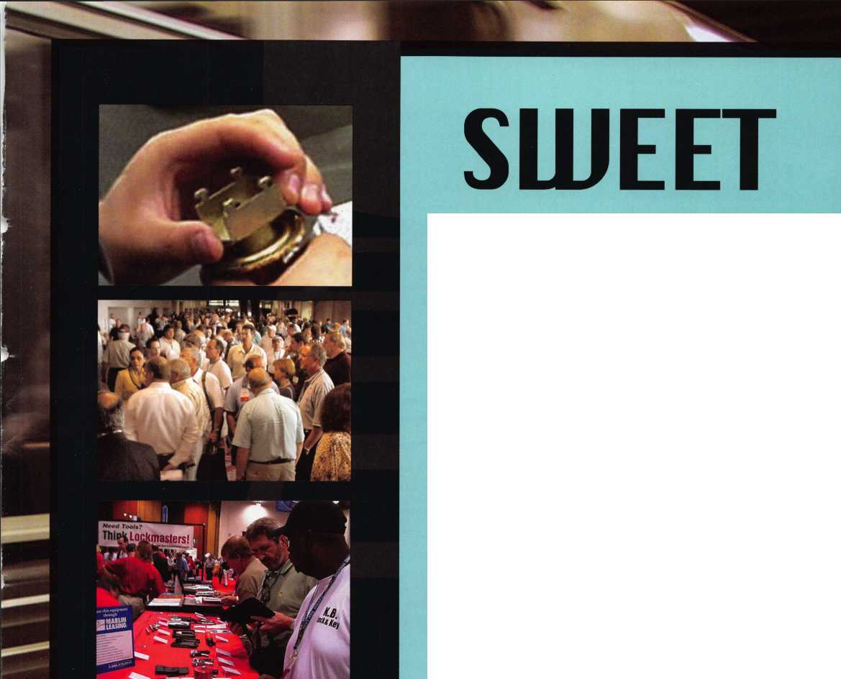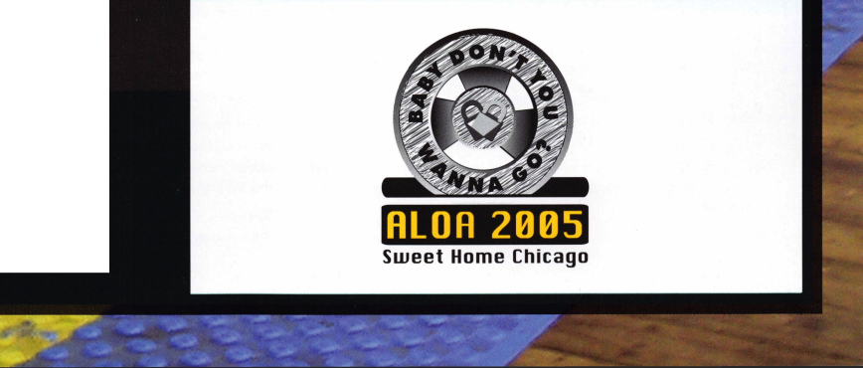

STATE OF THE ASSOCIATION

By Charles W. Gibson, Jr., CAE, Executive Director

The Governance Policy of ALOA requires  
that the Board of Directors establish "Ends"  
for the association. These Ends are the pur-  
pose of existence of ALOA. The staff then  
determines and carries out the "Means" of  
achieving these Ends. The Board has directed  
me to report to the membership concerning  
the Means.

The Board has established five Ends. These  
Ends are described in detail in the Governance  
Policy. The Policy is available on line at  
**[www.aloa.org](http://www.aloa.org)**. You can request a copy by

calling the ALOA office at (800) 532-2562. Copies will also be available at  
convention at the ALOA booth. I have listed the Ends in the order of priority  
established by the Board, then listed some of the Means used in 2003 to  
accomplish the Ends.

END 1 - LEGISLATION - A positive legislative environment for ALOA members.

ALOA effectively represented members' interests in bills all over the country. ALOA also actively  
participated and effected change in the regulation process of many different laws. During 2003,  
ALOA worked on bills and regulations in Texas, Alabama, New Jersey, Florida, Connecticut, Louisiana,  
Rhode Island, Ohio, Tennessee, Iowa, Arkansas, Wisconsin and California. This work is in addition to  
the Federal government, where ALOA has worked tirelessly on various bills. ALOA has successfully  
assisted the implementation of licensing laws in North Carolina, New Jersey and Texas. ALOA repre-  
sentatives attended meetings, sat on boards and contributed greatly to the final product these  
states will present to their citizens. ALOA worked closely with the National Burglar and Fire Alarm  
Association, to forge a lasting relationship and cut down on future harmful legislation. ALOA partici-  
pated in a coalition to support the Association Health Plan Legislation now before Congress, and is in  
the process of evaluating other coalitions to strengthen other causes. ALOA participated in the fight  
for access to rekeying information of automobiles. ALOA also joined with other associations in the  
submission of an amicus brief to the U. S. Supreme Court concerning the protection of logos.

Monitored over 400 bills related to the security industry, focusing mainly on those that would affect  
the locksmithing industry. Negotiated with our StateNet monitoring service to include new software  
which monitors regulations more closely. Wrote articles in Keynotes to try and shed light on issues  
that potentially affect large numbers on locksmiths. We maintained contact with key locksmiths in  
states where impending legislation could affect the industry. (Ohio, Alabama and Arkansas were  
three main areas) Watched the ALOA website get a "facelift" and continued to post weekly updates  
on the Legislative page. Worked closely with other associations and organization to increase our  
voice on specific issues. The National Federation of Independent Business, National Burglar & Fire  
Alarm Association and the American Society of Association Executives are some of the closest.  
Conducted a State-of-the-States roundtable at Convention.

Updated the legislative "How To" guide and had it ready for convention. The Association Affiliate  
program is designed to promote the profession of locksmithing by strength through numbers. For  
the Government Affairs Department, it is an accessible and effective program to be heard by gov-  
ernment. We recently helped jumpstart the Hawaii Chapter back into action and met with various  
other associations (Such as John Choko and the San Diego Chapter) to help bolster and strengthen  
lagging membership numbers. ALOA also targeted new associations in the Northeast for possible  
affiliation and has already begun the process of bringing them into the fold. This includes associa-  
tions in Vermont, New Hampshire and New York.

Worked diligently to help get the Texas registration bill passed. Made three trips to Austin to help  
facilitate the implementation of the regulations. Have already helped ensure that no harmful inter-  
pretations of the bill are made. Fought hard on a licensing bill in Rhode Island. We were rewarded

with its introduction on February 24^, and are looking forward to its move onto the floor. Talked  
with US Representative Sherman (CA) about a possible bill to specifically identify locksmiths, with

regard to automobile repair.

END 2 - EDUCATION: An educated membership, prepared for the future.

The ACE program conducted 168 full day and 39 half-day ACE classes & seminars at 22 locations for 2003. It should be noted that in an effort to bring ACE classes closer to the members, 91 of these full day classes were conducted away from the convention at sites that included Tokyo, Vancouver, BC, Portland, OR, Denver, CO, Casper, WY, Jacksonville, FL, Somerset, NJ and Sturbridge, MA.

We have contracted ACE events in 2004 for LSA(2), TLA(12), Minnesota Chapter of AL0A(4), Boston(2), Alabama(2), Vermont(2), Georgia (3 events), Syracuse, NY(2), Northern lndiana(2), MINK(4), PLA(12) & YANKEE(5). We have proposals out to 7 additional potential sponsors for 2004.

ALOA conducted training in the areas outlined in the ends statement as follows:

|  |  |  |
| --- | --- | --- |
| 14% Automotive | 28 classes | 456 students |
| 16% Electronic Security | 33 classes | 528 students |
| 13% Safe and Vault Servicing | 27 classes | 364 students |
| 52% Mechanical Security | 107 classes | 1583 students |
| 6% Business | 12 classes | 111 students |
| Total number of student class days | 3042 |  |

Proficiency Registration Program (A Component of Education):

We administered the PRP at 46 regular sittings with 531 participants in 2003.

In addition there were 52 ACE classes that provided after class PRP exams. There were 343 students that chose the option to take the after-class PRP's. The pass rate for these exams is 88%.

Currently there are 701 CML's, 639 CPL's, 2843 CRL's and RL's (646 grandfathered RL's).

There are 2777 registrants in the program who have taken but not passed some portion of the CRL requirement.

There are a total of 6960 participants in the PRP database at this time.

ALOA also administers the SAVTA STPRP. There are 12 CMST's, 190 CPS's and 165 who have taken and not passed the CPS or CMST exam.

The pass rate for the 36 PRP categories has improved in the last year by 9 - 52% depending on the category. This improvement is attributed to the after class PRP exams, update of several categories and the revision of several ACE classes to include information that is being tested.

END 3 - RECOGNITION: A membership recognized by manufacturers, related industry groups, insurance underwriters, retail and wholesale hardware providers, government, institutions and the general public.

One of the areas where we provide membership recognition to security product manufacturers is through the ALOA Annual Convention & Security Expo where over 250 manufacturers regularly exhibit, recognizing that ALOA members are the most qualified buyers and providers of security hardware and services. In addition our sales staff contacts hundreds of additional companies to inform them of our exposition.

We have worked with NBFAA, ASIS and DHI on a variety of projects, mostly legislation and educa­tion. ALOA is recognized by these groups as a viable professional organization. ALOA has had recip­rocal arrangements with DHI regarding convention attendance at member rates. ALOA also has an agreement with DHI for providing training materials to members at a discount. ALOA is exchanging VIP passes and convention promotional material with the National Cargo Security Council who is having their convention at BWI on July 18-20. ALOA is promoting the ALOA convention to the fol­lowing industry groups: International Facility Managers Association (IFMA), Building Owners & Managers Association (B0MA) and Association for Facilities Engineering(AFE).

We are currently negotiating with both Allstate and The United Services Automobile Association to permit ALOA certified locksmiths to perform the security inspections that allow homeowners o reduced insurance rate. In many states State Farm requires locksmiths to be ALOA certified before they will provide them with business liability insurance.

We continue to work closely with SHDA on legislation. The Executive Director attends the SHDA Board meetings and the Legislative Manager attends the SHDA convention.

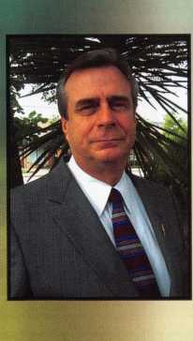

Keynotes • July/August 2004

The US Department of Labor through the Bureau of Apprenticeship and Training has certified the updated ALOA National Apprenticeship Standards for Locksmiths. We worked with a coalition for the Federal Facilities Protection Act to require locksmiths to be ALOA certified to work on federal facili­ties. The act has not been passed, however ALOA's presence and certification program is now well documented. As we continue to be a part of the legislative process, we are becoming better known.

It is our expectation that some of the states that are in the process of enacting registration or licens­ing laws and regulations will use the ALOA test for their testing requirement. ALOA has provided input (by request) on policy regarding the hazards of auto unlocking to Law Enforcement agencies such as the Fayetteville, Arkansas PD and others.

ALOA has many institutional locksmiths as members and instructors. There are 240 members who list a college or university as their business address. ALOA has provided assistance with key control policies and other issues to several educational facilities and has received requests for training from various institutions such as the Tampa Airport Facilities Maintenance Department, DFW Facilities Maintenance Department and Sandia Laboratories in New Mexico. The ALOA logo is being used in combination with a link to our site by about 90 of the ALOA members. Over 30 of these members feature the logo on their sites. Associate members also link to the ALOA site. During the convention advertising period, this number will increase. The ALOA logo is affixed to all correspondence. I can­not determine that there has been any increase of the use of the ALOA logo. The certification of retail locksmiths is currently being developed by the Board.

Depositories, UL887 - Delayed Action Time Locks, UL1034 - Burglary Resistant Electric Locking Mechanisms in addition that panel worked on and received ANSI approval for UL771 as well as UL1034. Currently they are working on a proposed High Security Electronic Locks Standard - UL2058. ALOA participated in the Security Industry Association's (SIA) World of Electronic Access Control course development. This work has been completed and because of our participation, our members will soon be able to take the courses online at a discount.

IN-STOCK...MORE SAFES

***FREE Freight Program***

***(30 States)***

AMSEC FireKing **liariall HAYMAN** MEIUNK yiCTOft

END 4 - COMMUNICATION: Industry communication that serves ALOA members

The two continuous forms of communication available to the membership are Keynotes and the web site. Both of these vehicles routinely feature information about products, techniques and industry news. Convention provides the members with direct access to the manufacturer, both on the show floor and in classes. There were 173 exhibitors at the past convention, many of these were manufac­turers. Many of the seminars and half-day classes at convention were taught by manufacturers.

The manufacturers' representatives are at convention along with instructors and authors. These people demonstrate products and answer questions of all sorts in their booths and in the classes and seminars. Many of these same "experts" provide the articles for Keynotes.

Much of the communication among members is provided through Keynotes and convention. We also have a forum on our web site that is not frequently used. I have recently concluded an agreement with ClearStar that ALOA members will receive a 33% ($30 per year rather than $45) discount for ClearStar. This is the forum of choice of many locksmiths and it will now be available at a reduced rate for ALOA members.

END 5 - PROFESSIONALISM: High standards of competency and professionalism upheld.

The Code of Ethics is distributed to all new members. In signing the application for membership, members agree to abide by the code. The code is on our web site in the area that can be accessed by the general public. In 2003 we had several incidents reported by members regarding applicants who desired to join ALOA, but who the members felt past actions by these applicants violated the Code of Ethics and Bylaws. We investigated those applicants by performing state background checks, and found that most, indeed, were not eligible for membership.

The PRP is becoming more nationally recognized through the various state licensing agencies requesting either specific portions of our test (Illinois) or contracting with the ALOA PRP department to develop a customized test based on the ALOA PRP (North Carolina). There are other states (Louisiana and California) who have indicated that they will use the ALOA PRP certifications as quali­fications for licensing in lieu of the state exam. In addition we are working with the Texas Licensing Board to develop criteria for education and certification for the new Texas Locksmith License which goes into effect September 2004. We received over 250 email requests for information regarding the PRP over the last year and there were approximately that many telephone requests. We respond by email with an informational letter and send packets of information by mail that promote the ALOA PRP, education, and membership. Many of the PRP categories have been updated. The coordination between the classes that are being developed and updated along with the ability to take the after class PRP has caused a higher pass rate leading to more certified ALOA members. Members who pass the various levels of the PRP are listed on the ALOA website and in Keynotes magazine.

In addition they receive a press release that can be sent to their local newspapers.

ALOA has participated with several industry groups on many issues. The Education Manager repre­sents ALOA on the UL Standards Technical Panel for Physical Security Devices, (STP 687) which this last year updated the standards for UL437 - Key Locks, UL786 - Key Locked Safes, UL771 - Night

TURD 1©

WHOLESALE SERVICE

800-848-9790

**New!** Keedex Stainless Steel Armored Door Loops

AVAILABLE FROM YOUR KEEDEX DISTRIBUTOR

ALL

STAINLESS STEEL  
DESIGN

FLEXIBLE STAINLESS

STEEL CONDUIT

STAINLESS STEEL  
END PIECES

STAINLESS STEEL  
MOUNTING SCREWS

COSTS NO MORE  
THAN MOST DOOR  
LOOPS THAT HAVE  
PLASTIC END PIECES

MADE IN U.S.A.



Ideas That Work

Call or write today for your free catalog!

Keedex, Inc.

12931 Shackelford Lane  
Garden Grove, CA 92841  
714-636-5657 • Fax: 714-636-5680  
e-mail: [info@keedex.com](mailto:info@keedex.com)

[www.keedex.com](http://www.keedex.com)

Keynotes • July/August 2004

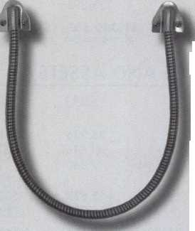

FINANCIAL REPORT

The financial records of ALOA for 2003 were audited by the firm of Sutton Frost Cary. The ALOA Board of Directors reviewed this report at their meeting in May of this year. Part of this report, the "Statements of Activities" (Profit and Loss) and the "Statements of Financial Position" (Balance Sheet) are included with this report to the membership. The auditing firm was of the opinion that ALOA's financial records fairly and accurately portray ALOA's financial position.

Although ALOA is a "not for profit" corporation, it is necessary for ALOA to make enough money to provide services to members. Recognizing this, the ALOA Board of Directors now requires that the association show a "profit" of no less than four per cent each year. In 2003 ALOA had revenue in excess of expense (profit) of $137,451 (six per cent) before depreciation. This is the second consecutive year that ALOA has had a "profit". So far 2004 is going well. I expect that the association will have another year that meets the financial requirements of the Board.

ALOA remains financially capable of providing the services expected by the membership.

ASSETS

STATEMENT OF ACTIVITIES



|  |  |  |
| --- | --- | --- |
|  | 2003 | 2002 |
| Current assets: |  |  |
| Cash | $541,610 | $297,748 |
| Certificate of deposit | 65,302 | 64,341 |
| Accounts receivable | 217,599 | 257,527 |
| Inventory | 41,909 | 35,907 |
| Prepaid expenses | 108,801 | 134,020 |
| Due from affiliate | 22,811 | - |
| Current portion of notes |  |  |
| receivable from affiliates | 21,001 | 23.232 |
| Total current assets | 1,019,033 | 812,775 |
| Property and equipment:  Land | 79,836 | 79,836 |
| Building and improvements | 302,516 | 302,516 |
| Furniture and equipment | 511,320 | 495.912 |
|  | 893,672 | 878,264 |
| Less accumulated depreciation | (700.565) | 1670.935) |
| Property and equipment, net | 193.107 | 207.329 |
| Notes receivable from affiliates, |  |  |
| less current portion | 138,395 | 159,395 |
| $1,350,535 | | $ 1,179,499 |

LIABILITIES AND ASSETS

|  |  |  |
| --- | --- | --- |
| Current liabilities: | 2003 | 2002 |
| Accounts payable | 96,936 | $74,735 |
| Accrued expenses | 41,516 | 51,179 |
| Current maturities of long-term debt | 7,060 | 7,061 |
| Due to affiliate | - | 22,572 |
| Prepaid dues | 663,622 | 538,132 |
| Prepaid exhibit fees | 404.050 | 449.230 |
| Total current liabilities  Long-term debt, less | 1,213,184 | 1,142,909 |
| current maturities | - | 7,060 |
| Total liabilities | 1,213,184 | 1,149,969 |
| Net assets-unrestricted | 137,351 | 29,530 |
| $1,350,535 | | $1,179,499 |

|  |  |  |
| --- | --- | --- |
| Revenues | 2003 | 2002 |
| Membership dues and services | $984,936 | $988,257 |
| Convention | 890,465 | 763,044 |
| Management fee | 138,000 | 126,000 |
| Advertising | 77,820 | 53,831 |
| Promotional programs | 37,201 | 56,480 |
| Interest | 21,069 | 24,065 |
| Educational programs | 89,943 | 91,300 |
| Miscellaneous | 41.989 | 41.296 |
| Total revenues  Expenses | 2,281,423 | 2,144,273 |
| Administrative | 1,248,275 | 1,228,229 |
| Convention | 389,224 | 387,804 |
| Keynotes magazine | 174,814 | 181,934 |
| Building operations | 64,301 | 55,652 |
| Member services | 85,866 | 75,168 |
| Depreciation | 29,630 | 38,858 |
| Promotional programs | 29,564 | 35,579 |
| Educational programs | 140,673 | 133,606 |
| Committee | 11,255 | 8,067 |
| Total expenses | 2,173,602 | 2,144,897 |
| Decrease in net assets | 107,821 | (624) |
| Net assets at beginning of year | 29.530 | 30.154 |
| Net assets | | |
| at end of year | $137,351 | $29,530 |



Keynotes • July/August 2004

**One Company...  
Endless Solutions**

Ease of operation, flexibility and security are the key words used to describe the SMARTLINC from LA GARD. Providing you with the ability to manage multiple locks through a single keypad, the SMARTLINC was designed with simplified programming and easier access in mind while still giving you the high security you have come to expect from LA GARD.

* The SMARTLINC is backed with a UL listed Type 1 electronic lock, the same security and reliability of the SMARTGARD
* Can manage up to five locks in a single safe
* Multiple users, audit capabilities, and time lock
* Over 30 years security expertise and a recognized world leader in high security locks for safes, vaults and ATM's.

Another first from LA GARD - your partner in security.

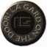

LA GARD, INC. 3330 Kashiwa Street, Torrance, CA 90505

Ph: 310-325-5670 Fax: 310-325-5615 Fax On Demand: 877-LAGARD2

Email: [theone@lagard.com](mailto:theone@lagard.com) [www.lagard.com](http://www.lagard.com)

IELAJGARD

One Company... Endless Solutions

©2004 LA GARD, all rights reserved, a MASCO Company (NYSE: MAS)

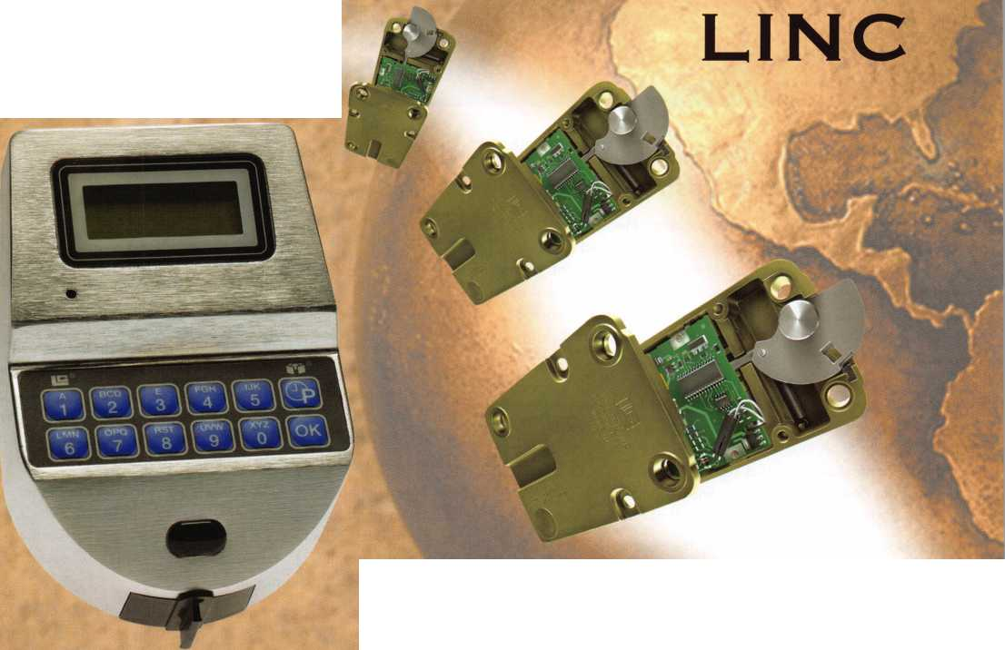

Senate Task Force Finishes Work; Bush Continues to Push for AHPs

May was a busy month on the Association Health Plan issue, as the Senate Republican Task Force on the Uninsured released a report outlining solutions aimed at expanding coverage to the uninsured on May 1 1. The Association Health Plan legislation (S. 545) is listed under the heading of "Solutions to Provide Coverage to the Uninsured" as one of two "Market Reform Alternatives." While Senator Judd Gregg (R-NH), Chair of the Task Force, indicated the Task Force members did not reach a consensus on the AHP legislation, the fact that it was included in the Task Force proposal represents significant progress. This is a strong indication that support for the AHP bill in the Senate is gaining momentum, and is a significant victory. Our coalition once again commends Senators Snowe and Talent for their strong efforts and leadership on behalf of the AHP legislation.

In addition to being recognized by the Senate Uninsured Task Force, the AHP bill got its first Democratic cosponsor of the 108th Congress in the Senate. Senator Robert Byrd (D-West Virginia) announced his formal cosponsorship of S. 545 in a press release on May 13. Senator Byrd's decision to support the AHP bill is a major development because it is vital that legis­lation have bipartisan support in order to pass the closely divid­ed Senate.

Despite the production of the Senate Uninsured Task Force pro­posal, the outlook for health care legislation of any kind in the Senate is highly uncertain and problematic in this election year. The best way to make progress in getting the AHP legislation on the Senate agenda is to get more cosponsors for the bill.

President Bush Continues Push for AHP Legislation

President Bush on May 25th continued to press Congress to enact the AHP legislation. At a speech in Youngstown, Ohio, in which he discussed his health policy agenda, the President said: "We need what's called association health care plans. This will allow small businesses to pool risk so they can have the same purchasing power as large businesses do." Urging Congress to enact the AHP bill has become a standard part of President Bush's speeches around the nation.

House of Representatives

The House approved a re-introduced version of the Association Health Plan bill (H.R. 4281) on a vote of 252-162 on May 1 3, 2004. This is the second time in the 108th Congress that the House has passed the AHP legislation (it passed on a vote of 262-162 in June, 2003). On this vote, all Republicans voted for the bill except Rep. Charlie Norwood (R-GA), who voted "present," and those not voting due to absence. H.R. 4281 was supported by 37 Democrats, one more than the 36 Democrats who voted for H.R. 660 in 2003. Nine Democrats who voted against the bill (or did not vote at all) in 2003 sup­ported the bill in 2004: Boucher (D-VA), Clay (D-MO), Clyburn (D-SC), Costello (D-IL), Frost (D-TX), Jefferson (D-LA), E. Johnson (D-TX), Rahall (D-WV), and Thompson (D-MS).

On the other hand, six Democrats who voted for the bill in 2003 reversed themselves and voted "no" in 2004: Davis (D- IL), Rush (D-IL), Sanchez (D-CA), Skelton (D-MO), McCarthy ID- MO) and Meek (D-FL). Rep. Steve Israel (D-NY), who voted for H.R. 660 in 2003, did not vote in 2004.

The reasons for these changes in votes by certain members is inevitably the result of their own political calculations. What is important is that the AHP gained more than it lost among those members changing their votes in an election year. In other words, this second House vote of the 108th Congress is another strong victory for the AHP bill! Once again, TAHC salutes Representatives Sam Johnson (R-TX), Cal Dooley (D-CA), Nydia Velazquez (D-NY) and John Boehner (R-OH) for their leadership on behalf of the AHP legislation in the House.

After approval of H.R. 4281, a legislative rule previously approved by the House combined this bill with two other health care bills and sent all three as a package to the Senate. Thus, if the Senate acts on any of the bills on an individual basis, it will be easier for the House to include any of the three in any conference committee that might meet in 2004. The other bills are a medical liability reform bill (H.R. 4280) and a bill to allow taxpayers to roll over up to $500 in unused benefits in flexible spending accounts into HSAs (H.R. 4279). These bills were approved by the House on May 1 2 on votes of 229-197 and 273-152, respectively.

**70**

Keynotes • July/August 2004

U.S. Department of Labor Enforcement Activities

Secretary of Labor Elaine Chao announced on May 1 8 that the U.S. Department of Labor is launching a series of seminars aimed at providing employers and benefit plan officials with a better understanding of fiduciary responsibilities under federal law. The seminars, entitled "Getting It Right - Know Your Fiduciary Responsibilities," will be conducted in Florida, Ohio, Massachusetts, and Arizona beginning in June, 2004. More information on this program can be obtained at the DOL's web­site: <http://www.dol.gov/ebsa/fiduciaryeducation.html>.

Senate Finance Committee Explores Legislation

The Senate Finance Committee is working with state insurance commissioners to explore the need for legislation to reduce problems experienced with fraudulent health insurance opera­tions, including Multiple Employer Welfare Arrangements, according to Montana Insurance Commissioner John Morrison at a May 21 press conference in Washington, DC. The press conference was convened by America's Health Insurance Plans (the industry trade group resulting from the merger of HIAA and AAHP) to announce a television advertising campaign to pro­vide consumers with information needed to make good deci­sions when purchasing health insurance (AHIP has also estab­lished a website for this purpose, which can be viewed at [www.avoidfraud.org](http://www.avoidfraud.org)). Also at the press conference, the National Association of Insurance Commissioners released a let­ter to Senators Charles Grassley (R-IA) and Max Baucus (D-MT), Chairman and ranking minority member of the Senate Finance Committee, respectively, containing legislative recommendations to change federal law to combat fraudulent health insurance operations, including changes to ERISA. Senator Grassley has indicated he is considering introducing legislation aimed at cracking down on fraudulent health plans.

It is unclear at this time if any legislation of this nature will be introduced this year. Legislation to amend ERISA would be in the jurisdiction of the Senate Health, Education, Labor and Pensions (HELP) Committee, not the Finance Committee, and HELP Committee Chairman Judd Gregg (R-NH) has not indicat­ed any interest in pursuing legislation of this nature on this issue to date. Given the natural relationship of this topic to the AHP legislation (which is one part of the solution to this problem), this could potentially provide additional opportunities for movement of the AHP bill in the Senate in the future.

If you have questions, would like more information, or need any assistance in contacting Senators in support of the AHP bill, please let me know! (214) 827-1701 ext. 16 or [paul@aloa.org](mailto:paul@aloa.org)

Motor Vehicle Right to Repair Act:

I recently helped organize a meeting in Southfield, Michigan. Board member, Mark Blum also attended. The meeting's pur­pose was to specifically discuss our issues with the automobile manufacturers. Eight different manufacturers were represented either in person or via teleconference. Also in attendance were other highly qualified locksmiths, representing various areas of our industry. Things progressed nicely and an agreement was laid out to get specific responses within two months.

A locksmith committee of sorts has been formed and is currently working on a graph to present to the manufacturers by June 1st. The manufacturers will have responses on each specific issue within a month.

This development will eventually get more information available to locksmiths looking to work on cars that they had previously been unable to work on. After the information that still isn't available is relayed to the manufacturers, talks will begin on the release of this information as well.

Our legislative angle is also still being pursued. We are curently up to 95 co-sponsors in the US House of Representatives and recently secured a sponsor for the Senate companion legislation.

Association Health Plan Legislation:

Just a few short days ago, the US House of Representatives approved the Association Health Plan bill (H.R. 4281) on a vote of 252-162, with nearly all Republicans and 37 Democrats sup­porting the bill. This vote is very similar to the vote on the identi­cal H.R. 660 in June, 2003 (262-162), with the difference apparently being the number of members of Congress not vot­ing due to absence. This is another strong victory for the AHP legislation!

A rule approved by the'House combines H.R. 4281 with two other health care related bills and sends all three as a package to the Senate. Thus, if the Senate acts on any of the bills on an individual basis, it will be easier for the House to include all three in any future conference committee with the Senate. The other bills are a medical liability reform bill (H.R. 4280) and a bill to allow taxpayers to roll over up to $500 in unused bene­fits in their flexible spending accounts, or transfer unused funds into HSAs (H.R. 4279). These bills were approved by the House on May 12 on votes of 229-197 and 273-152, respectively.

Regards,

Paul Kanitra

Government Relations Manager

71

Keynotes • July/August 2004

Classifieds



EMPLOYMENT

FOR HIRE

Product Manager

Kaba llco Corp., the world leader in the manufacture of key blanks, key cutting machines, and replacement cylinders, is seek­ing a Product Manager, responsible for the strategic direction and marketing of automotive transponder keys and equipment. The ideal candidate will possess a strong understanding of auto­motive diagnostics and automotive key generation and program­ming.

Responsibilities:

Direct and perform all aspects of product development, product changes and product promotions.

Manage and communicate sales and technical information for internal and external business customers.

Develop and maintain a pricing program that balances competi­tive challenges and at the same time meets revenue growth and profit objectives.

Prepare the marketing plans for assigned product lines and rec­ommend changes to meet market and competitive conditions.

Conduct field test of product software and hardware to insure market needs are met and design training programs for distribu­tion and end users to understand the applications of each.

Leads internal research efforts to identify automotive and security trends pertaining to the product line.

Managing all elements of the product line support requirements including merchandising, advertising, literature, website informa­tion, etc.

Skills/Education:

* Four year degree in Business Administration, Marketing or related technical field.
* Minimum of four years experience as Product/Brand Manager/Engineer for a technical product related to automo­tive diagnostics or automotive security.
* Strong written and oral communication skills.
* Proven ability to prepare and implement business plans and strategic assessments.
* Must have proficient Microsoft Office Suite experience in Excel, Word, PowerPoint

Interested candidates may send their resume with salary history in confidence to:

Human Resource Department, Kaba llco Corp., P.O. Box 2627, Rocky Mount, NC 27802, fax: 252-446-4702, or e-mail to [resume@irm.kaba.com](mailto:resume@irm.kaba.com) An EOE M/F/H/V.

EXPERIENCED LOCKSMITH WANTED

Harris County is seeking an experienced Locksmith For informa­tion please see website

<http://co.harris.tx.us/hrrm>

Or call (713) 755-5906 all applications must be applied in per­son • 1310 Prairie, 2nd floor, Houston, Texas 77002

BRANCH MANAGEMENT MANAGER

Safemasters, an established company, has an outstanding oppor­tunity in the Boston area for a results driven manager with a proven record. Preferred candidate will have, supervisory and admin skills, strong people skills, P&L exp.& sales ability. Responsibilities include directing & motivating a growing team including locksmiths and dispatch & inventory, and growing the market through sales, productivity & profits.

Prior experience in physical security, alarms, access control, or locksmith field helpful.

Our associates enjoy an equitable salary plan plus generous incentive and bonus plans for results oriented managers, and comprehensive benefit plans including 401 (k) and company matching plan. If you have a proven record and are looking for a company that both supports and encourages associates, forward your resume with salary history today.

Safemasters - Operations #93 Email: [hr2@safemasters.com](mailto:hr2@safemasters.com)

FAX: 800-233-2454 attn. Bryan Shaffer - #93 Voice Mail: 800-295-4702 xl54

LOCKSMITH FOR HIRE

Immediate opening with a full-service locksmith & security com­pany located in Aurora, CO. Seeking a Senior Service Technician proficient in all phases of locksmithing including safes and electronics. Company vehicle will be provided including all maintenance and fuel on vehicle. Benefits include a 401-K plan, Health Insurance, Vacation and Holiday Pay. Salary negotiable.

Contact: Sheila or Susan • Arapahoe County Security Center

15200 E. Miff Ave • Aurora, CO 80014 phone: 303-745-5500 fax: 303-745-5567

LOCKSMITH FOR HIRE

Locksmith, South Orange County, CA. Excellent opportunity for experienced technician in access control, safes and standard locksmith work. Van and all tools provided. Excellent pay and benefits. Send resume or call Tony's Locksmith at 949/492- 5700. Fax to 949/492-0246.

STAR SAFE AND LOCK

Star Safe & Lock, a 57-year-old commercial locksmith company, is looking for a qualified locksmith and safe technician in South Los Angeles County to South Orange County, California area.

We will provide continuous training for the right individual but knowledge of locksmith basics is a must. Health and Dental insur­ance programs. Fax 801-469-1077. Email [info@starsafe.net](mailto:info@starsafe.net)

LOCKSMITH WANTED

Busy shop in Woburn, MA is looking for experienced locksmiths to join our team. If you're a self-motivated hard worker willing to work reasonable hours and be compensated for your abilities, this is for you. We have a large client base for commercial, resi­dential, safes, door and glass storefronts and automotive cus­tomers including 2 AAA contracts. Please call John for more information at 781-933-9999 or send resume to: Locks & Keys Inc., P.O. Box 222 • Woburn, MA 01801 (all inquiries kept strictly confidential)

STOP LOOKING!!!!!

EXPERIENCED TECHNICIANS WANTED LOCK INTO YOUR FUTURE NOW!

If you are experienced, intelligent, and desire a secure future, come join our team. We are a full service commercial/residen­tial security service (locks,keys,safes,cctv,access control, door related hardware). We offer: top wages, company vehicle, 401k, paid vacation, paid holidays, new uniforms, cross train­ing, and job satisfaction. We are looking for the best tech's, who are ready to be treated and compensated as professionals.

Bass Security Services, Inc.

Ph#216-755-1200 ex.# 124

Fax#216-755-1220

E-MAIL / [rmesnick@bass-security.com](mailto:rmesnick@bass-security.com)

WANTED TO BUY/SELL

WANTED TO BUY

Safemasters Co. Inc. is seeking to acquire an additional lock­smith business in the greater Boston area. If you are an owner and would like to explore the possibility of selling your business, we would be interested in talking with you. Confidentiality assured. Contact Bryan Shaffer at [hr2@safemasters.com](mailto:hr2@safemasters.com), or voicemail 800.295.4702 (ext. 154).

LOCKSMITH BUSINESS WANTED

Locks & Keys. Inc. is looking to purchase a locksmith shop and/or mobile locksmith business in the Massachusetts/New England area to help grow our current business. If you are considering retiring or would like to sell and stay on as a locksmith with us, please call John at 781-933-9999 to discuss details. All inquiries kept strictly confidential. Thank you for your consideration.

FOR SALE

Mobile Locksmiths Business. 2002 Freightliner Sprinter. HPC Code Machine and code books, extra cutters. Lots of tools.

Many years in area. Growing business. Buy and go to work, completely ready. Located in NE Maryland. Call 888/339- 5625. Priced to sell quickly. ALOA Member.

BUSINESS FOR SALE

Colorado Commercial Locksmith Business (Est 1974) located in vibrant golden triangle, adjacent to downtown Denver. Includes vans, equipment, inventory, and loyal customer base. Building also available with additional rental income capacity. Serious inquiries: Mr. Jones (Agent), 1420 Jamaica Street, Aurora, CO, 80010-3498, Fax 303-573-9099.

WHOLESALE SAFE DEPOSIT LOCKS

Allied, Diebold, Herrin, Hall & Mavin, llco, Lefabure, Mosler, Precision, S&G, Security Corp., and Yale. Locks from early 1900s to current. Call or email for lock type and pricing sheet. Quantity discounts. Call WBI at 954-484-2404 or email sales @wbi.us

Classified Advertising Policy

Classified advertising space is provided free of charge to ALOA members, and for a fee of $.60 per word, $15 minimum for non-members. Classified ads may be used to adver­tise used merchandise and overstocked items for sale, "wanted to buy" items, business opportunities, employment opportunities/positions wanted and the like. Members or non­members wishing to advertise services or new merchandise for sale may purchase a "Commercial Classified Ad, " for a fee of $1.30 per word, with a minimum of $40. Each ad will run for two issues. For blind boxes there is a $5 charge to members and non-members. All ads must be submitted in writing to the ALOA office by the fifteenth of the month, two months prior to issue date. Send to Keynotes Classifieds, 3003 Live Oak St., Dallas TX 75204-6186. ALOA reserves the right to refuse any classified advertisement that it

deems inappropriate according to the stated purpose of the classified advertising section.

OVERSTOCK ITEMS

30 Key Machines from Belsaw, Curtis and Mini's to Framon #2, Abloys, Dom and ITL 900. $50-$ 1200. Hundreds of mostly-orig- inal Schlage knobs, deadbolts and mortise cylinders $3. Latches $l-$5. Weiserbolt knobsets $12. Dexter entry sets $12. Also Dexter/Master and Master/Schlage. One hundred pounds of original Adams-Rite product including 12 pounds of new small repair parts $150. Over 125 car-opening tools plus wedges, instructions and misc. $250. Key racks—Curtis (blue or brown) $25, Cole (yellow) $50, ILC tower (tan) $100.

Tom Bortner 574-264-7374.

BUSINESS FOR SALE

SMALL MOM-AND-POP

Locksmith and glass business for sale in Golden Valley, AZ. Retirement is forced for health reasons. On busy US Highway 68. Golden Valley is between Kingman, AZ, and Laughlin, NV.

In fast-growing Mohave County. Leased shop. Dodge Ram Van 2500. Both well-equipped and stocked. $65K plus equipment and inventory. Asking $48,900. All reasonable offers will be considered. New money only. Call 928/565-2294 or e-mail inquiries to [lmburks@ctaz.com](mailto:lmburks@ctaz.com).

BUSINESS FOR SALE

Growing East Tennessee locksmith business, established 1987. Supports three locksmiths, two fully equipped vans and building on corner lot fronting main highway through town. Shop cus­tomers, residential and commercial accounts ready for someone to take over. Call 423-586-3101. Monday-Friday. 8:00 a.m. to 5:00 p.m., EST.

FOR SALE

Sarasota Lock & Key Shop—Sarasota's oldest Lock & Key shop. Owner wishes to retire in October 2004. $40,000 for inventory and equipment. Includes registered fictitious name. New owner will have to relocate as building will be sold separately. Inspection invited M-F, 9a-5p. Contact Pete at 1537 State Street Sarasota, FL 34236 • Phone (941J953-3773

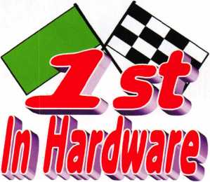

From Start To Finish  
We're 1st In Hardware  
**Baltimore’s Newest Source For  
Door Hardware Security Products**

*Specializing In Storefront Hardware  
Including Husky Door Closers*

**We Stock Scorpion CX-5  
High Security Products**

**Phone: 866-397-9900  
Fax: 866-646-0045  
[www.lstinhardware.com](http://www.lstinhardware.com)**

**Lockcraft shakes up the market:**

**Our expanded line-up of priced-right**

**automotive locks, keys and service**

**tools opens up better opportunities for  
you. And our 5-day/90% order fill**

**includes OEM quality replacements fo**

**Daimler Chrysler, Ford, GM, Honda,  
Nissan,Toyota and many more.**

***Better get reacquainted  
with Lockcraft!***

VISIT OUR BOOTH 1120 AND 1122  
AT ALOA FOR SPECIAL OFFERS!

Lockcraft

2345 N. Central Avenue Brownsville, TX 78521 Phone: 877-567-5470 Fax: 512-233-2414

**TM**

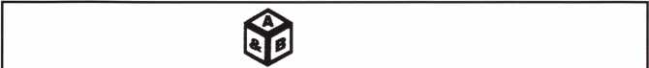

SAFE CORPORATION

MANUFACTURES OF QUALITY DEPOSITORY SAFES AND CHESTS

DISTRIBUTING FROM WAREHOUSES IN

* LOS ANGLES, CA
* CHICAGO**,** IL
* GLASSBORO, NJ

A & B is now a stocking distributor

for Mutual Safes

featuring

AB-4-30-3S AB-9-2 WS 10-2

Chose from over 75 models in stock

We ship your order within

24 hours

See us

*of [www.a-bsafecorp.com](http://www.a-bsafecorp.com)*800-253-1267  
Fax 856-863-1208

CALL FOR YOUR  
CATALOG TODAY

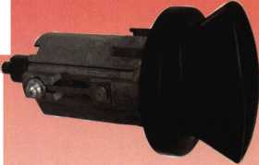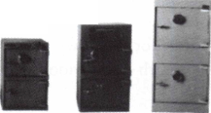

The Curious Curator Presents

French Masterpieces Part i of 2

by AJ Hoffman, CML

This article appeared in the July issue of The Antique Lock Collector, the 20- page quarterly publication of the West Coast Lock Collectors Association. If you would like to join and receive this publication, please send $iy (U.S.), $18 (Canada) or $20 (international) to Bob Heilemann, Ace Lock & Key, 142J Lincoln Blvd., Santa Monica, CA 90401.

Most lock and key collectors around the world have only seen pictures of masterpiece keys and locks in books. Some collectors have been lucky enough to visit European museums to see them in person, behind glass. Few have had the privilege of touching one. They are so rare and desirable that they seldom make it into private collections, especially this side of the Atlantic. When one is offered for sale, it brings a five-figure price on the auction block.

I never thought Fd own one, let alone two. My first masterpiece key is shown to the right. It came from the auction of Peter Phillips’ collec­tion in London in November 2002.

When a CML was a CML!

In France, the institution of the masterpiece officially began in 1392. The locksmith’s artistry reached its pinnacle in the 17th century and the keys shown in this article date from roughly 1625 to 1775. They are illustrated actual size.

France is not the only country in Europe where masterpieces had to be fabricated. However, the level of artistry required in France far exceeded the requirements for locksmiths in other countries, so the French masterpiece is what most collectors think of when we hear mas­terpiece key.

Why “Masterpiece”?

They are called masterpieces because the French locksmiths of the day were required to make such a lock and key in order to become master locksmiths, at which time they were permitted to open their own forge or shop. The masterpiece was to prove the candidates’s artistry as well as technical skill.

I’m relying on the great detail provided in the book, Des Clefs etdes Hommes by Marc Feldmann for the historical information in this article.

These locks and keys were entirely made of iron. Their parts are sawed, chiseled, chased, and filed, then pinned, riveted or fused together in the heat of the forge.

The complex wards inside the lock were too delicate to resist any seri­ous burglary attempt so the finished masterpiece was never destined for actual use; its production was merely a test. The finished master­piece would sit on a shelf gathering dust. The greatest purpose it could ever serve after completion would be as a model for the new master’s future apprentices to study for their own masterpiece, or to be sold (for very little) if the locksmith or his widow needed money.

Imagine spending a year of your  
life fabricating something that  
had no use and little cash val- ^  
ue in the long run! There was j  
little market for the sale of  
masterpieces in these lock-  
smiths’ lifetimes. It wasn’t until  
much later that they became  
collectors’ items. By that time  
many had been lost or  
destroyed.

The features of these keys  
are generally similar because  
the guild proscribed the gener- ^  
al construction of the key and  
left the artistic detail of  
each of its sections to  
the candidate.

In fact, the standard  
shape of the upper por-  
tion of these keys gives them their  
common names in German

(Laternengriffschlussel  
- lantern-bow key)  
and French (clef a  
lanterne - lantern  
key). The French  
and German terms

for masterpiece are  
also used: chef d’oeu-

vre and Meisterstuck,  
respectively.

The Locksmith  
Guild’s Rules

The masterpiece rules varied from city to city with the most rigorous standards enforced in Paris. Locksmith guilds changed their require­ments from time to time over the centuries, but beginning in 1723, candidates were given one year to fabricate the lock and key, once the task was assigned.

Up to the 15th century the masterpiece was always a door lock with its key. In 1650 the candidate could be asked to make a lock for a cabinet, buffet or chest. Locks usually incorporated one or more tricks to reveal the keyhole and to open them.

The level of complication of the key bit and corresponding wards in the lock also varied by area and by such considerations as the candi-



Keynotes • July/August 2004

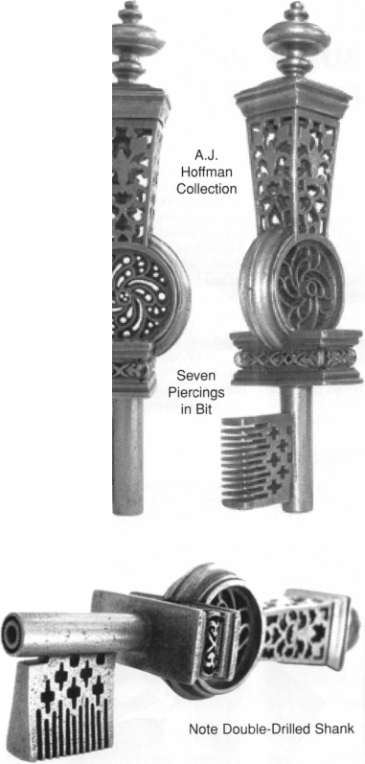

date’s family background as well. For instance, special privileges were usually granted to locksmiths’ sons and to candidates who had mar­ried locksmiths’ widows. The technical requirements also varied depending on whether the candidate had gone through the full apprentice and journeyman stages, and even whether he was a native of Paris. There will be more detail on this later.

As early as the 13th century tradesmen were forbidden from working on weekends and holidays. Until the end of the 16th century master candidates were further forbidden from working on their master­piece at night. The guild felt that the weak light from candles and lanterns was inadequate for such fine work after dark. Perhaps more importantly, the examiners had the task of appearing at their conven­ience to observe the candidate at work. This ensured that the candi­date was actually making his own test piece, rather than having a master friend or employer make it for him.

The rules were strict and the guild’s examiners did not hesitate to reject candidates whose masterpiece was not up to standards.

The candidate actually had to go live and work with one of the exam­iners. This prevented both assistance and interference from his regu­lar co-workers.

The examiner set a special room aside that included all the necessary tools at the disposal of the candidate, who had to pay rent as well as a security deposit for the tools. If candidates were caught working at home, they lost the right to ever become masters.

In the regulation of 1650 the masterpiece was presented for two reviews. The first was before the key was finished; probably after the bit was done but before the bow was fabricated. At that time, the key was marked with a special stamp. The second review was for the lock with its wards and case finished and it too was marked with the candidate’s name. This was done to prevent a masterpiece from being used a second time.

One of the most frequent abuses was when a master, who was unable or unwilling to work, lent his name and the operation of his shop to someone else. The law of 1723 punished this practice by closing the shop for one month. Repeat offenders had their master tile revoked forever.

Alongside all these rules however, a candidate always had the possibil­ity of buying his master title outright, either directly from the Crown or from his city government. Cities and towns sometimes “sold” the master title as a way to increase revenues in times of fiscal deficits. However, the masterpiece remained the sole proof of a locksmith’s ability. Money could buy the title but it could not guarantee ability

Ward Terminology

French locksmithing jargon has different terms for each of the many different types of wards and their corresponding cuts in the bit of the key. Most of these have no English language equivalents.

One such word that figures prominently in the discussion of master­pieces is pertuis. Two of its sounds are not present in standard Ameri­can phonetics, but a rough way to indicate pronunciation is pear twee, both singular and plural, with the accent on the last syllable.

This is the word for  
holes cut through  
the key bit, as well  
as the correspon-  
ding wards in the  
lock. I will use the  
termpiercing(s) as the  
closest equivalent.

The other special type  
of wards in these  
keys is the comb  
wards, so called  
because the fine  
teeth in the end of the

bit resemble

those  
of a comb.

The Guild’s  
Examiners

The examin-  
ing board was  
elected by the  
masters and its  
members were  
considered the  
officials of the  
guild’s administra-  
tion. They were  
responsible for  
enforcing the  
guild’s rules and  
those of the king.

17 cm  
long

Bremer

piercings  
in bit

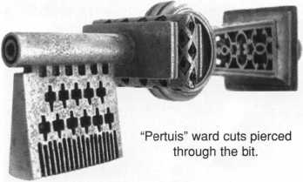

There were two examiners in the 13th century. In 1392 the number increased to four, where it would remain. Each examiner served a two-year term and half the board was elected each year.

One of the duties of the examining board was to establish the level of difficulty of the masterpiece. This was significant because it could make it easier or harder for certain candidates to pass and be admit­ted into the trade.

In order to prevent influence peddling, eight former members of the examining board were summoned to the guild’s office to give their opinion as to the level of difficulty of the masterpiece to be produced.

The examiners also regulated the relationship between shop owners and their employees.

They followed candidates’ progress from apprentice to master. They assigned the masterpiece, checked up on the candidates, judged the masterpiece, assisted in the process of joining the guild, and attended the proceedings when the master was sworn in before the king’s court.

All this activity was a full time job so examiners could not spend much time at their own business. They received monetary compen­sation as well as being excused from their regular duties of guarding the gates to the city.

Keynotes • July/August 2004

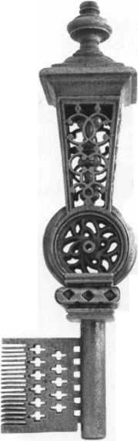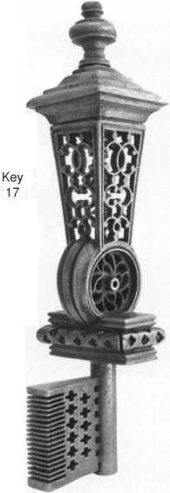

**A Peek Under**

**the Hood**

***)***

This rare glimpse “inside the lantern” is possible because the pin that secures the top on the Bremer key was missing when I obtained it. It was relatively easy for me to remove the cap for cleaning and photography.

t

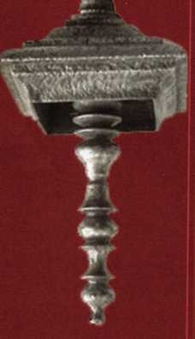

This feature is typical of French  
masterpiece keys but it is easy to  
miss because is so hard to discern  
in photos of complete keys, and  
when viewing these keys through  
the glass of museum showcases.

This part spins, together with the  
button on the top of the cap.  
Perhaps the button spins so the  
key can be carried on a ribbon or  
cord, without tangling. Most mas-  
terpiece keys have this spinning  
button as well.

Not All Masterpieces Were Created Equal

In Lyon, thirteen piercings were required in the masterpiece. In Angers the number was nine. In Orleans, the official record stated that a candidate had to make a chest lock whose key had nineteen piercings!

The masterpiece requirements also usually differed between candidates who went through the full apprenticeship, (apprentis- sage) as opposed to those who had only done their eight years of on-the-job train­ing (<compagnonnage). In Bordeaux in 1612, people with apprenticeships were only required to make a lock with five piercings while the requirements for others were left to the discretion of the masters.

Feldmann next states that the fully appren­ticed candidate in the 17th century only needed to make seven piercings and this number could be raised to 21 for other can­didates, at the discretion of the examining board. Presumably this differentiates Paris from Bordeaux, but it is not clear in the book.

The rules for Parisian locksmiths were the most demanding. As a result, the title of locksmith of the city of Paris and sur­rounding areas was the most sought-after. This title allowed the craftsman to set up shop anywhere in the kingdom.

With the exception of the number of piercings in the bit, the general form of the key had the same requirements for all can­didates and common shortcuts that would be used in normal work of the day, such as silver soldering instead of fusing the iron in the forge, were not permitted in order to keep the level of difficulty high

Masterpieces were most often made in an older style. For instance, those made under Louis XIV (1638 - 1715) had decorations



Keynotes • July/August 2004

recalling the 15th century. Although it was decreed in 1650 that these locks would be made in a contemporary style, test pieces continued to follow the Gothic style.

The rules of 1650 stated that all candidates had to make the same thing, except for the number of piercings. In 1691 the guild changed the rules to favor masters’ sons, and those who married masters’ daughters or widows by setting the level of the mas­terpiece’s complexity higher for others. This tended to keep outsiders out of lock- smithing.

Original Value

In most cases, the finished masterpiece remained the property of its maker. It cost a lot to produce, especially for candidates who were not within the family of a master locksmith who could help them financially during the many months of its fabrication.

Candidates coming from outside the trade often sold their masterpiece to make ends meet. At the beginning of the 15th century, the price could reach six pounds. Later the price of the master piece was determined by the number of piercings. Today? Well, they’re worth a bit more!

“The” Museum

The most breathtaking collection of early locks and keys I’ve ever seen is in the Musee le Secq des Tournelles in the city of Rouen, an hour or so outside of Paris. There are plenty of masterpeice keys but hundreds of other magnificent antique locks and keys from Roman times to the early 19th century, forming a large portion of this museum of all types of antique iron­work. This is an absolute must-see if you ever go to Paris.

The museum is housed in a 16th century church building and was founded by Henri le Secq des Tournelles, born in 1853.

It's family reunion time at ALOA!

ALOA’s annual event has always pro­vided us the opportunity to come together as an industry and renew friendships, partnerships and techni­cal expertise. It’s the same for the companies of the Kaba Group. We’re all there and anxious to show off what’s new.

This year’s show is extra special...

• The new fully updated ILCO® key  
blank catalog will be available

* Take a look at the new NASCAR® Signature Series of key blanks
* Test-drive the Universal II code machine
* Power up with the new E-Plex®
* Try out the self-charging PowerLever® PROX
* Secure a unique dealer keyway with Peaks® Global
* Check out the affordable Kaba LC Series with Intellibolt ™ technology
* Sign up as a member of the excit­ing Kaba Mas Dealer Network

Can’t make the show this year?

Visit our new Kaba-llco website and click on Kaba-Connections.  
We’ll give you a look at everything we’re doing at ALOA.

So join the family...in person...or on-line.

Kaba Americas



www. kaba- ilco. com

KABA

TOTAL ACCESS

I

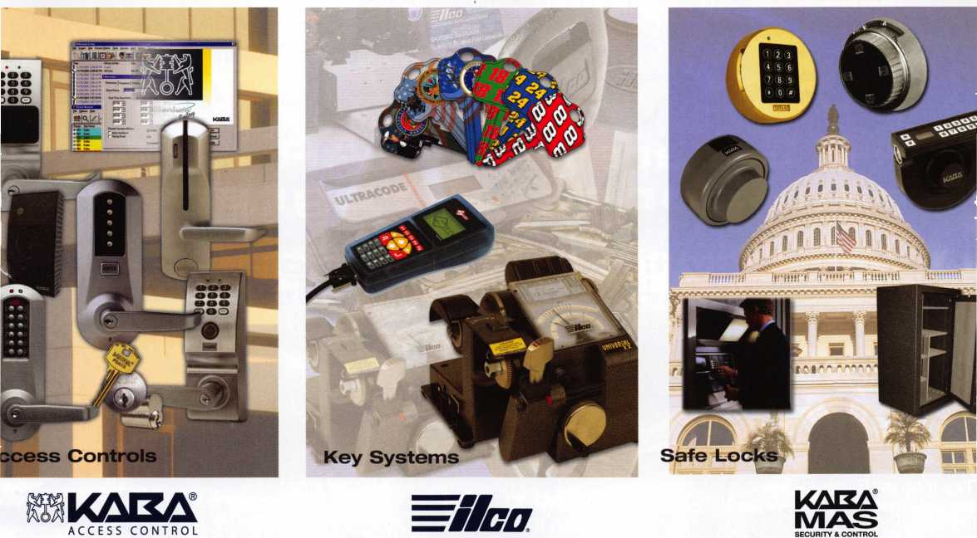

**New Generation STAR XL GAN Transponder Programmer**

**I've lost my Taurus keys... :an you make me a new set?'**

**How much of your money lave you sent to the ocal Ford Dealer?**

**NGS STAR XL CAN**

**Locksmith 8008LXLC**

**Did you Know...**

**..the Dealers charge an average of $100 per ;ransponder key?**

**..you can get the factory ;ransponder tool for less ;han the cost of doing one <ey per month?**

**Say YES" 1 shone calls**

**CAN VIM**

**81201L**

**Use what the Dealers use for complete coverage on ALL Ford/Lincoln-Mercury and Mazda vehicles equipped with transponder keys. The NGS XL CAN offers complete transponder coverage including CAN protocol and the ability to clear ALL Diagnostic Service Codes**

**rou re neverJomyour own ■ »**

**oil Free Technical Support ■KU800-342-5080**

**SQ04 Software Update and GAN Vehicl  
Interface Module now available.**

**Waekon/Hickok Inc. 2004 All rights reserved.**

